**Team Portfolio**

**Team Name: The Influencers**

**Project Manager: Rohit Pandey**

**Team Members:**

**Dipesh BC(c7202612)**

**Bijay Giri**

**Rajbir Chand**

**Kadamber Varma**

**Sushant Tiwari**

# Overview

This is an e-commerce website which was created in-order to solve the current market crisis for the local shop owners at Clehuderfax. With the online market blooming all around the globe, Clehuderfax will be no stranger to influence on the local market and physical outlets in Clehuderfax. Clehuderfax will be the answer to tackle the current issue and provide the local shop owners with an online platform for the retailing of their goods.

Table of Contents

Overview 2

Project Planning 5

Belbin’s Analysis 6

Individual Belbin’s Analysis 6

Team Belbin’s Analysis 7

MS Project 13

Task Sheet 13

Gantt Chart 14

Calendar 14

Resource Sheet 16

Team Planner 16

Network Diagram 17

Timeline 19

Skill’s Audit 20

Individual Skill’s Audit 20

Team Skill’s Audit 21

Project Initiation 22

Project Charter 22

Project Contract 25

Communication and Collaboration Tools Used 26

Trello 26

Slack 26

Google Drive 28

Project Execution 29

Project Designing 29

Entity Relationship Diagram 29

Extended Entity Relationship Diagram 29

Final Composite Entity Relationship Diagram 30

Use Case Diagram 30

Requirements Catalogue 34

Functional Requirements 34

Non-Functional Requirements 39

Team Logo 39

Product Logo 40

Risk Register 40

Individual Risk Register 40

Individual Risk Profile 41

Team Risk Register 42

Team Risk Profile 43

Website Mockup 44

Wireframes 46

Webpage 58

Pictorials 59

# Project Planning

A group of traders who are trying to sell fresh goods based in Clehuderfax have decided to band together and will explore the possibility of offering a joint e-commerce portal to their online shops.

Initially the e-commerce website will be of 5 traders where we have butchers, greengrocer, fishmonger, bakery and delicatessen. And their product lines will not overlap and that their products will be unique to all of them. The website supports a maximum of 10 shops in the first instance and will increase with its popularity. They expect the site to be viewable on mobile as well as desktop devices and viewable on the most popular browsers. They will offer 3 collection slots 10-13, 13-16, and 16-19. For the pilot these will only be for Wed, Thus, Fri. When placing and paying for their order users should identify a collection slot, which must be at least 24 hours after placing the order and for the payment of the goods they will do it through PayPal. There will be a maximum of 20 orders per slot allowed.

User should be able to search product by Shop or by product type and given a virtual basket were this item can be stored. They must register or login before checking out.

The management will look after every transaction made, activity of traders and customers and generate daily, weekly and monthly report for all traders who are working with us.

## Belbin’s Analysis

Identification of team structure, team performance, team roles, individual roles, and individual performance. The Belbin analysis allows the identification of team roles that the team members can perform well.

### Individual Belbin’s Analysis

|  |  |  |
| --- | --- | --- |
| Version:1.0 **Belbin’s Analysis** Date reviewed: | | |
| Primary role | Dipesh B.C. | Specialist |
| Secondary role | Dipesh B.C. | Plant |
| Least likely role | Dipesh B.C. | Co-ordinator |

**Your Name: Dipesh B.C.**

|  |  |  |
| --- | --- | --- |
| Do you think the descriptions of these roles are an accurate description of your behaviour in teams? How do you see yourself differently? | Dipesh B.C. | Yes, the descriptions of these roles are an accurate description of my behaviour. I see myself differently in the way I solve problems in my daily life and my helping behaviour with others. |
| Are there roles identified by Belbin that you might like to develop in yourself more? Which ones and why? | Dipesh B.C. | Yes, there is a role I would like to develop and become better at and that is team worker. Developing this role is important for me because in future most of the time I must work with a team where I will meet team members of different natures with attitudes. Cooperating with the team and helping them is the key of success to finish any work in each time. |
| What possible situations in the coming months can you identify where you could work on developing these skills? | Dipesh B.C. | Situations like when one or more of my team members are sick or when they are unreachable or when they might have to deal with stuff of higher importance is where I could come in handy and develop my team working skills. |
| Considering your team working, how do you think you could improve your effectiveness in group work and in contributing to the success of teams that you work in? | Dipesh B.C. | I think that by being more social and more diplomatic I could improve our effectiveness in group work and by contributing to the success of the team. |
| Are the results of this inventory consistent with how you worked in the Foundation Project in your small groups for discussions and presentations? | Dipesh B.C. | Yes, the results of this inventory are almost consistent with Foundation Projects. There are some slight changes as this exercise contain continuous documentation of each task done and regular update on improvement of the project. |
| How well do you want to contribute to group presentations? | Dipesh B.C. | I want to give my best effort in my group presentations. |

### Team Belbin’s Analysis

|  |  |  |
| --- | --- | --- |
| Version:1.0 **Belbin’s Analysis** Date reviewed: | | |
| Primary role | Bijay Giri | Co-ordinator |
| Dipesh B.C. | Specialist |
| Kadamber Verma | Implementor |
| Rajbir Chand | Shaper |
| Sushant Tiwari | Team Worker |
| Secondary role | Bijay Giri | Specialist |
| Dipesh B.C. | Plant |
| Kadamber Verma | Complete Finisher |
| Rajbir Chand | Monitor Evaluator |
| Sushant Tiwari | Co-ordinator |
| Least likely role | Bijay Giri | Monitor Evaluator |
| Dipesh B.C. | Co-ordinator |
| Kadamber Verma | Resource Investigator |
| Rajbir Chand | Resource Investigator |
| Sushant Tiwari | Resource Investigator |
| Do you think the descriptions of these roles are an accurate description of your behaviour in teams? How do you see yourself differently? | Bijay Giri | Yes, the descriptions of these roles are an accurate description of my behaviour. I see myself differently as there is diplomacy and strategizing in most of the decisions I make. |
| Dipesh B.C. | Yes, the descriptions of these roles are an accurate description of my behaviour. I see myself differently in the way I solve problems in my daily life and my helping behaviour with others. |
| Kadamber Verma | Yes, I believe the above roles are verified to my description and my skills, I came up with. I do not see myself differently in the wide sense though I slightly remember all the time that I assure the work and accuracy of the work before I proceed on the task to complete. |
| Rajbir Chand | Yes, I think that the above roles that I have defined for myself define me the way I am in real life. And therefore, I do not see myself anywhere differently than what I have already described. |
| Sushant Tiwari | Yes, the descriptions of these roles are an accurate description of my behaviour. I see myself differently as there is diplomacy and strategizing in most of the decisions I make. |
| Are there roles identified by Belbin that you might like to develop in yourself more? Which ones and why? | Bijay Giri | Yes, I would like to mention that there is one role that I would like to develop more and that is Co-ordinator. I want to develop this role because the Co-ordinator is the one who manages the team and plans the working and divides the work equally to all group members in a team which ultimately leads to better team working and efficiency in group work. |
| Dipesh B.C. | Yes, there is a role I would like to develop and become better at and that is team worker. Developing this role is important for me because in future most of the time I must work with a team where I will meet team members of different natures with attitudes. Cooperating with the team and helping them is the key of success to finish any work in each time. |
| Kadamber Verma | I have already assigned myself for the multiple roles I mentioned above. Although, I would love to develop a role of “Specialist” which I am lacking that I will be strengthen soon to become more productive in order to perform specific and potential task. |
| Rajbir Chand | Now that I already have three of the roles described for myself for which I am already capable of so therefore the one role I would like to develop more In, the coming years is that of the “Specialist”. Simply the reason being I am not good at it, so I hope I gain some knowledge for that skill set. |
| Sushant Tiwari | I have already mentioned my primary role, but Co-ordinator is a role where I would like to improve my quality. Because Co-ordinator is a backbone of a Group. |
| What possible situations in the coming months can you identify where you could work on developing these skills? | Bijay Giri | Situations like when a group member is not working as expected or when a group member is not cooperating with the team. |
| Dipesh B.C. | Situations like when one or more of my team members are sick or when they are unreachable or when they might have to deal with stuff of higher importance is where I could come in handy and develop my team working skills. |
| Kadamber Verma | There might be various possible situations in the future that will define the skills I’m working with currently, Because I’m engaged in the multiple roles in the project, so I have wide range of opportunity to sharp my skills in the future. |
| Rajbir Chand | We in the team have decided to go with the rotating kind of leadership which will create a chance not only for me but for everyone else. So, I consider that as one of the situations where I can work to enhance my skill set for that role. |
| Sushant Tiwari | Situations like when a group member is not working as expected or when a group member is not cooperating with the team. |
| Considering your team working, how do you think you could improve your effectiveness in group work and in contributing to the success of teams that you work in? | Bijay Giri | Becoming more confident in my decision making and better at recognising others talent will help me improve my effectiveness in group work and in contributing to the success of teams I work in. |
| Dipesh B.C. | I think that by being more social and more diplomatic I could improve our effectiveness in group work and by contributing to the success of the team. |
| Kadamber Verma | Me as one of the team members of my team working by carrying an effective set of responsibilities. All of us has been assigned to be dedicated to the project. Me as a part, I came up with high determination to fulfil the work needs required to my roles and responsibilities. I could be a remarkable example throughout group if I could able to turn my ideas into actions more than I can ever in the present scenario. I am dedicated to my ideas to contribute for the success of my team. |
| Rajbir Chand | This could be done by regularly attending meetings that will be held in the group because I think punctuality already contributes to the effectiveness of anything. And yes, the other solution can also be participating and contributing towards the team objectives effectively. |
| Sushant Tiwari | I think that by being Confident and diplomatic. I could improve our effectiveness in group work and by helping to success our team. |
| Are the results of this inventory consistent with how you worked in the Foundation Project in your small groups for discussions and presentations? | Bijay Giri | The results of this inventory are almost consistent with the Foundation Project that I worked in with my small groups for discussions and presentations. |
| Dipesh B.C. | Yes, the results of this inventory are almost consistent with Foundation Projects. There are some slight changes as this exercise contain continuous documentation of each task done and regular update on improvement of the project. |
| Kadamber Verma | Since the initialization of the foundation project I have been giving my effective presence in the team by considering issues, roles and time. I found consistent results of all the founding projects because of strong bond and communication between the team members. Moreover, working in a small group have been structured well between so that we meet all the requirements and the objectives that a project holds. |
| Rajbir Chand | Till date everything has been going smoothly and effectively. So, in a way I could say that for the time being everything is consistent, and all this could be proven by because we have been meeting every assignment deadline by their specified dates of submission. |
| Sushant Tiwari | Yes, results of this inventory are almost consistent with the Foundation Project where I worked in with my small groups for discussions and presentations. |
| How well do you want to contribute to group presentations? | Bijay Giri | I want to give my best effort in my group presentations. |
| Dipesh B.C. | I want to give my best effort in my group presentations. |
| Kadamber Verma | If I talk about my contribution, I am being very well planned, and environment orientated. Before I stand for the presentation, I make concrete plan from abstract ideas in self- controlled manner. I disregard my self-interest to focus on the needs of a team and presentation work. I likely persuade myself to change if I feel that the change will yield positive results to group presentation as well as individually. |
| Rajbir Chand | According to me I have been contributing well enough to the group and the reason being that I regularly attend all meetings and also bring in important changes to be made in the project and also keep adding up resources for the group to make effective use of. |
| Sushant Tiwari | I want to give my best in our group presentations. |

## MS Project

Microsoft Project, which is a project management software product, developed and sold by Microsoft. It is designed to assist project manager in developing a schedule, assigning resources to tasks, tracking progress, managing the budget, and analyzing workloads and many other things.

### Task Sheet

Task sheet shows the whole working plan with details along with starting and ending dates of specific task.

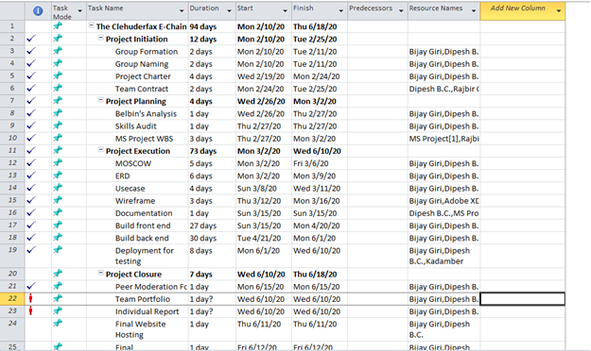

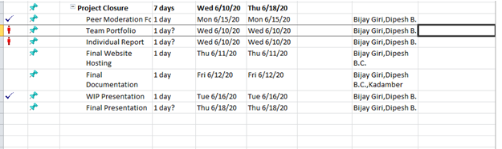

### Gantt Chart

A Gantt chart is a horizontal bar chart that visually represents a project plan over time. Modern Ganttcharts typically show you the status of—as well as who is responsible for—each task in the project.

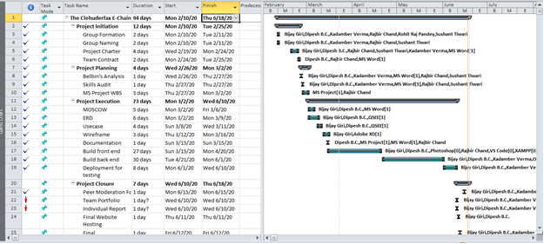

### Calendar

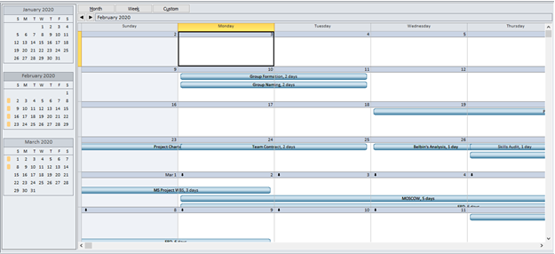

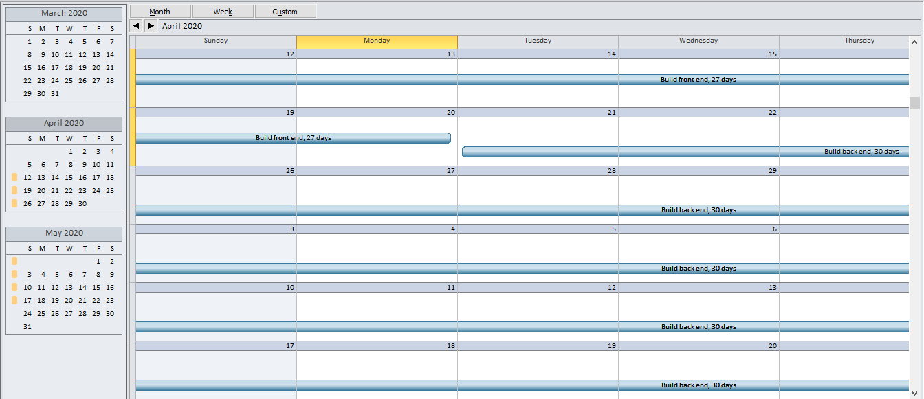

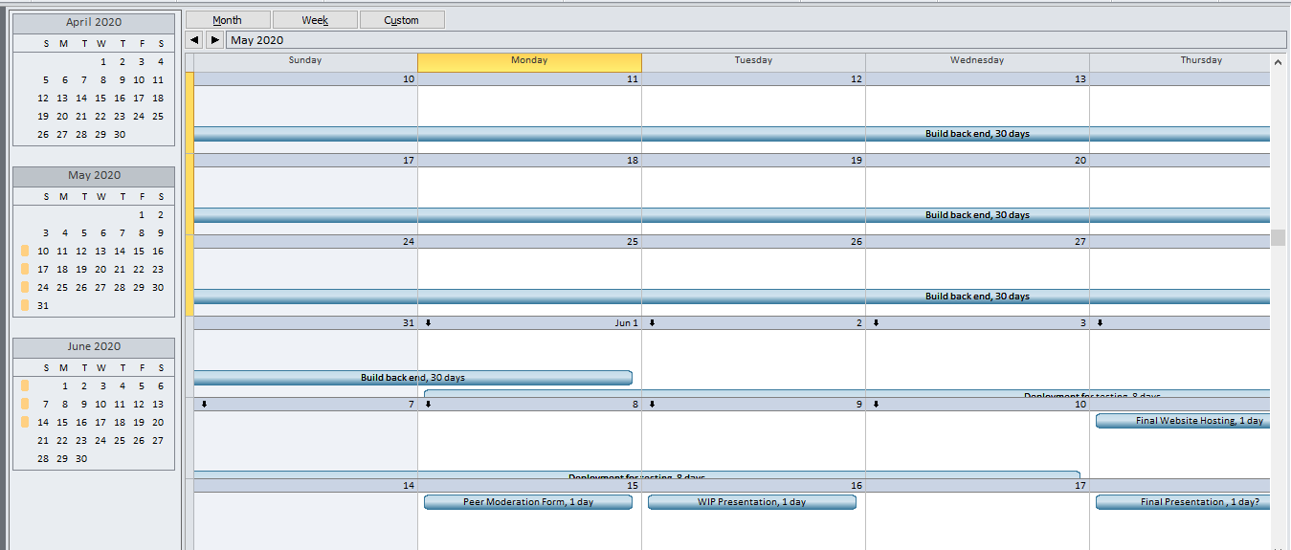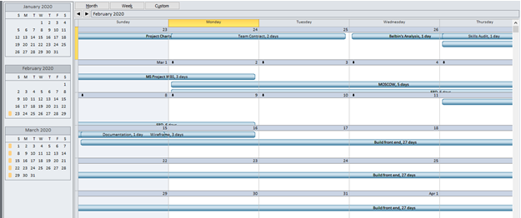

### Resource Sheet

The Resource Sheet is a view within Project that allows the user to view, create, and edit resources and resource information.

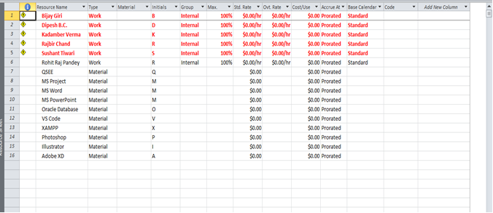

### Team Planner

Team planner is a feature available only with the project professionals. A feature that gives project managers greater visibility into, and control over, their team's work.

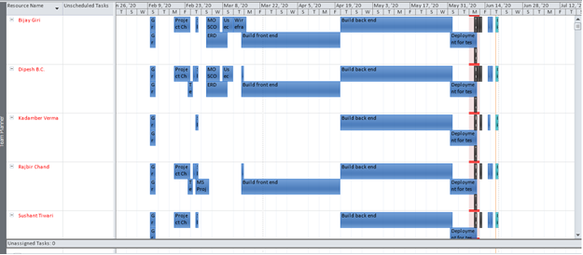

### Network Diagram

A network diagram is a graphical representation of all the tasks, responsibilities and workflow for a project. It is used to map out the schedule and work sequence for the project.

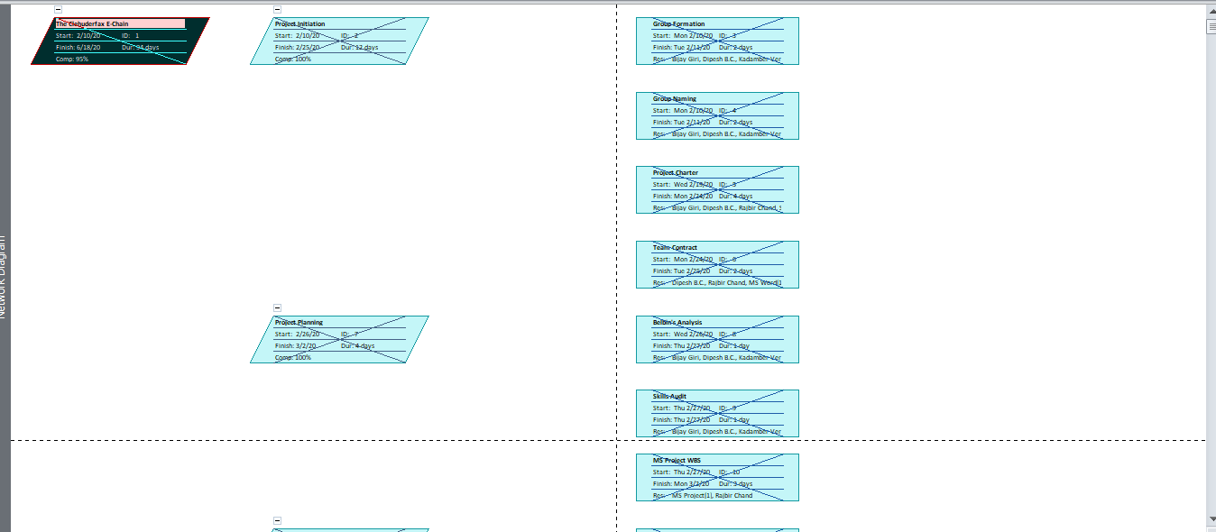

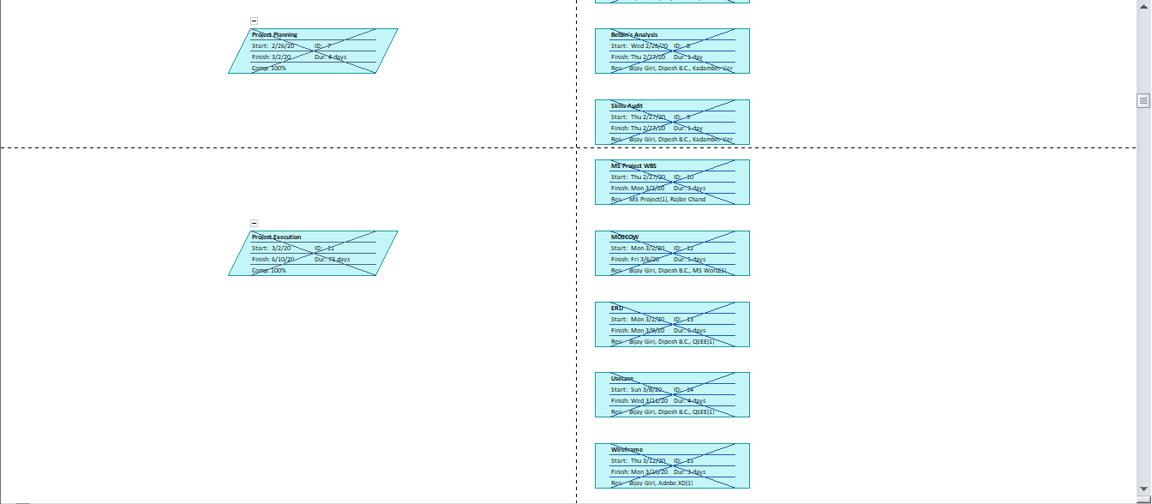

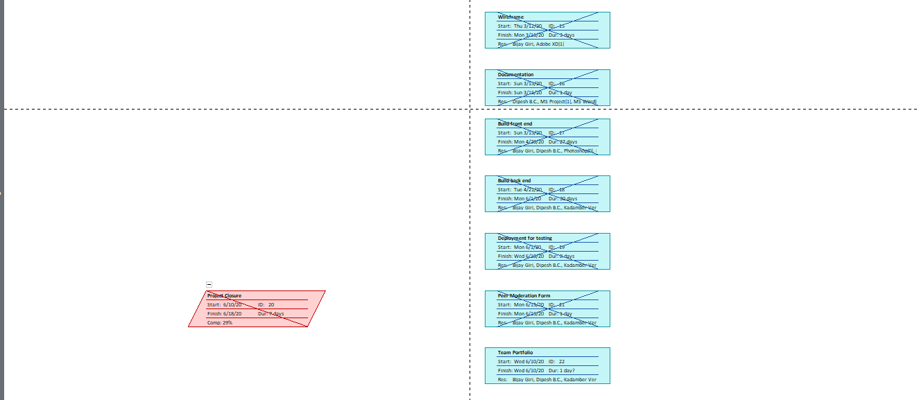

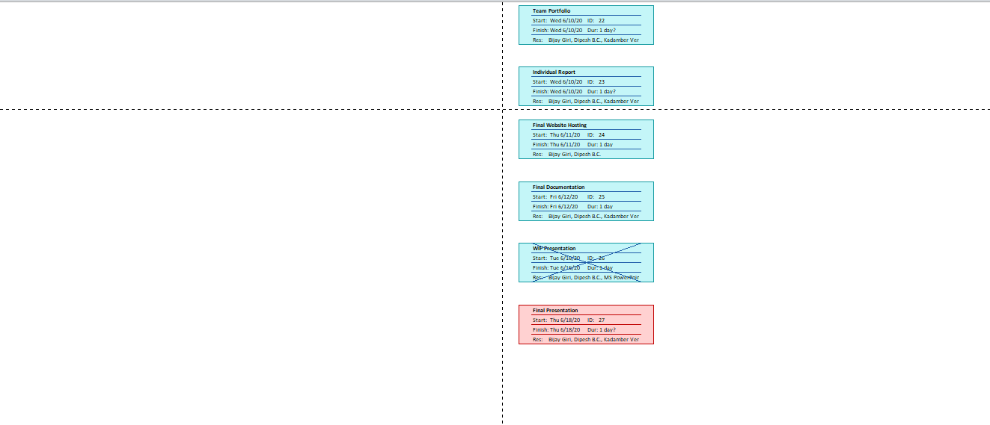

### Timeline

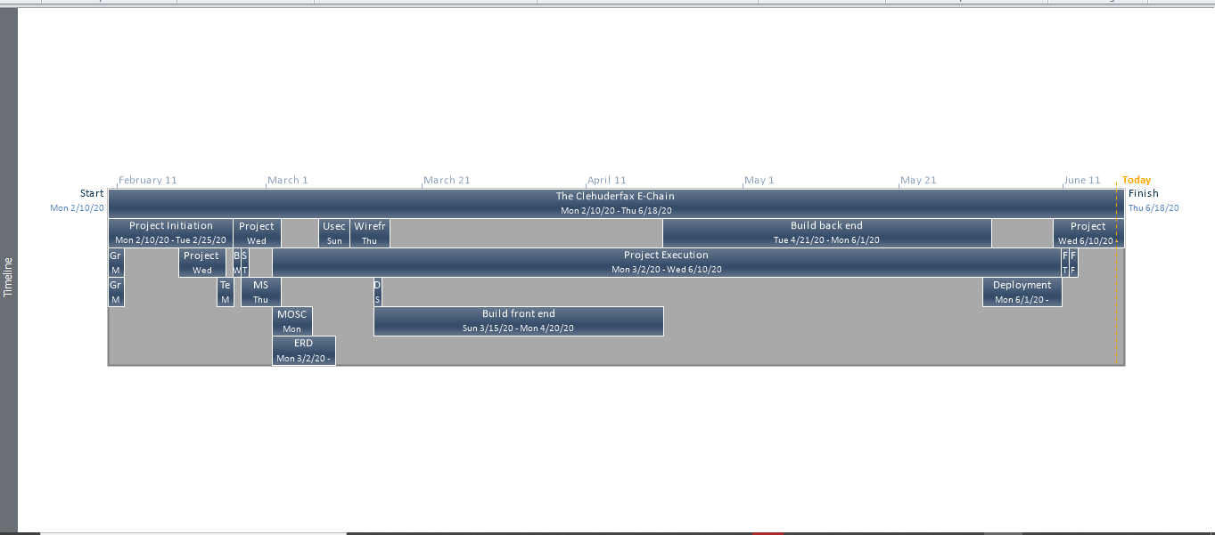

## Skill’s Audit

A skills audit is essentially a process for measuring and recording the skills of an individual or group. The main purpose for conducting a skills audit in an organization is to identify the skills and knowledge that the organization requires, as well as the skills and knowledge that the organization which currently they have.

### Individual Skill’s Audit

Individual Skill Audit defines and classify the member skill and limitations in various challenging criteria.



### Team Skill’s Audit

Team Skill Audit defines and classify the team member’s skill and limitations in various challenging criteria.



# Project Initiation

## Project Charter

A project charter is a formal, typically short document that describes your project in its entirety including what the objectives are, how it will be carried out, and who the stakeholders are.

|  |
| --- |
| Project Title: The Clehuderfax e-chain  Sponsored by: The British College, Thapathali, Kathmandu  Manager: Rohit Pandey  Leader: Bijay Giri  Team Name: The Influencers  Target Customer: Local Traders of Cleckhuddersfax |

Version Control

|  |  |  |
| --- | --- | --- |
| Version | Date | Summary of changes |
| 1 | 2/19/2020 | *Initial version* |
| 2 | 3/24/2020 | *Added new attributes to ERD, updated final submission date to 19th June and calculated new estimated budget that incorporates the 4 weeks extension time period, removed taiga.io from collaboration tools as it was more than sufficient collaborating using slack, GitHub.* |
|  |  |  |

Project Justification

|  |
| --- |
| As the national chains have started to find space in Cleckhuddersfax by setting up convenience stores and are proposing to develop even larger stores, the traders in that area have congregated to start an online portal for their shops. This will help the traders contend with the bigger store on opening hours without losing their family time.  People's reliance on their local shopping area and the continued growth of local independent businesses is evidence that customers can be attracted to the ecommerce platform. And this online portal will solve the problem of locals being not able to shop as they were working most of the time when the shops were open. Traders are producing locally sourced, high-quality goods which are getting increasingly popular but cannot be purchased through local supermarkets.  So, this online portal will help the traders sell these goods to the local market on click and collect basis and will provide the customers better and easy shopping experience. |

Project Scope

|  |
| --- |
| 1. *Increase weekly product sales by 25 percent in 6 months.* 2. *Increase the website’s sales conversion rate by 5 percent in 2 months.* 3. *Attract new customers that would otherwise not be able to shop with the traders.* 4. *Improve sales support online to increase closing rate by 5 percent in 12 months.* 5. *Improve customer satisfaction overtime via online polls and surveys.* |
| *High level requirements:*   1. ***Customer Interface***    1. *Website with a theme that reflects heritage of the area and open to new and creative ideas.*    2. *At least five traders support system with maximum 10 shops.*    3. *Product search functionality by shop categories and products.*    4. *Cart and add to favourites function for products.*    5. *User login and registration functionality.*    6. *Email confirmation for new user registration.*    7. *Product collection slot.*    8. *Product invoice delivery to the customers.*    9. *Responsiveness feature on mobile devices and major web browsers including internet explorer.*    10. *PayPal, Stripe payment gateway implementation.*    11. *Product rating and product review.* 2. ***Trader Interface***    1. *CMS system for creating, managing, and modifying products.*    2. *Traders login system.*    3. *Product invoice delivery to corresponding product traders.*    4. *Database login function for traders for viewing orders and stock levels.*    5. *Admin login feature with authority to access the entire system.* 3. ***Management Interface***   *3.1 Management dashboard for accessing daily and periodic reports.*  *3.2 Daily report on orders placed for the traders.*  *3.3 Monthly product sales report for the traders.*  *3.4 Weekly finance report of products that have been delivered.* |
| *Major deliverables:*   1. *Unique user interface for customer, trader, and management.* 2. *Oracle Interface as a backend for database.* |

Duration

|  |
| --- |
| *Initial prototype presentation – 24th March 2020*  *Deployment for testing – 15Th May 2020*  *Final submission – 19Th June 2020* |

Estimated Budget

|  |
| --- |
| No initial hardware requirements.  Hours per week per person 6-7  Team of 5  Hence, total hours min: 6*5*16 = 480 hours max: 7*5*16 = 560 hours |

Roles and Responsibilities

|  |  |
| --- | --- |
| **Name** | **Roles** |
| Bijay Giri | Co-ordinator, Specialist, Monitor Evaluator |
| Dipesh B.C. | Specialist, Plant, Co-ordinator |
| Kadamber Verma | Implementor, Complete Finisher, Resource Investigator |
| Rajbir Chand | Shaper, Monitor Evaluator, Resource Investigator |
| Sushant Tiwari | Team worker, Co-ordinator, Resource Investigator |

Communication and Collaboration Tools

|  |
| --- |
| 1. ***Slack*** *– For team communication and collaboration at one place.* 2. ***Trello*** *- For progress tracking.* 3. ***GitHub*** *– For version control and documentation.* 4. ***MS******Project*** *– For Task tracking and documentation.* 5. ***Team meetings*** *– 3 to 4 meetings will be held each week for feedback, discussion and promoting team collaboration.* |

## Project Contract

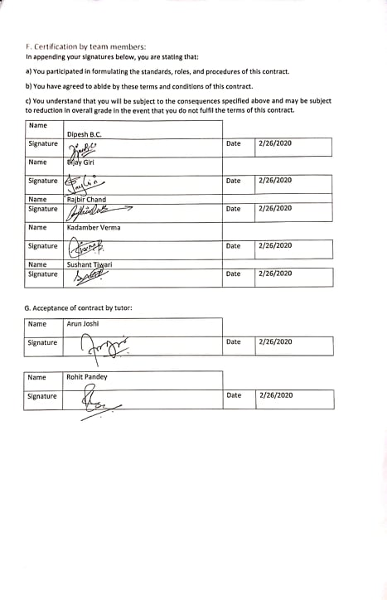

## Communication and Collaboration Tools Used

Team used various tools and medias to communicate with team members and being able to collaborate in productive manner by sharing information.

### Trello

One of the many tools we used is Trello. Trello is the fun, flexible and free way to organize plans, projects & more.

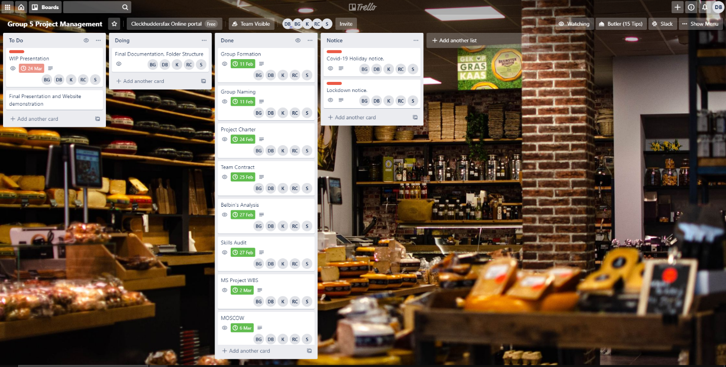

### Slack

Slack is a proprietary business communication platform and tool uses come together to get things done.

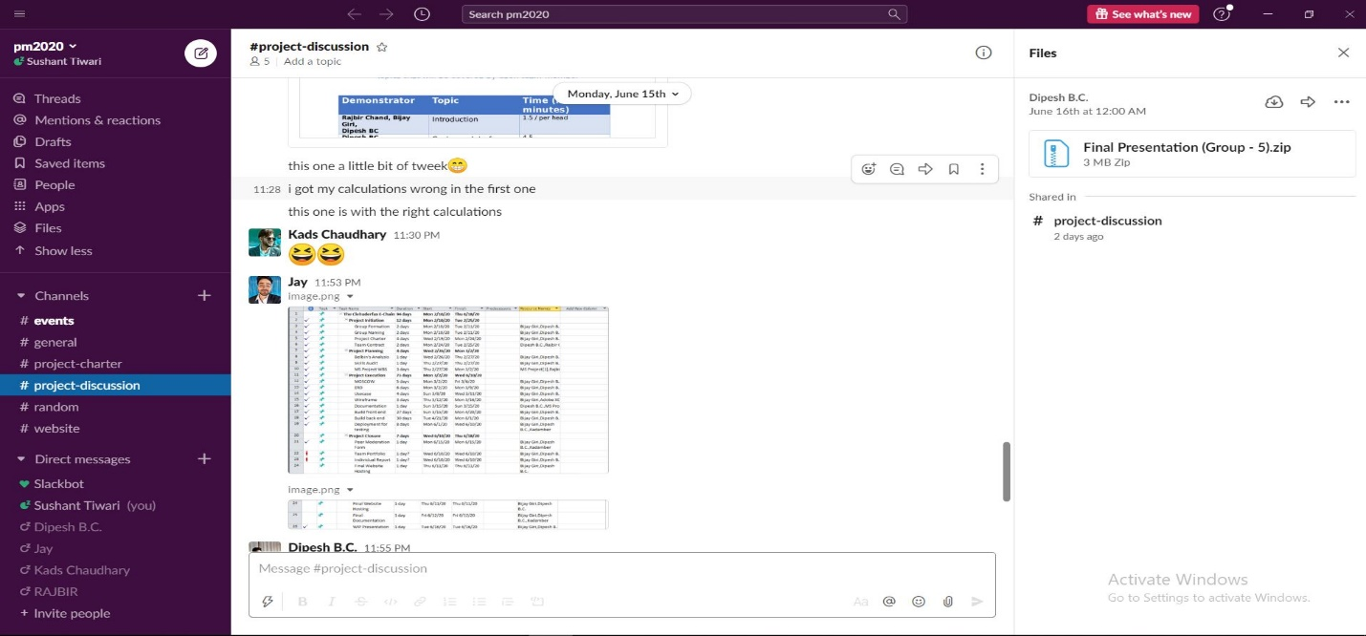

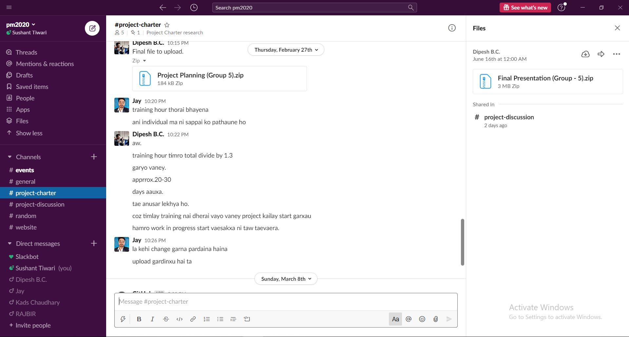

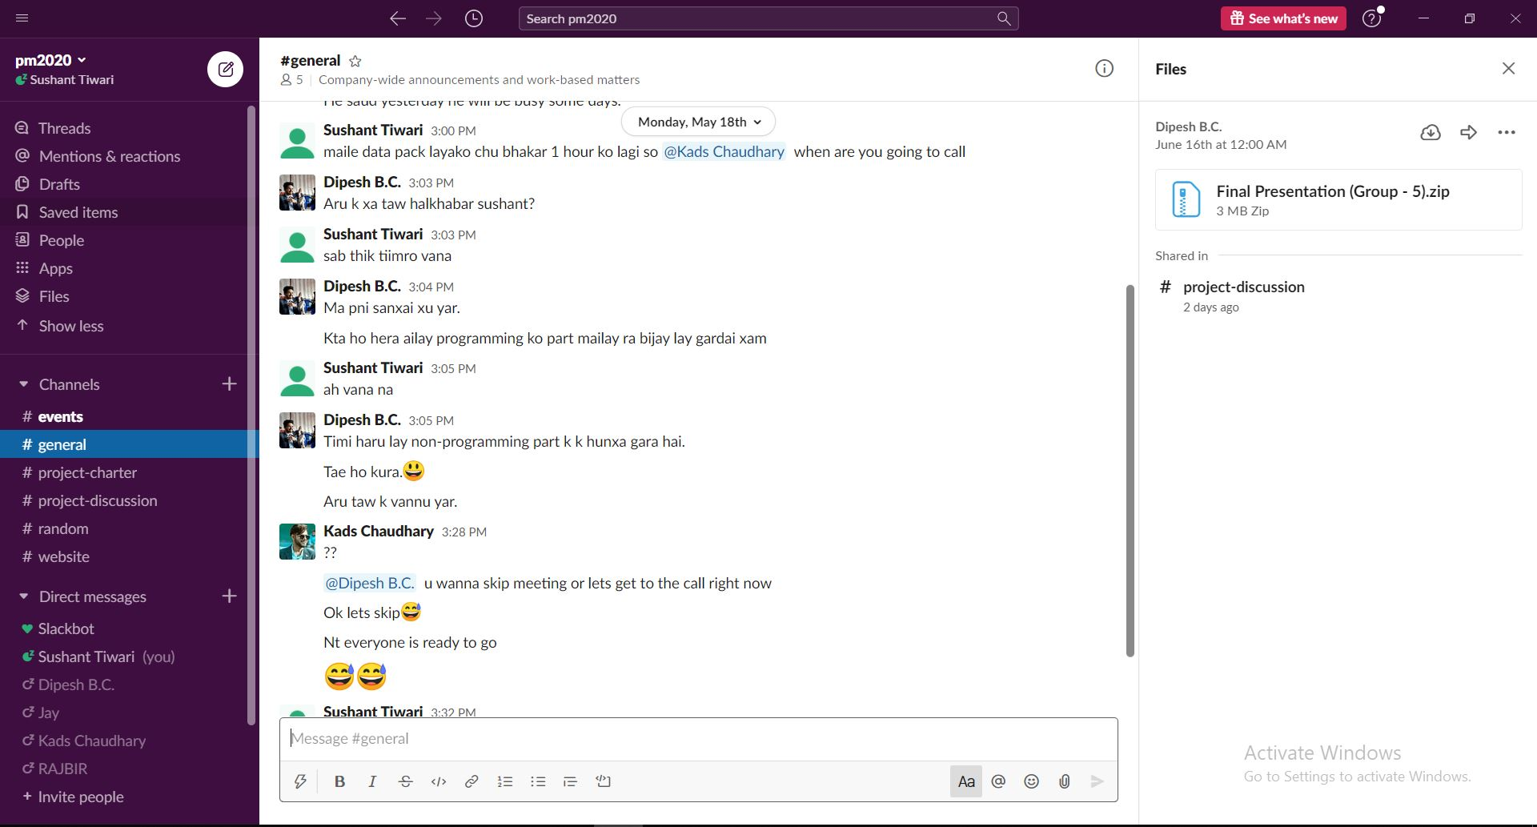

### Google Drive

It is file storage and synchronization service, very useful for file sharing with data loss prevention.

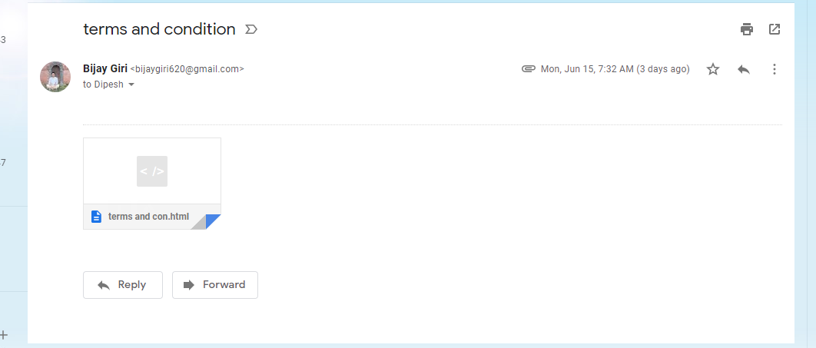

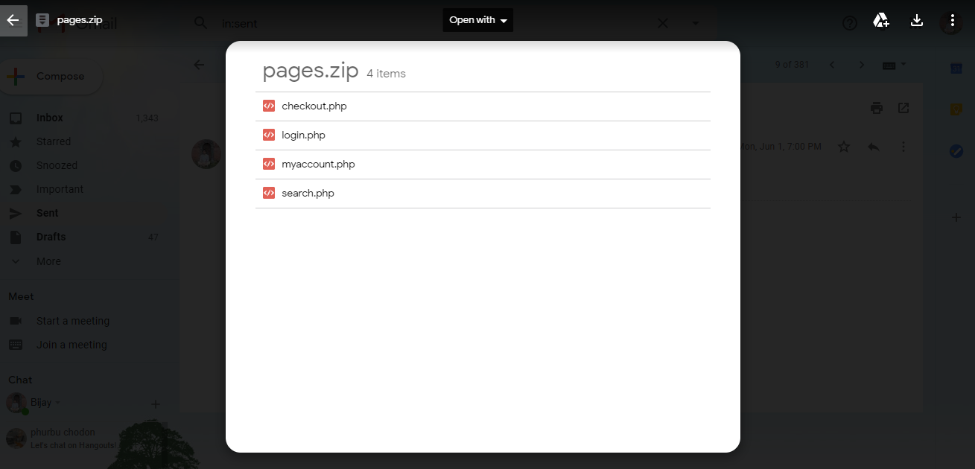

# Project Execution

## Project Designing

### Entity Relationship Diagram

An entity–relationship model describes interrelated things of interest in a specific domain of knowledge.

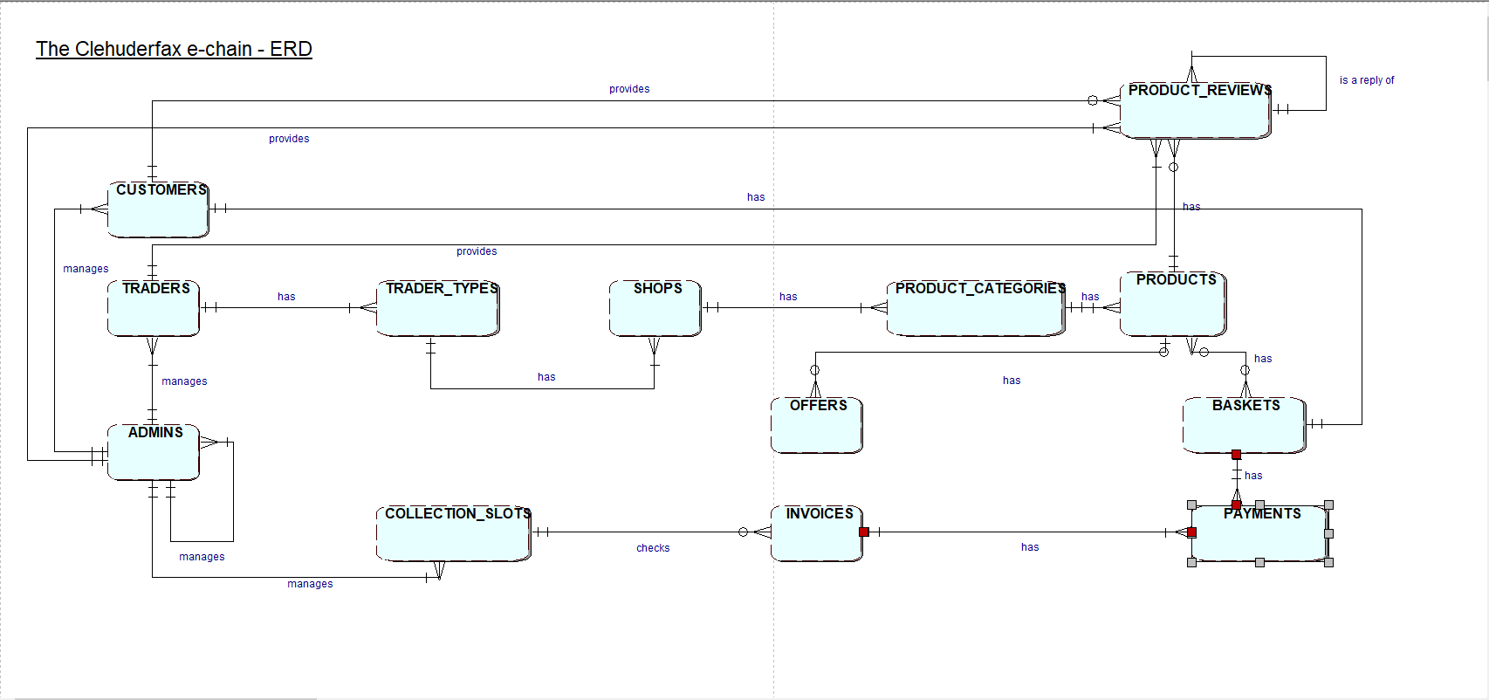

### Extended Entity Relationship Diagram

The enhanced entity–relationship model in computer science is a high-level or conceptual data model incorporating extensions to the original entity–relationship model, used in the design of databases.

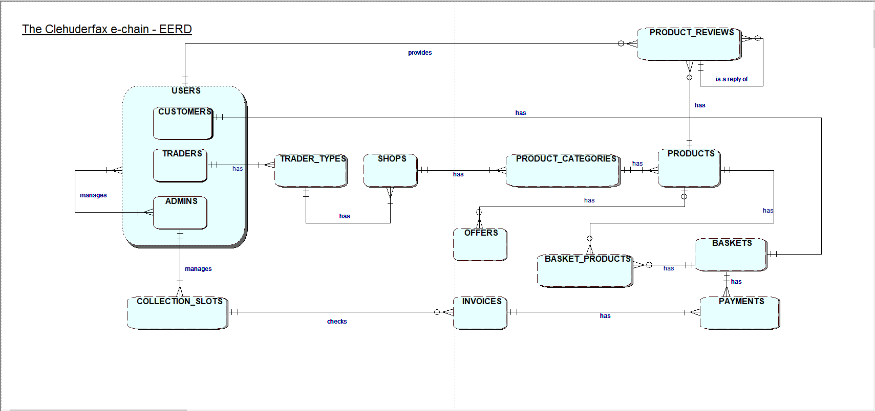

### Final Composite Entity Relationship Diagram

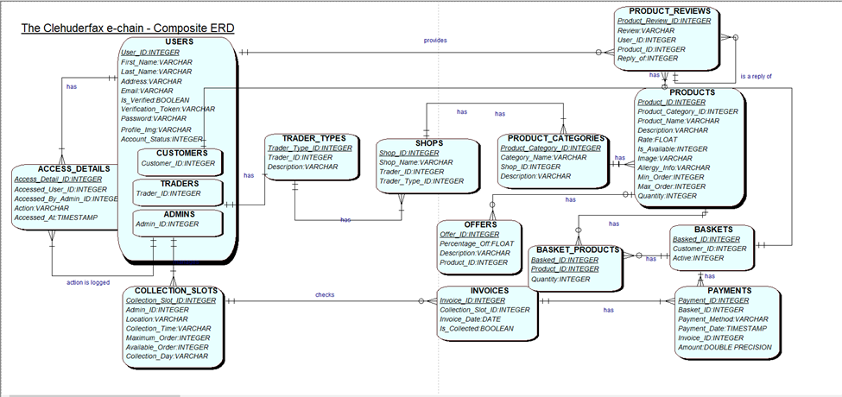

### Use Case Diagram

A use case diagram at its simplest is a representation of a user's interaction with the system that shows the relationship between the user and the different use cases in which the user is involved.

#### Use Case Overview

It shows the overview of product designing and concept.

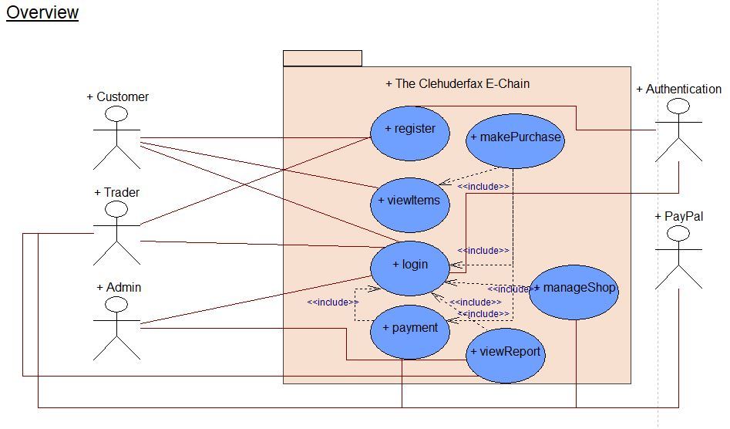

#### Customer Use Case Diagram

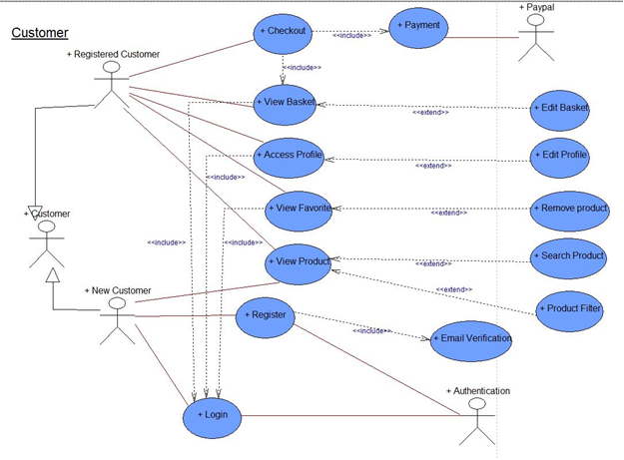

#### Trader Use Case Diagram

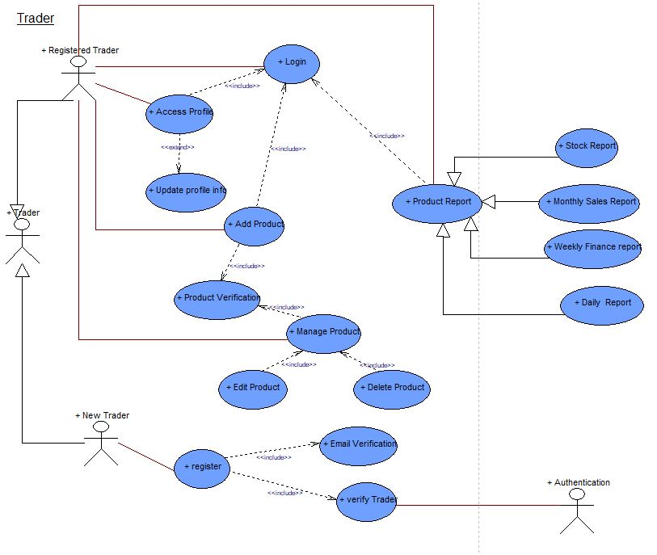

#### Admin Use Case Diagram

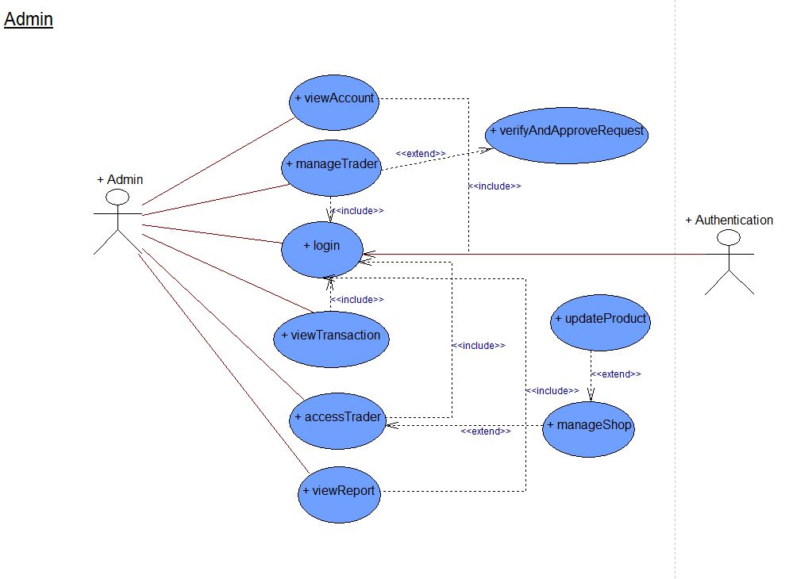

## Requirements Catalogue

Requirement Catalogue is required to fulfill the requirements of a website. Moscow (Must Have, Should Have, Could Have, Won't Have this time) is primarily used to priorities requirements of a website.

### Functional Requirements

#### Part A: Customer Interface

|  |  |  |
| --- | --- | --- |
| REQUIREMENT ID | DESCRIPTION | MOSCOW RULE |
| A1-F | **An Interface that allows the customers to view product** |  |
| A1F-01 | Users should be able to navigate products by shop or by product type. | **M** |
| A1F-02 | The product of each traders will not overlap, and products will be unique to them. | **M** |
| A1F-03 | Viewable on mobile as well as desktop devices and viewable on the most popular browsers. | **M** |
| A1F-04 | Each product will have name, product type, short description, quantity, price, image and traders. | **M** |
| A1F-05 | Customer registration and login system. | **M** |
| A1F-06 | Customer will be able to view ten shops. | **M** |
| A1F-07 | Customer will be able to check out and select collection slots. | **M** |
| A1F-08 | Customers will be able to make payment via online payment gateway. | **M** |
| A1F-09 | Users will be able to search products by open search. | **S** |
| A1F-10 | Users will be able to access their account and can update, edit, delete their account info including profile pictures. | **S** |
| A1F-11 | Users will be able to rate a product and provide a product review. | **S** |
| A1F-12 | Users will be able to sort products using filter such as price, ascending and descending order. | **S** |
| A2F | **The Interface will allow the customers to select activities to temporarily store in a favorites collection** |  |
| A2F-01 | Single basket that holds goods that spans all traders and requires a single payment. | **M** |
| A2F-02 | Customers will be able to view their orders | **M** |
| A2F-03 | Customers will be able to view total price | **M** |
| A2F-04 | The Cart will list product with a thumbnail image, price, quantity, total price and checkout or indicate no favorites are saved. |  |
| A2F-05 | Customers should be able to remove individual item or all from cart | **S** |
| A2F-06 | Customers should be able to shop again before checking out. | **S** |
| A2F-07 | Add to favorites link will appear for logged in users only. | **C** |
| A2F-08 | Add to favorites link will appear beside every product | **C** |
| A2F-09 | Customers should be able to clear individual or all item from favorites. | **C** |
| A2F-11 | The favorite’s page will list all favorites thumbnail image, product name and added time or indicate no favorites are saved. | **C** |

#### Part B: Registration and Login

|  |  |  |
| --- | --- | --- |
| REQUIREMENT ID | DESCRIPTION | MOSCOW RULE |
| B1F | **Interface that allows new user registration and user login** |  |
| B1F-01 | A login form for collecting username/email and password. | **M** |
| B1F-02 | Login button will be displayed on every page if the user is not logged in. | **S** |
| B1F-03 | Registration form for unregistered user login attempt. | **M** |
| B1F-04 | Server-side validation for user registration and user login. | **S** |
| B1F-05 | Server validation that informs users if they attempt to  log in using incorrect details | **M** |
| B2F | **Interface for user and trader login** |  |
| B2F-01 | A form that collects first name, last name, email, address, mobile number, password and terms and conditions checkbox for user registration | **S** |
| B2F-02 | User registration confirmation through email address | **S** |
| B2F-03 | A form that collects first name, last name, email, address, mobile number, shop name, password and terms and conditions checkbox for trader registration | **S** |
| B2F-04 | Traders registration confirmation through email address | **S** |
| B2F-05 | Server-side validation so that none of the fields are left empty or filled with wrong data. | **S** |
| B2F-06 | Password should be encrypted before storing in database | **S** |
| B2F-07 | Application of appropriate functions and techniques  to combat security risks posed by data being entered  into form | **S** |
| B2F-08 | Application of appropriate functions and techniques  to ensure validity of data entered including valid  email; names - alpha only; password includes at least  one capital letter, a number and a symbol | **C** |

#### Part C: Trader Interface

|  |  |  |
| --- | --- | --- |
| REQUIREMENT ID | DESCRIPTION | MOSCOW RULE |
| C1F | **Interface that allows allow authenticated traders to manage products** |  |
| C1F-01 | All products will have unique product ID, associated only with Trader. | **M** |
| C1F-02 | Traders should be able to login and access their details only. | **M** |
| C1F-03 | Homepage/dashboard for the trader | **M** |
| C1F-04 | Traders should be able to access CRUD operation for their shop products. | **M** |
| C1F-05 | Clicking the Delete link will remove the chosen item  and update the displayed catalogue of items  . | **S** |
| C1F-06 | Clicking the update link will show a form prepopulated with all editable details. Submitting the  form will update the chosen item and display the updated item. | **S** |
| C1F-08 | A facility will be provided to allow for the upload of  new images for a new item when added. | **C** |
| C1F-09 | Traders should be able to edit and modify their trader account. | **C** |
| C1F-10 | Traders will be able to login to the database daily to view reports on orders and stock levels. | **S** |

#### Part D: Admin Interface

|  |  |  |
| --- | --- | --- |
| REQUIREMENT ID | DESCRIPTION | MOSCOW RULE |
| D1F | **A facility to allow authenticated admin users to**  **manage the activities presented by the system** |  |
| D1F-01 | An active admin link will be provided once an admin  user has logged in. | **S** |
| D1F-02 | Admin home page or dashboard for admin | **M** |
| D1F-03 | The admin page will display all activities with the  option to create a new item, delete or update each  item  . | **M** |
| D1F-04 | An admin login that can access any of the trader accounts. | **S** |

#### Part E: Management Interface

|  |  |  |
| --- | --- | --- |
| REQUIREMENT ID | DESCRIPTION | MOSCOW RULE |
| E1F | **A facility to allow authenticated admin users to**  **manage the activities presented by the system** |  |
| EF-01 | A management dashboard is required. | **M** |
| EF-02 | Management dashboard should provide the traders access to a range of daily and periodic reports | **S** |
| EF-03 | Daily reports will be generated which will identify the goods and quantities that have been ordered. | **M** |
| EF-04 | Reports should be presented so that it is clear which delivery slots goods are required for and they will use this information to label goods for collection with a  customer ID and order ID as well as product details. | **M** |
| EF-05 | Traders will be provided with a weekly finance report which will identify payments to be made | **S** |
| EF-06 | Traders will be provided with a monthly report on their product sales | **S** |
| EF-07 | Report can be viewed ordered in several ways: alphabetically, by total number of orders per product, by total income per product. | **S** |

### Non-Functional Requirements

#### Part F: Non-Functional Requirements

|  |  |  |
| --- | --- | --- |
| REQUIREMENT ID | DESCRIPTION | MOSCOW RULE |
| F1F | **The website will comply with the following nonfunctional requirements** |  |
| FF-01 | HTML/CSS template suited to requirements. | **M** |
| FF-02 | Website designed as per wireframe | **M** |
| FF-03 | Template applied consistently throughout the site | **S** |
| FF-04 | Site built for maintainability: Files organized,  comments added, HTML using includes, bespoke  functions. | **S** |

## Team Logo

A Team logo symbolize the organization or service in respective view.



## Product Logo

Its present as a stylized version of the company's name if it has sufficient brand recognition.



## Risk Register

A risk register is a tool in project management. It is used to identify potential risks in a project or an organization, sometimes to fulfill regulatory compliance but mostly to stay on top of potential issues that can derail intended outcomes.

### Individual Risk Register

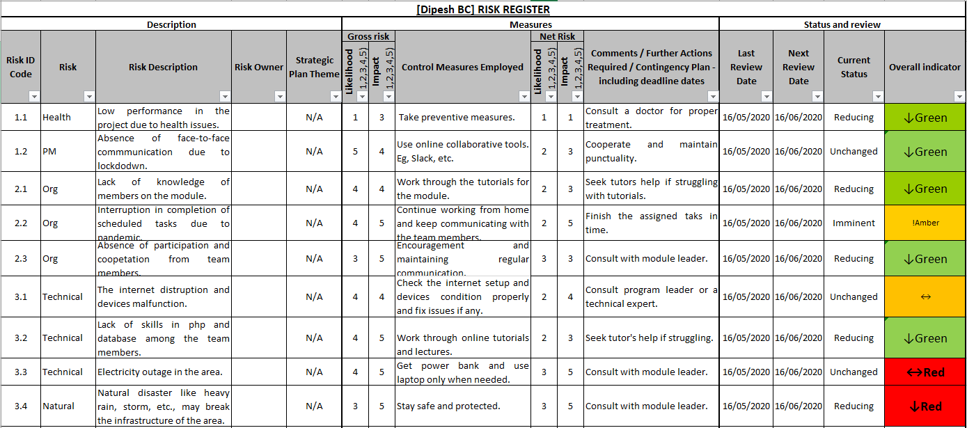

### Individual Risk Profile

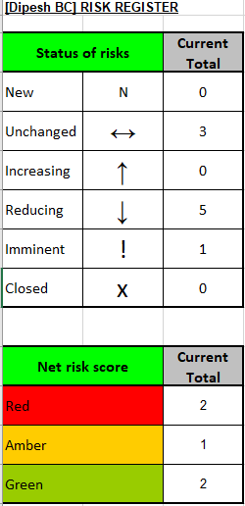

### Team Risk Register

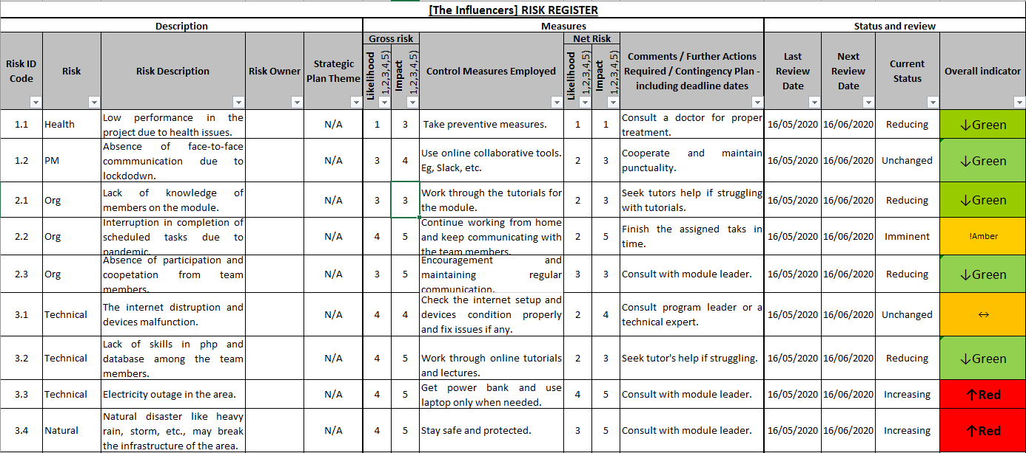

### Team Risk Profile

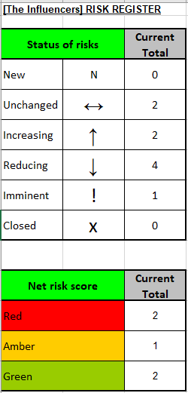

## Website Mockup



This is the mockup for our home page. Mockups are placed with pictures so that it’s easier to see how the design will look after uploading photos.

#### Single product

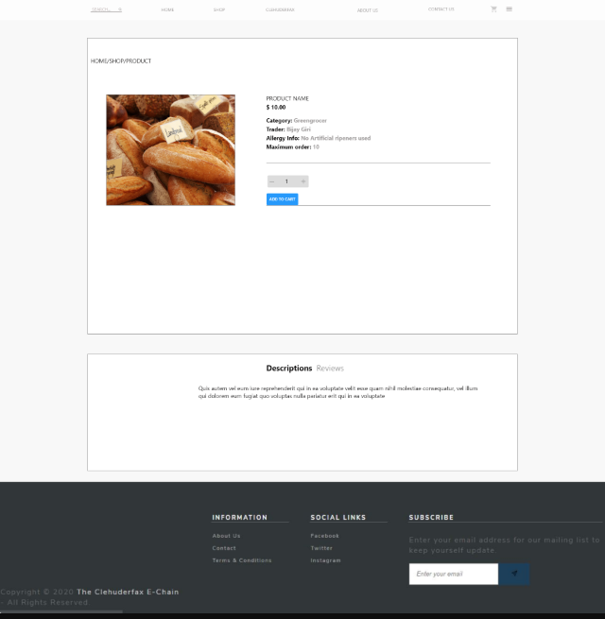

This is the mockup for single product page. This page shows the product details.

### Wireframes

Wireframe is a page schematic or screen blueprint, is a visual guide that represents the skeletal framework of a website. Wireframes are created for the purpose of arranging elements to best accomplish a particular purpose.

#### Homepage

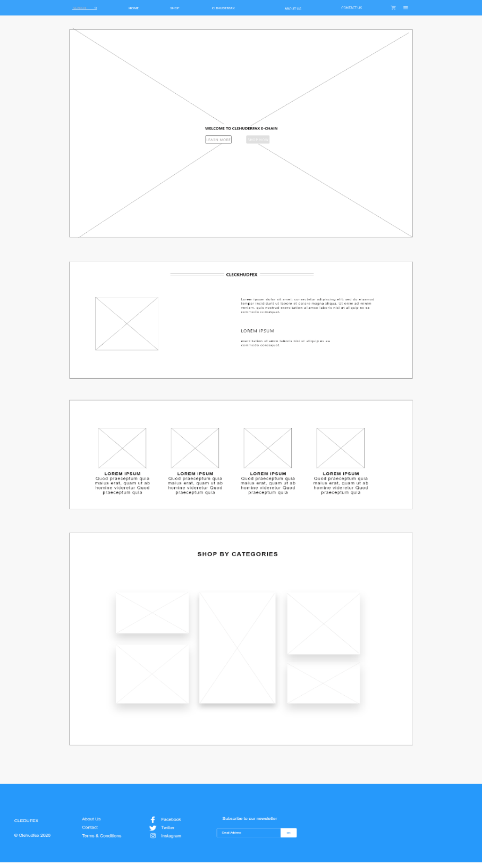

This is the wireframe for homepage. Homepage contain the navigation to different pages in the website. It displays the products and shops as well. Homepage has footer with the contact information.

#### Cart

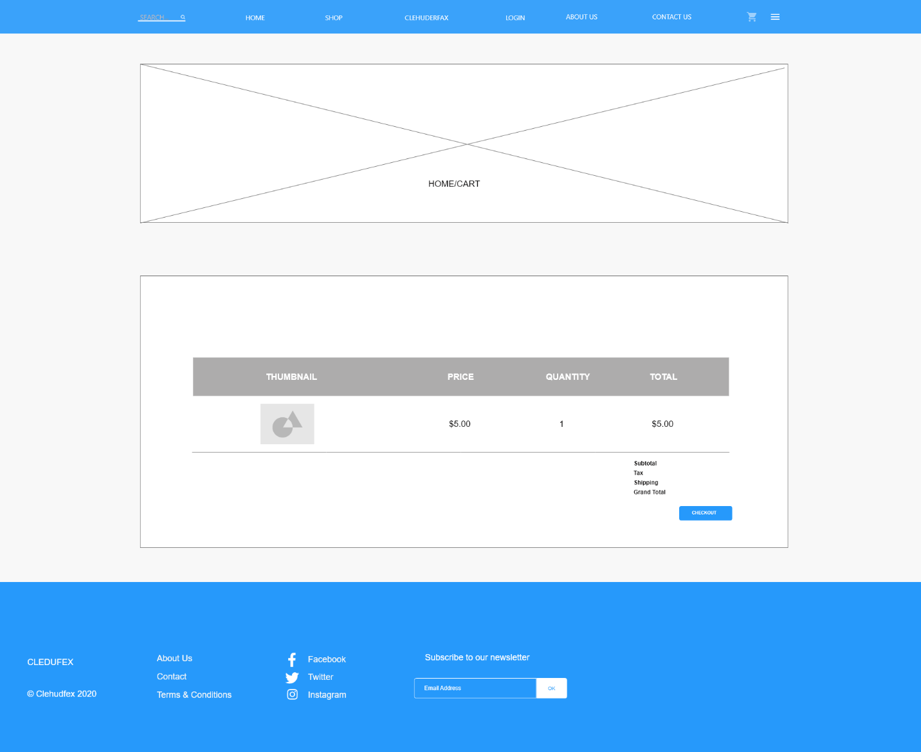

This is the wireframe for cart. Cart contains the products added by the user.

#### Customer login

This is the wireframe for customer login. Customer can log into their profile from this page

#### Customer Sign up

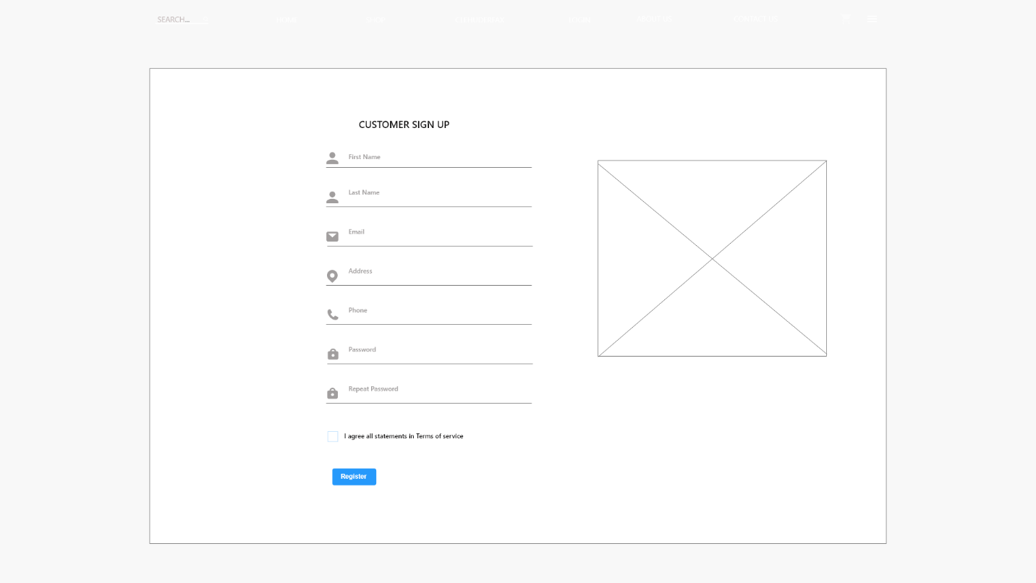

This is wireframe for customer sign up. Customer can make an account from this page

#### Trader sign up

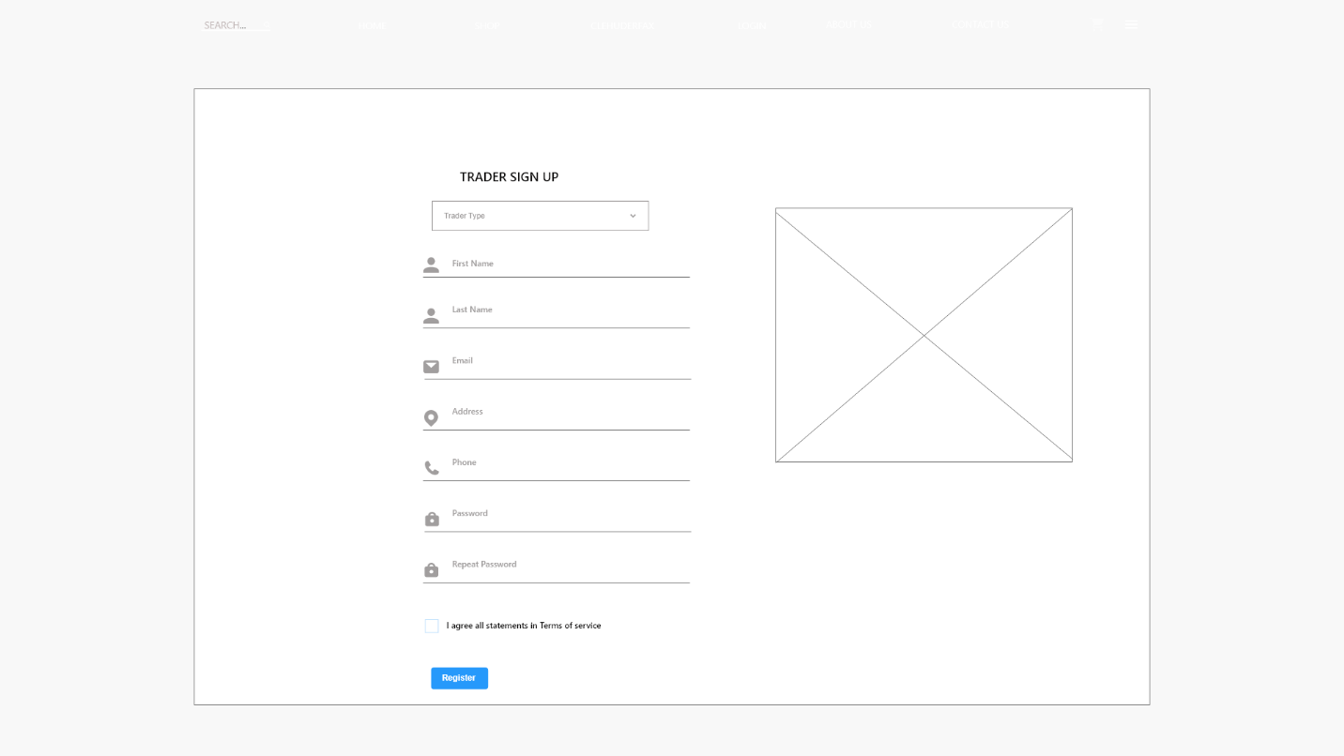

This is the wireframe for trader sign up. This is used to make a new trader account.

#### Contact Us

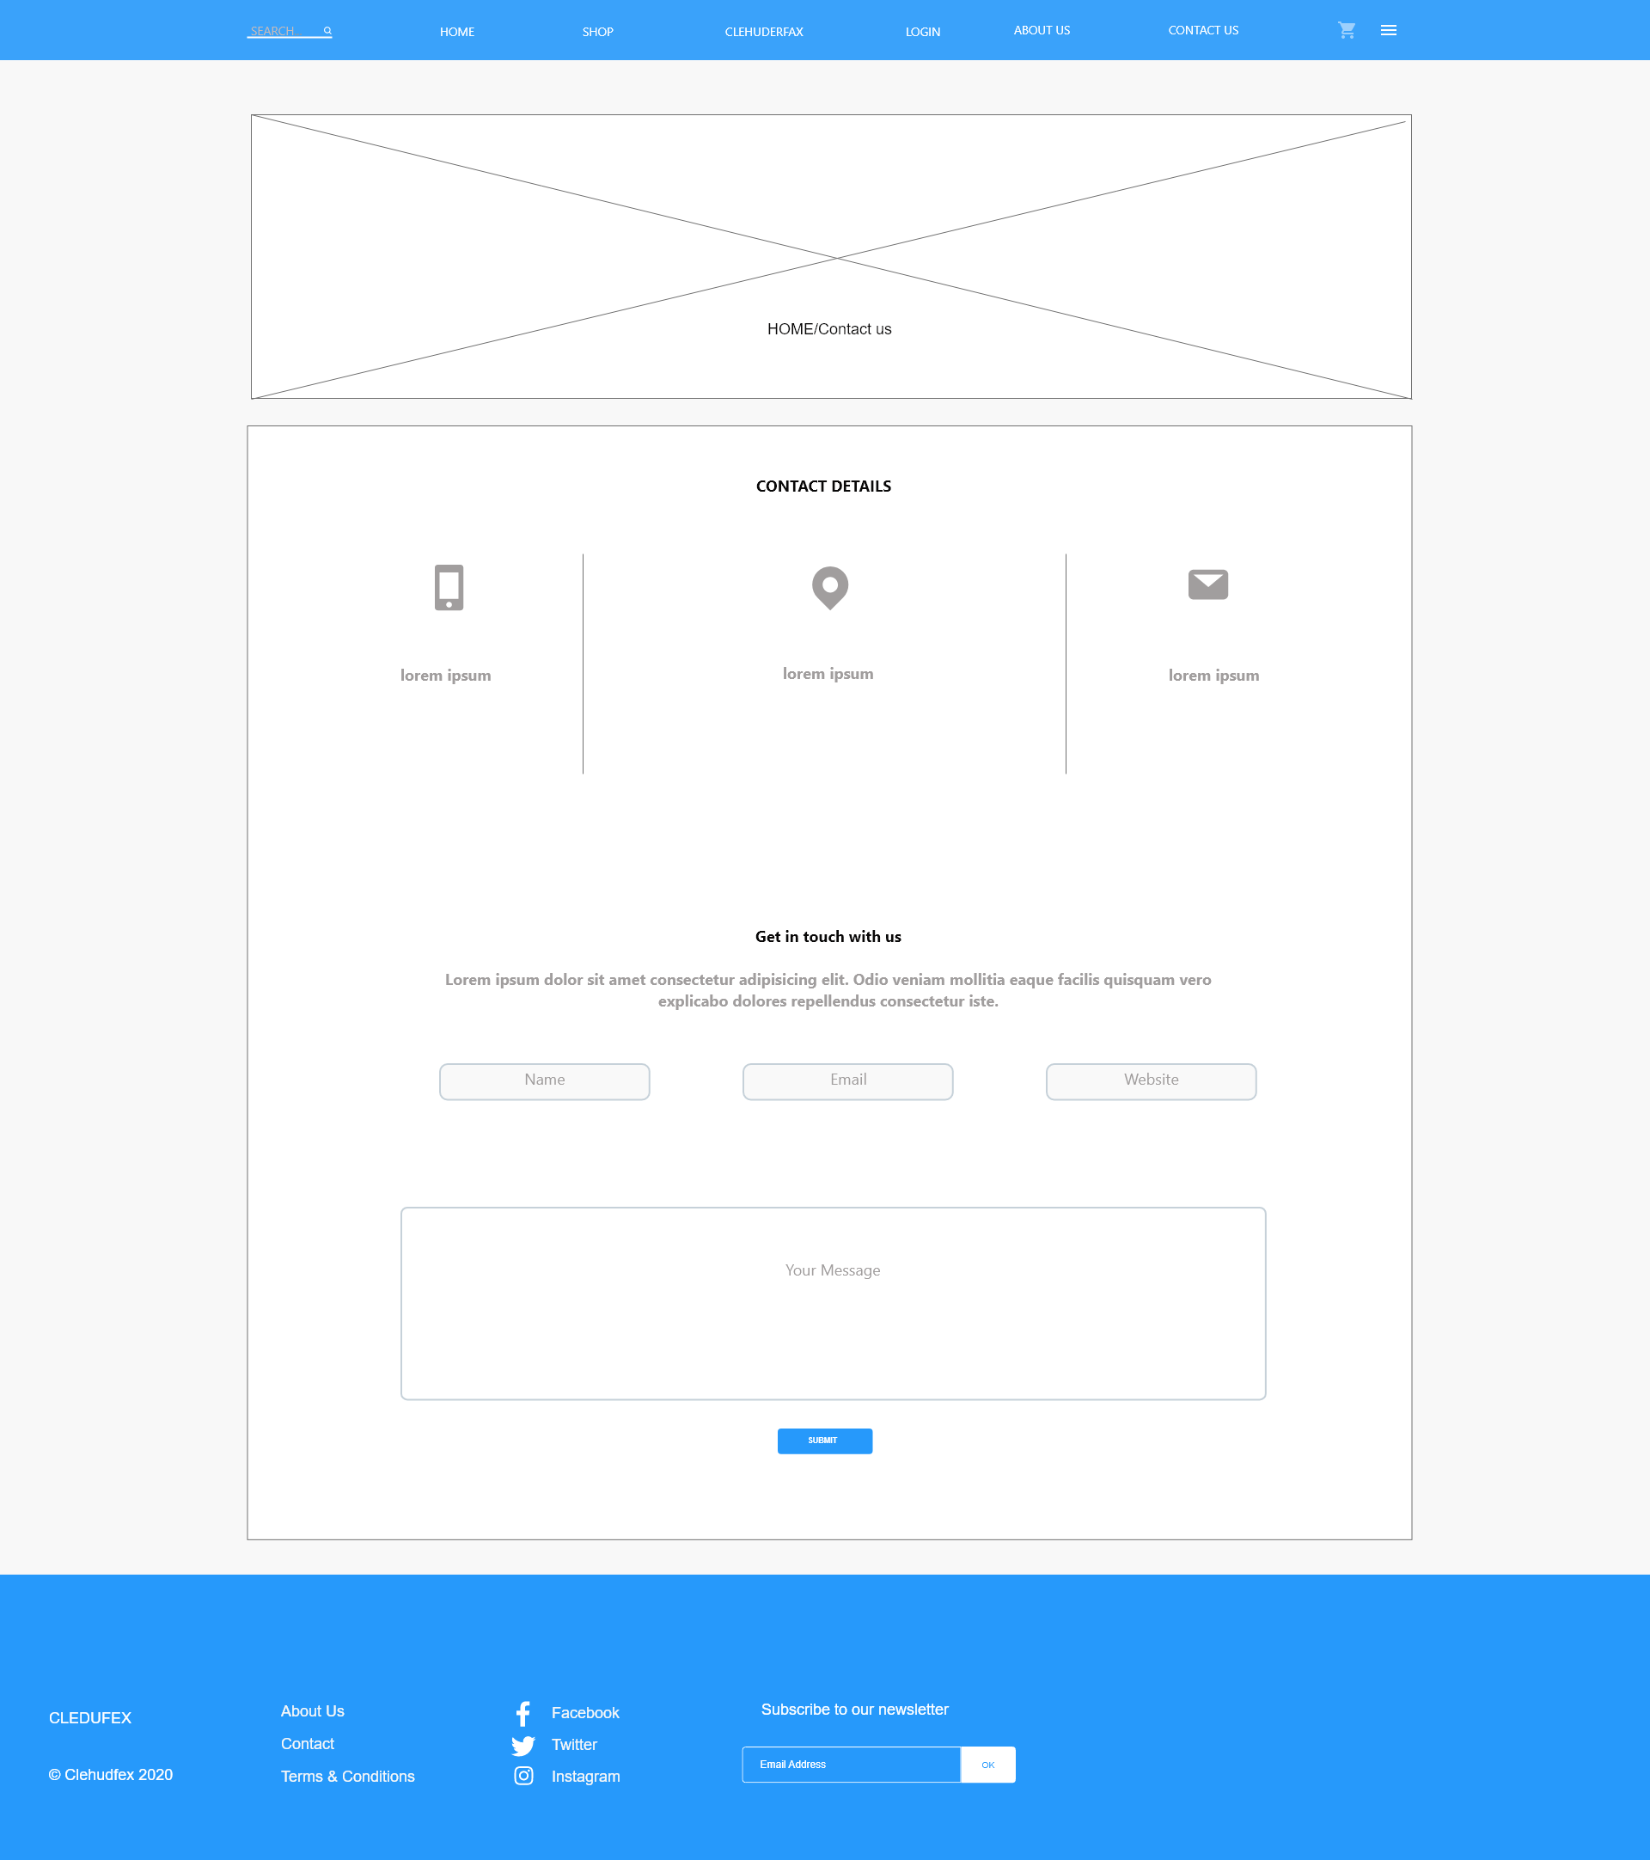

This is contact us page. Customers can send messages to admin from this page.

#### Shop

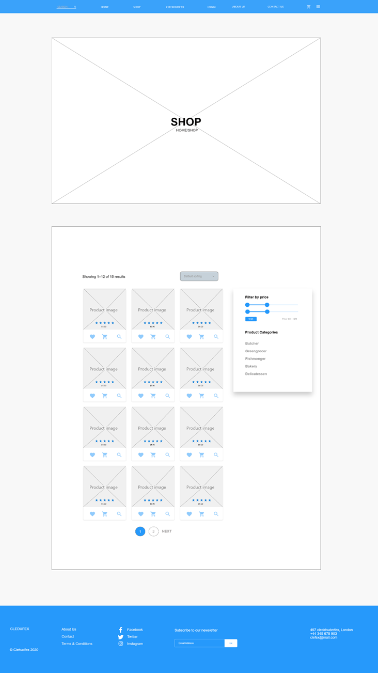

This is wireframe for the shop. It contains all the products with sorting features.

#### User Account

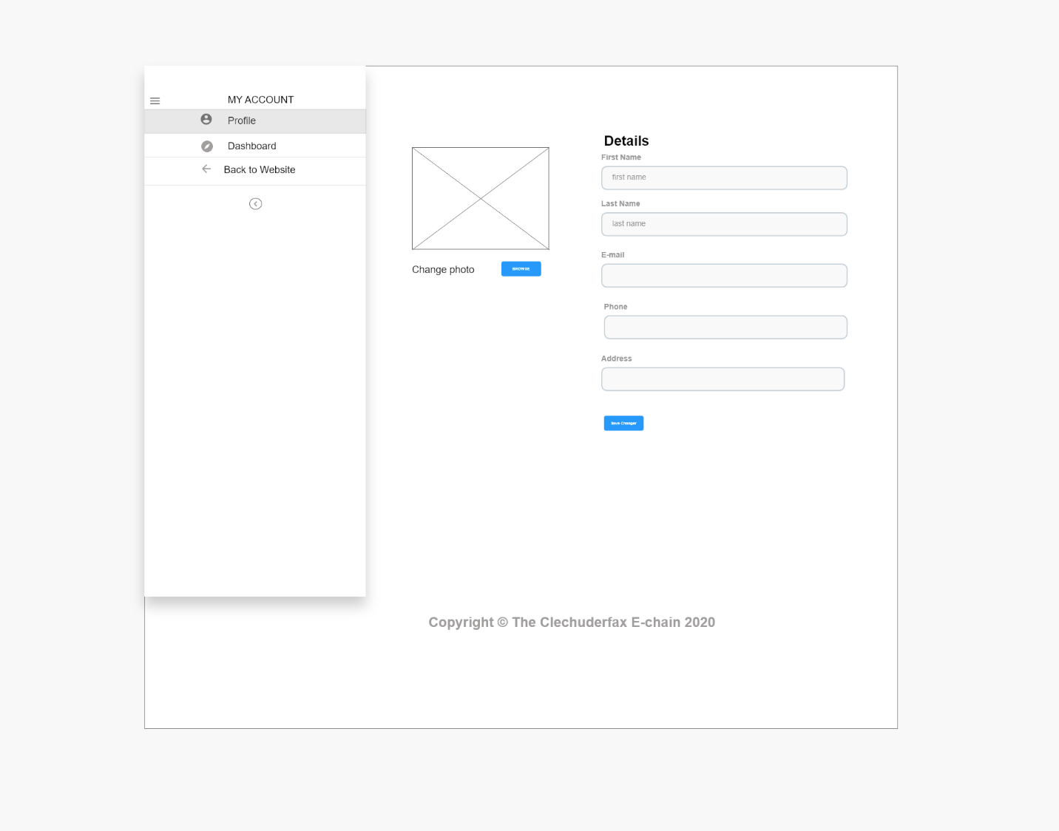

This is wireframe for user profile. User can update profile information from this page.

#### Check out

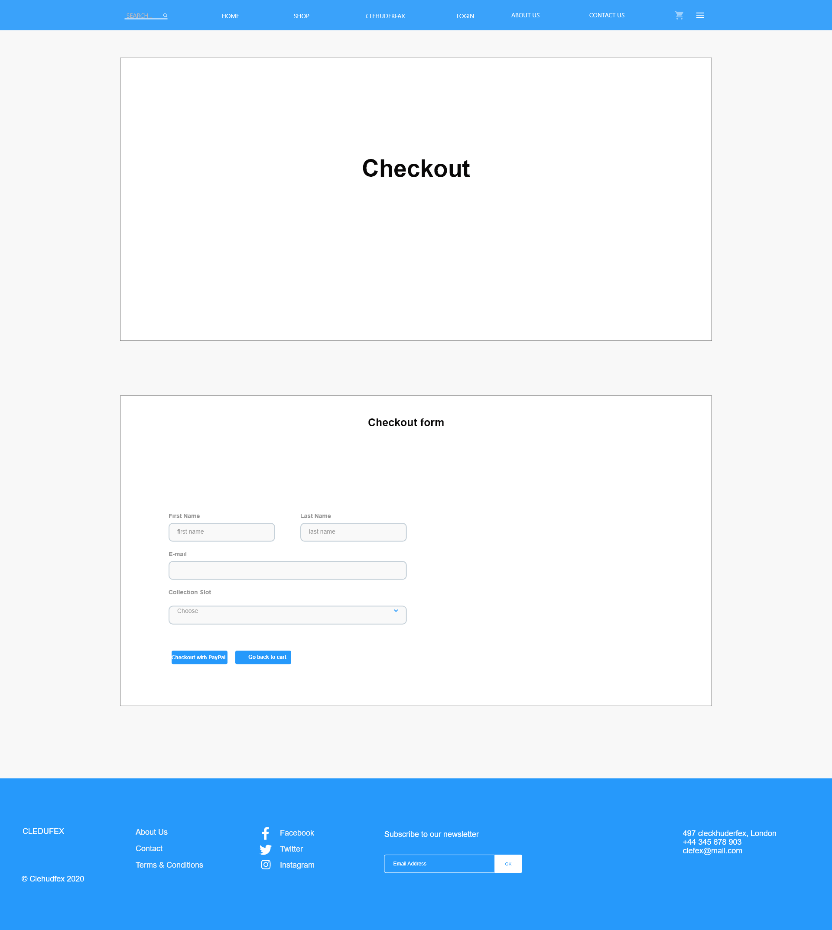

This is the wireframe for the checkout form. Checkout is done to buy any product from page.

#### About Us

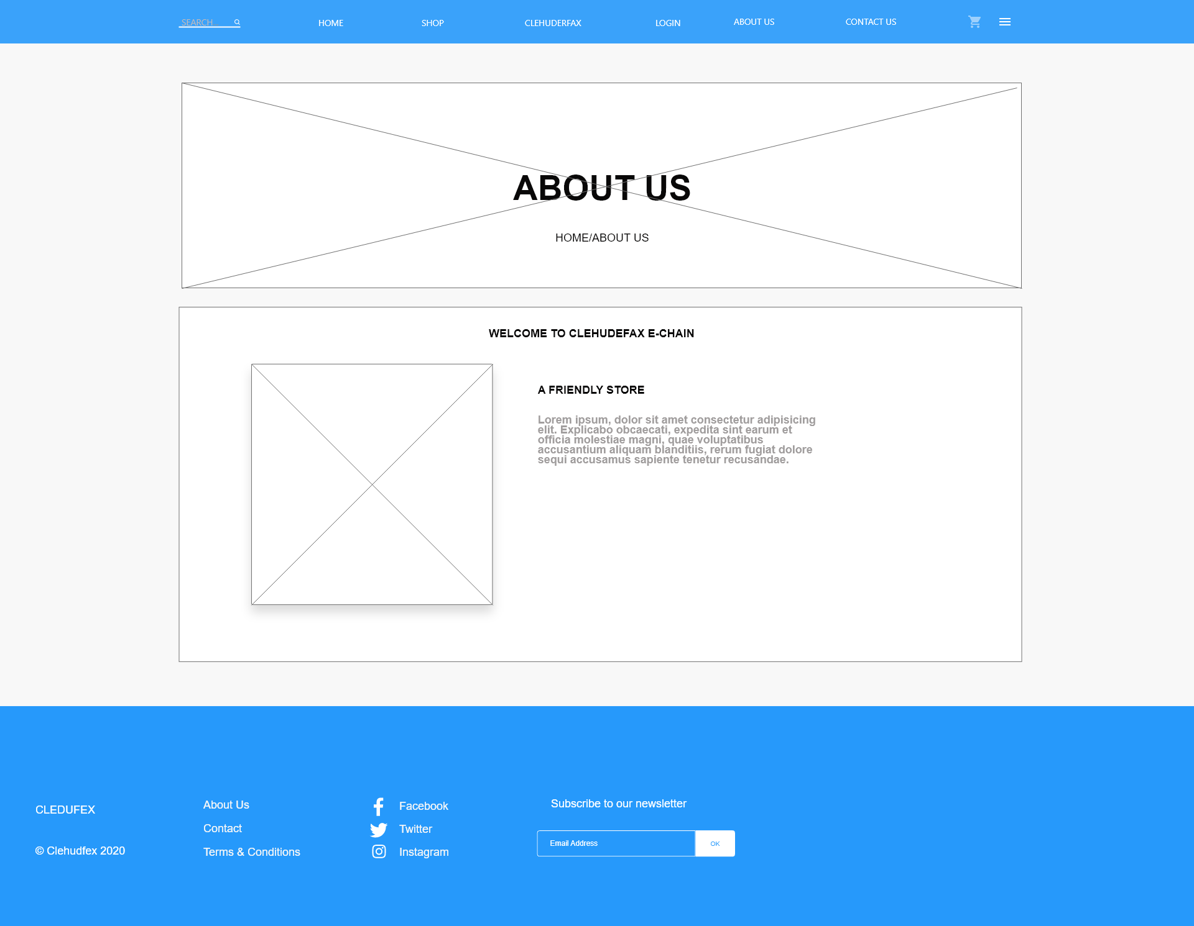

This is the wireframe for about us page. This page displays info about the website

#### Product detail

This is wireframe for single product page. This page provides product information, prices.

#### Admin Login

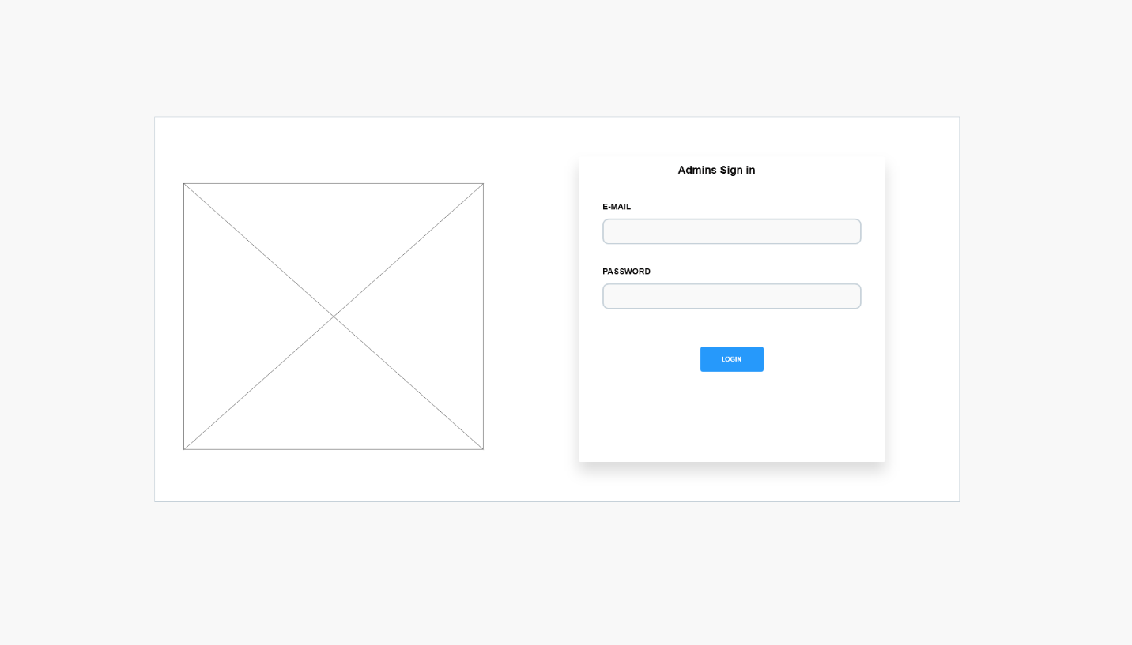

This is wireframe for admin login page. Admins can login from this page

#### Dashboard

A dashboard is a type of graphical user interface which often provides at-a-glance views of key performance indicators relevant to an objective or business process.

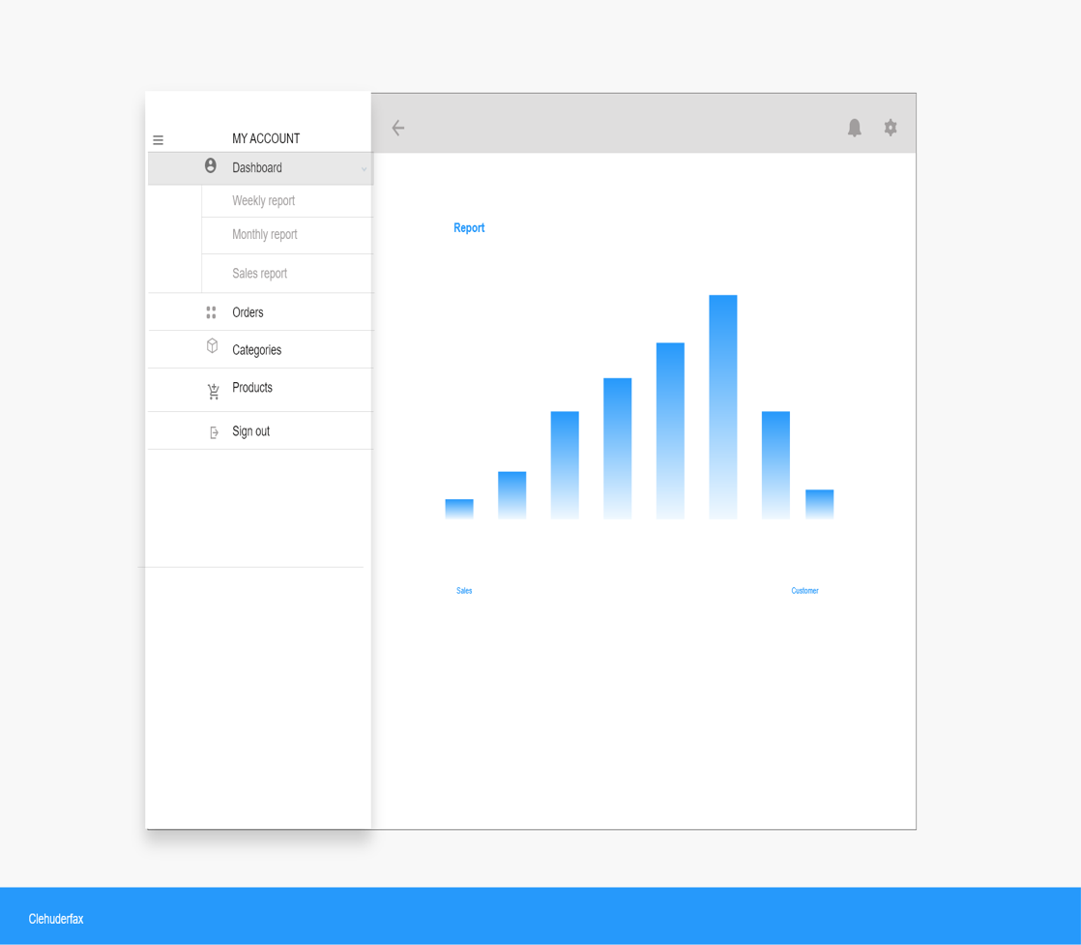

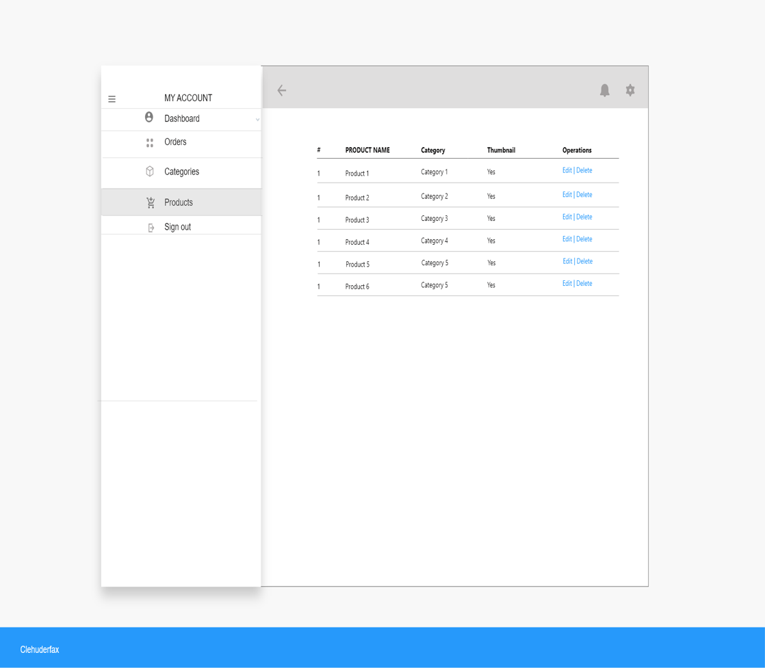

## Webpage

A web page is a specific collection of information provided by a website and displayed to a user in a web browser.

All the screenshots of website interface and functionality are attached below:

### Pictorials

#### User

##### Homepage

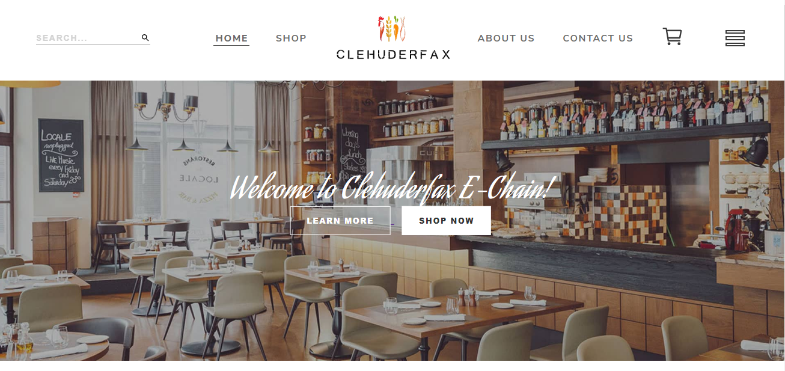





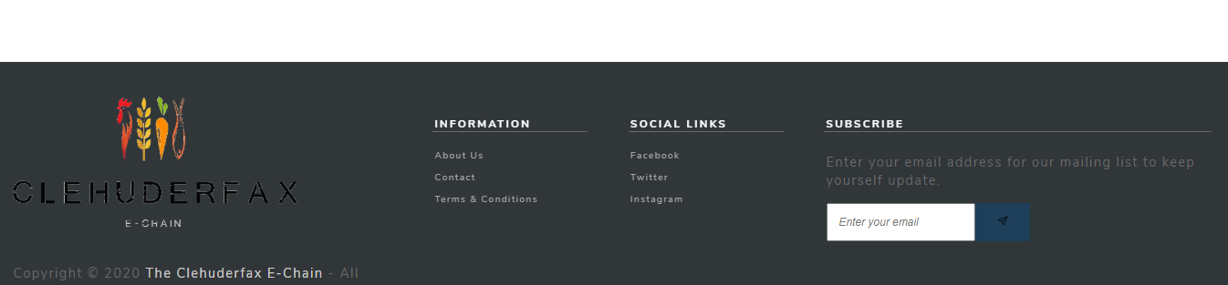

This is how homepage for our website looks like. Here you can see navigation for different pages in the page. You can see various products being featured. And different categories of products are available.

There is also a footer with all the contact information about the website.

##### Products Page

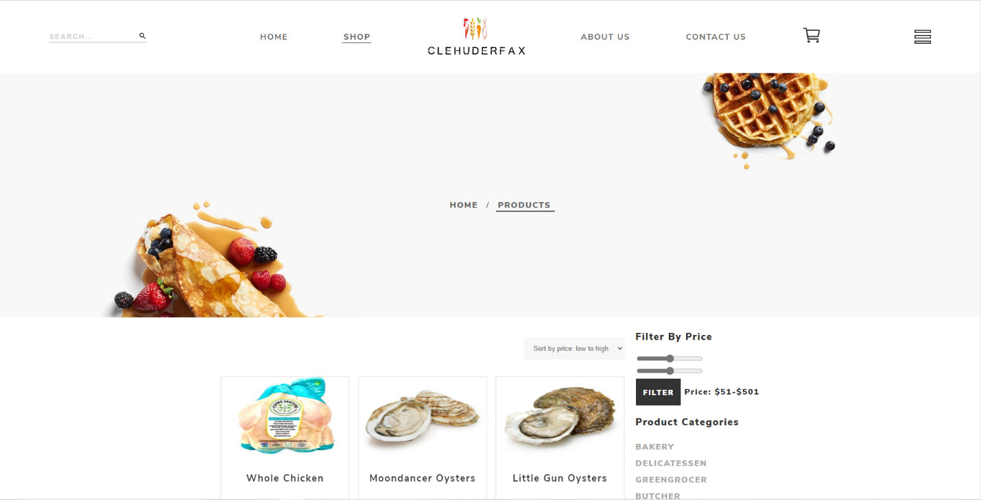

##### Search Products Page

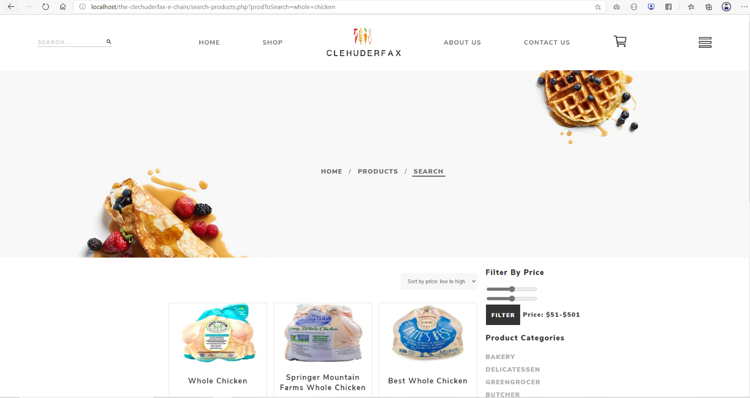

This page shows the search functionality. By clicking on the top left search button, you can type whatever product you are looking for and by hitting enter button, you get all the products that matches your search.

##### Product Details Page

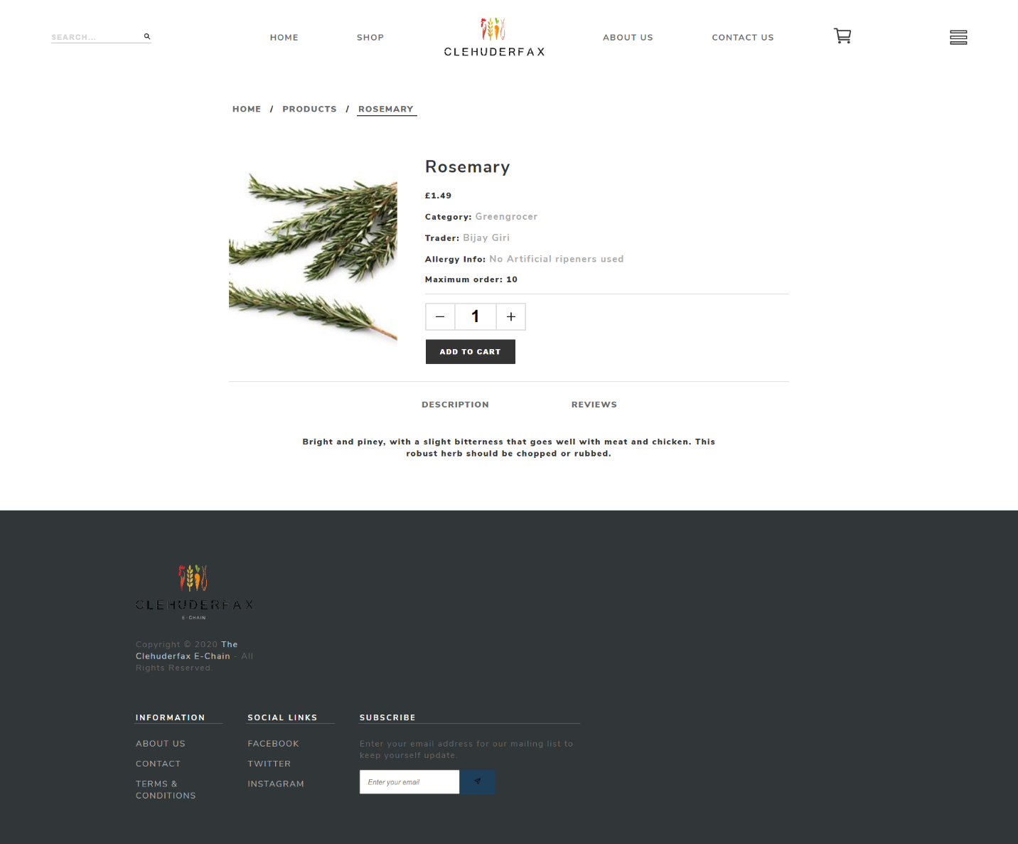

This is a single product page for our website. You can see information about the product such as the category, product name, Trader, Allergy info, maximum numbers of order and quantity. It also has a description about the product and review for the product.

##### Product Price Filter

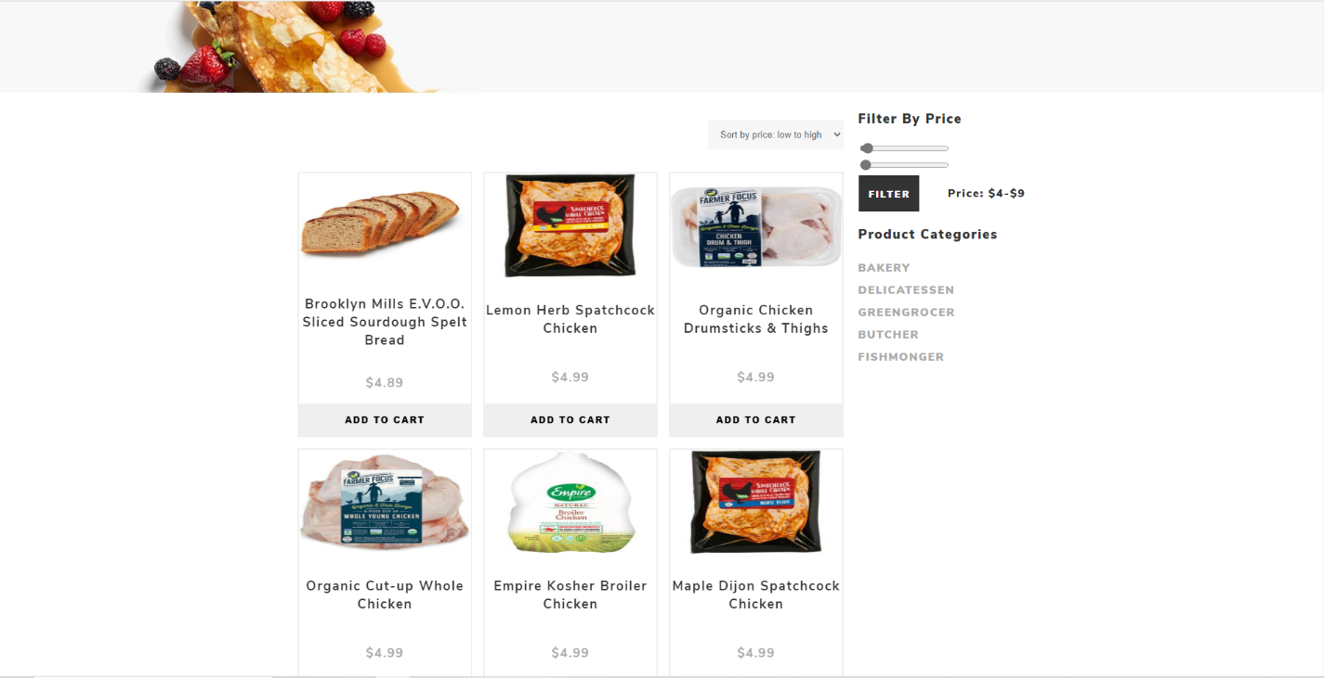

There is a price filter available on the shop page that allows customers to search an item between a certain price range with the help of sliding price bar.

##### Product Sort by price high to low

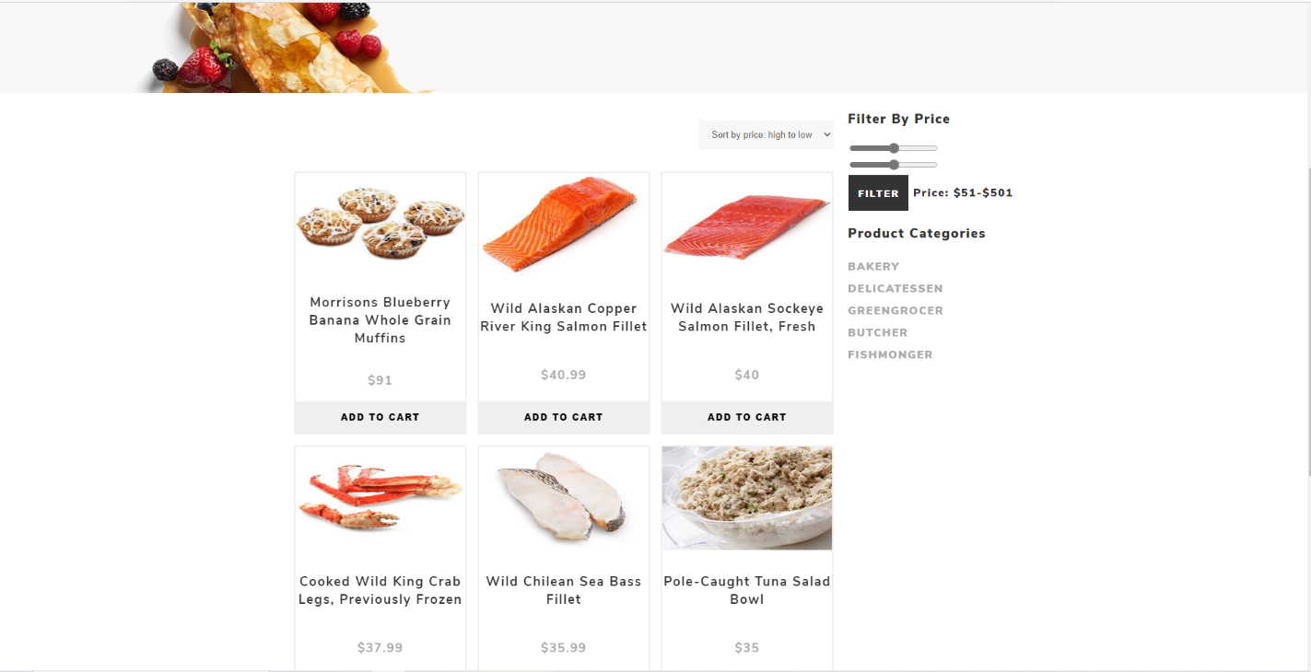

Customer can sort the products on the shop page from high to low prices by selecting sort by price high to low filter from the dropdown menu.

##### Product Sort by price low to high

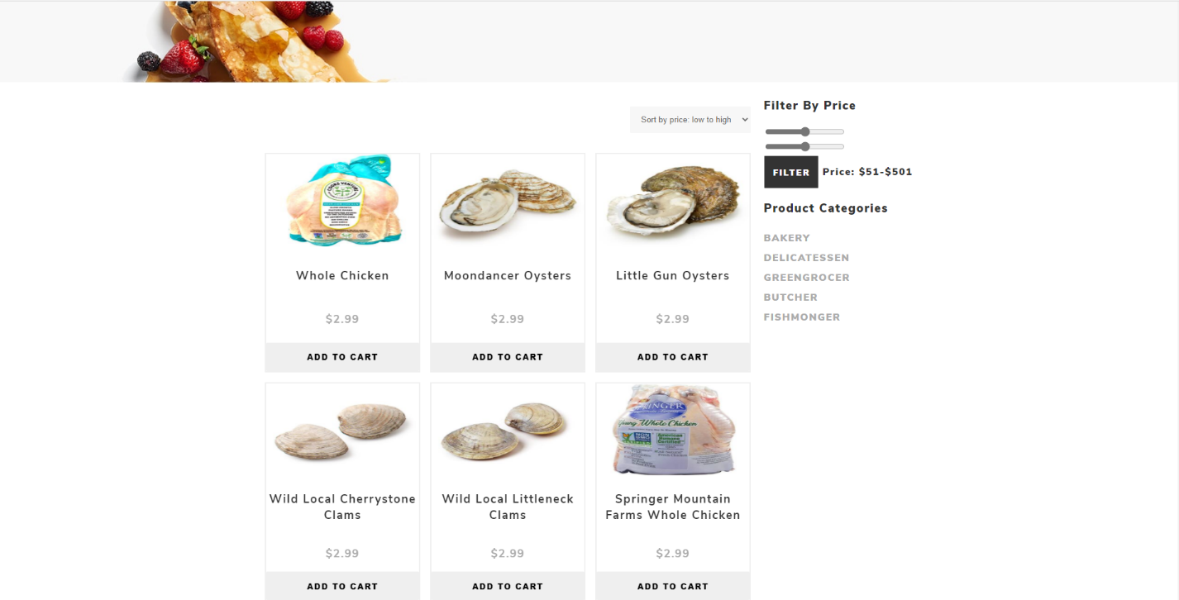

Customer can sort the products on the shop page from high to low prices by selecting sort by price low to high filter from the dropdown menu.

##### Specific Product Category

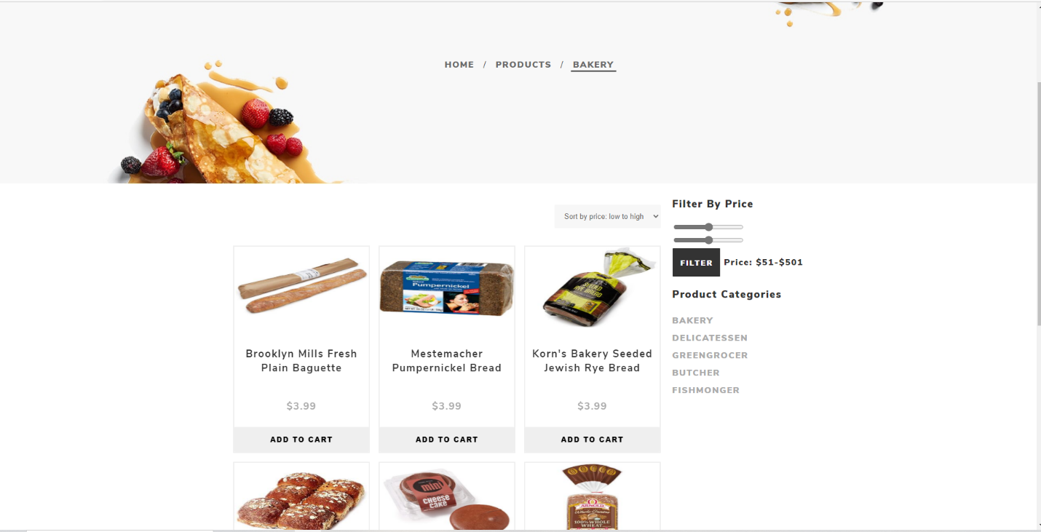

Customer can view products by categories by clicking on one of the categories on the right side. If the customer clicks on Bakery, only the product under Bakery will be shown to the customer.

##### Add to cart before login

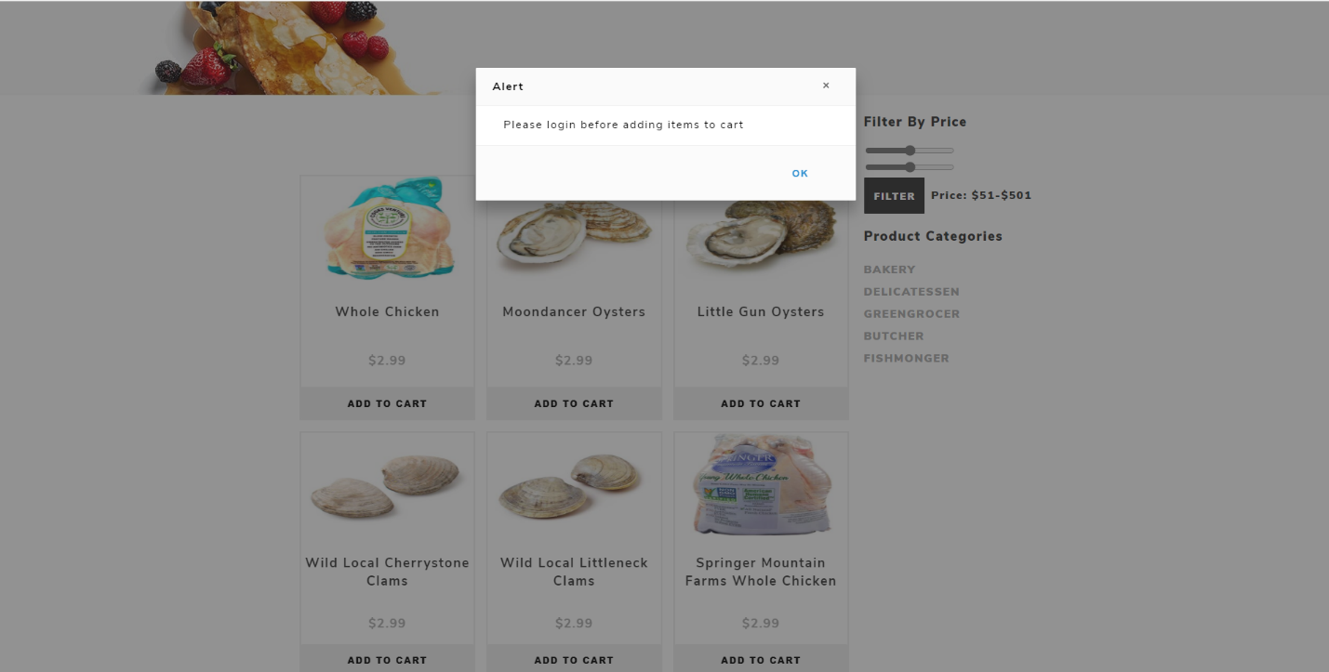

All the logged in and unregistered customers can view and search for product but when an unregistered customer tries to add a product to cart, he/she will be asked to login before adding a product to the cart.

##### Add to cart after login

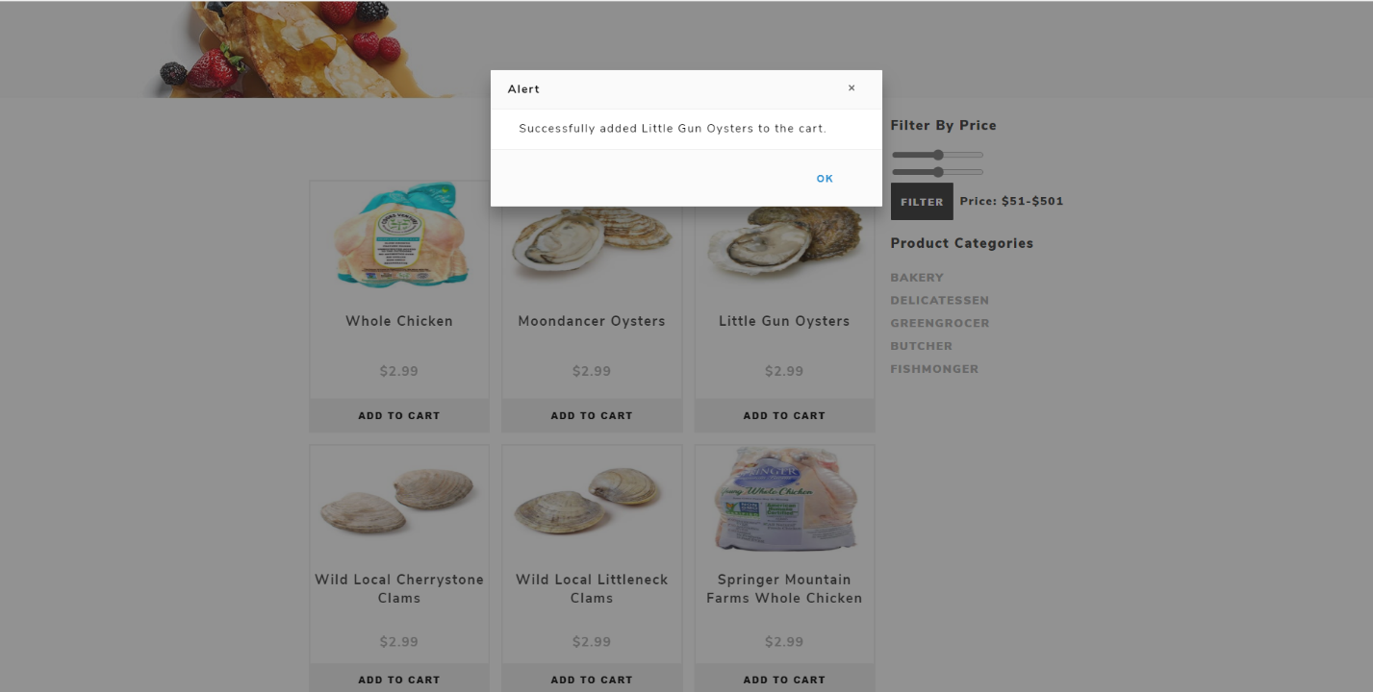

Once logged into account, customer can successfully add any products to his/her account. This message will be displayed when a customer adds product to his cart.

##### Add same products multiple times to cart

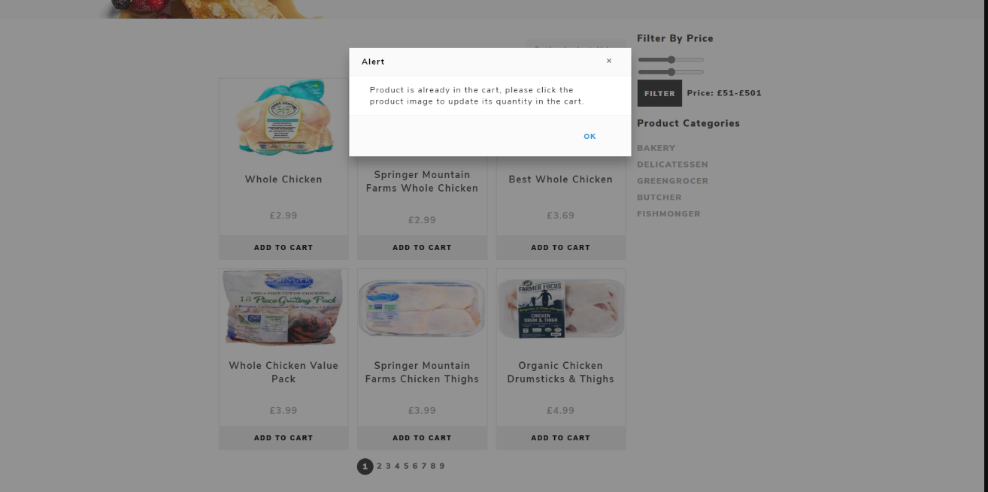

When a customer clicks on add to cart button on a same product more than once, he/she will be displayed with an alert message that will ask the customer to change the quantity of product in his/her cart and the product is already in the cart.

##### Cart

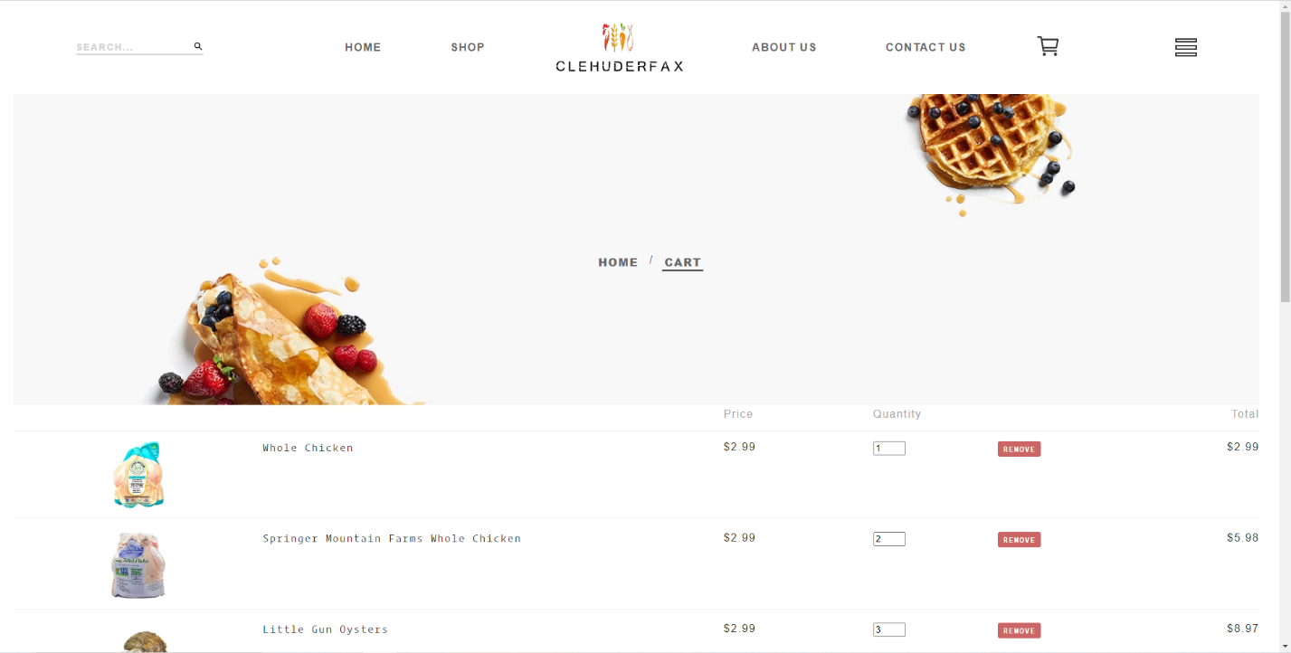

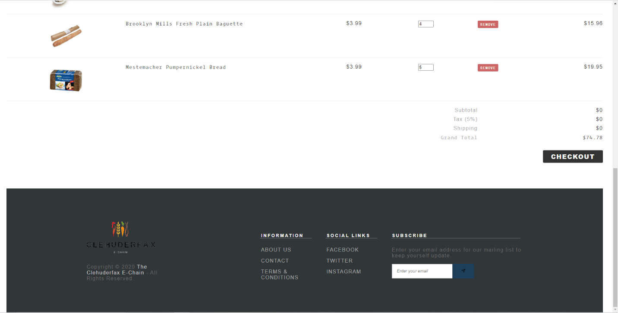

Product added by customers can be view by clicking on the cart icon on the navigation menu. It shows all the item added to cart with price, quantities (which can be edited), total price for each products and grand total of entire cart.

##### Sign Up

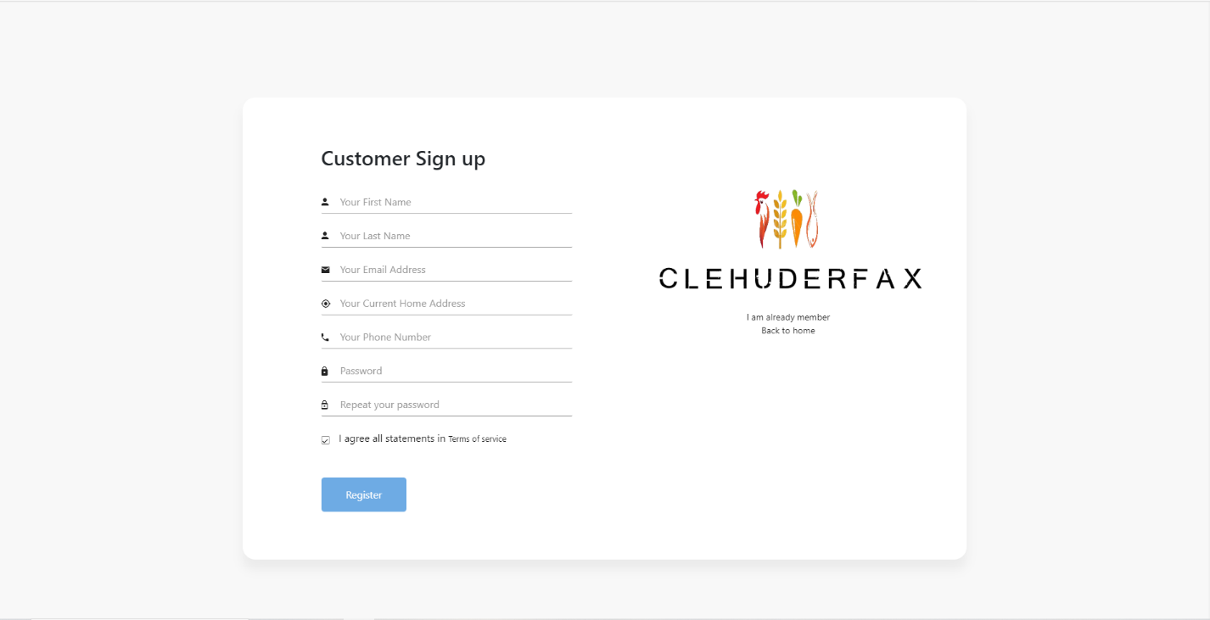

This is the customer sign up page and every customer must be a registered user to shop from the website. The customer must fill all the fields correctly to register successfully.

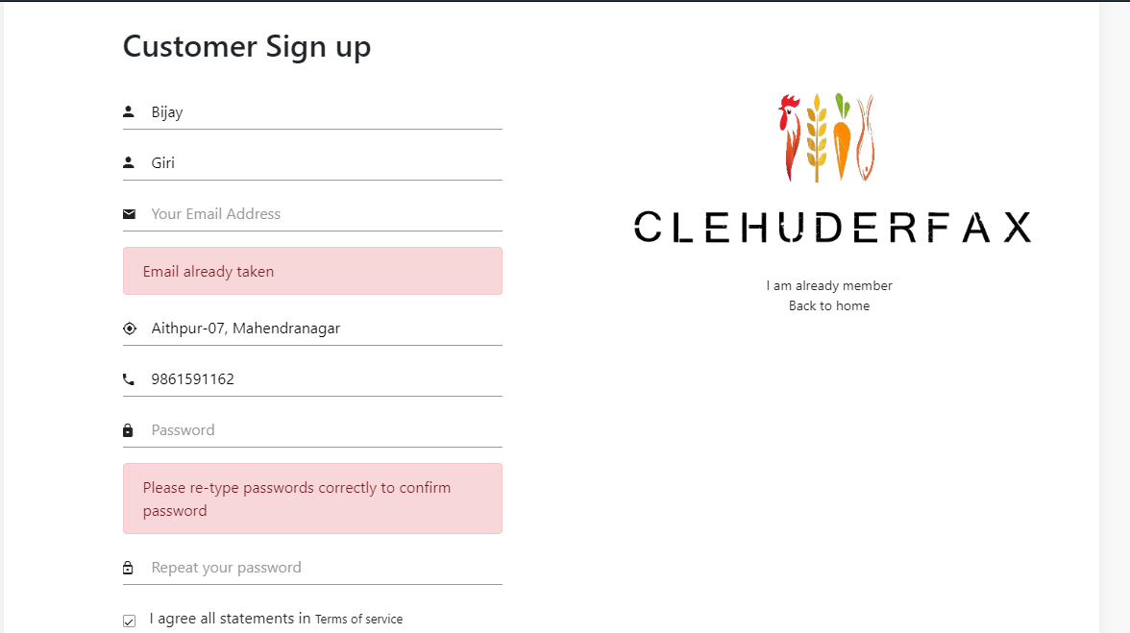

Instant validation is shown in the sign-up page. Users are not allowed to use the previously used email. The password in both fields should match and should contain uppercase, lowercase, one number and one special symbol. This makes the user account secure.

##### Email Verification

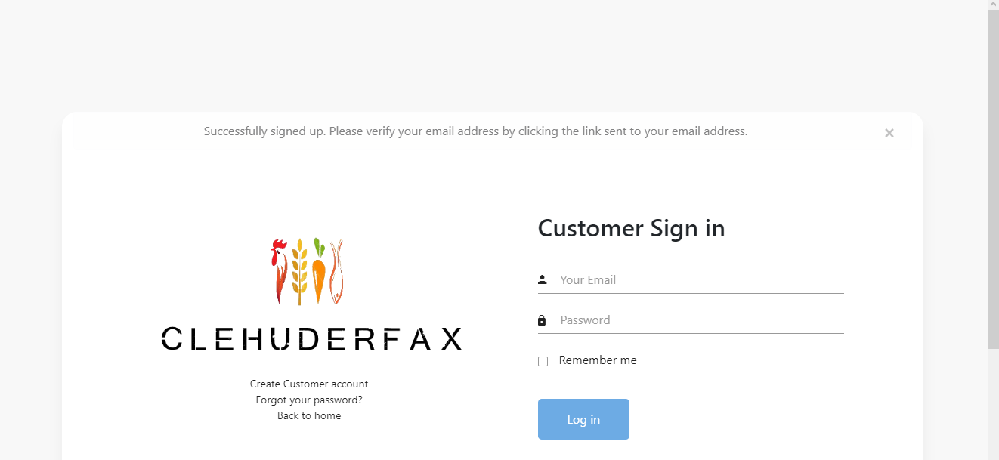

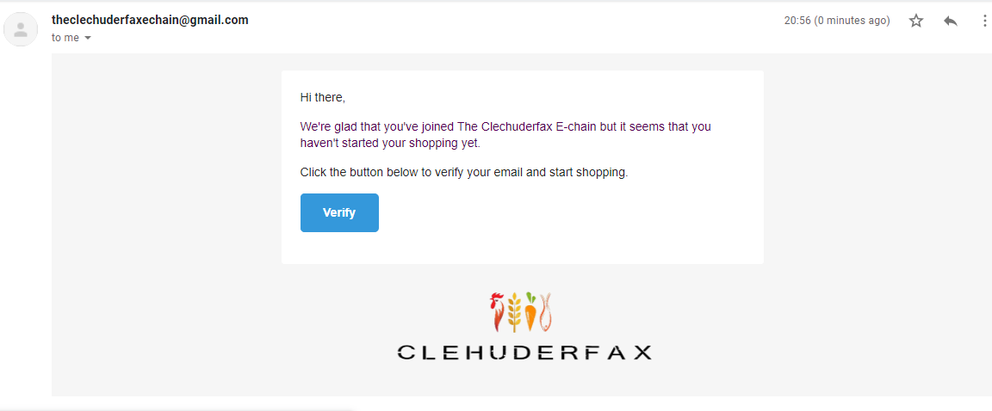

Once the customer is successfully registered, the customer is asked to verify his/her account via email. A verification link is sent to the customers email through which the account was made. The customer can verify his/her account by clicking on the verify button.

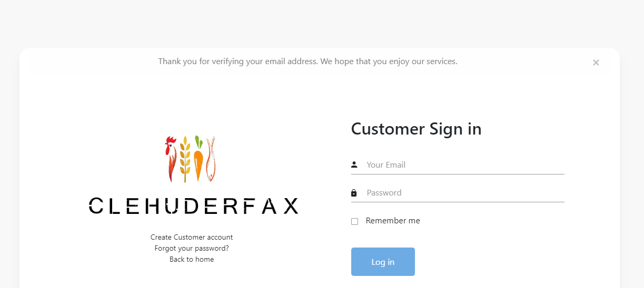

Once the customer verifies his/her email, customer can login into his/her account using correct email and password.

##### Sign In

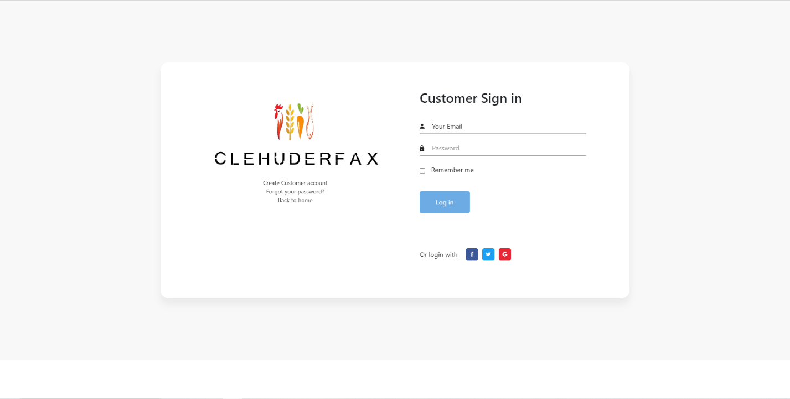

This is how sign in page for our website looks like. Customer can login into their account using correct email and password.

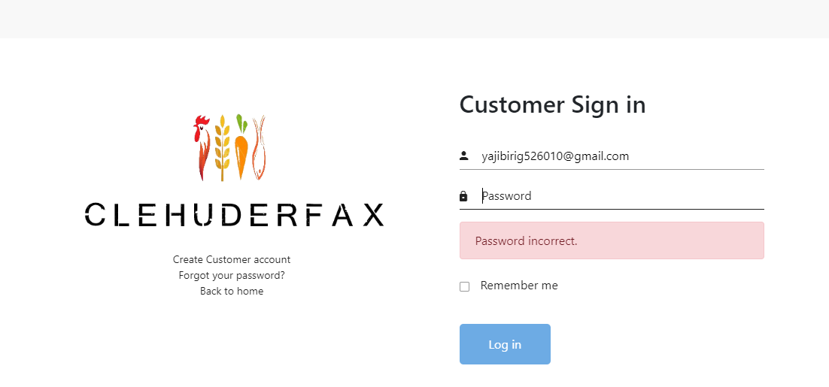

Error message for incorrect user credentials is displayed.

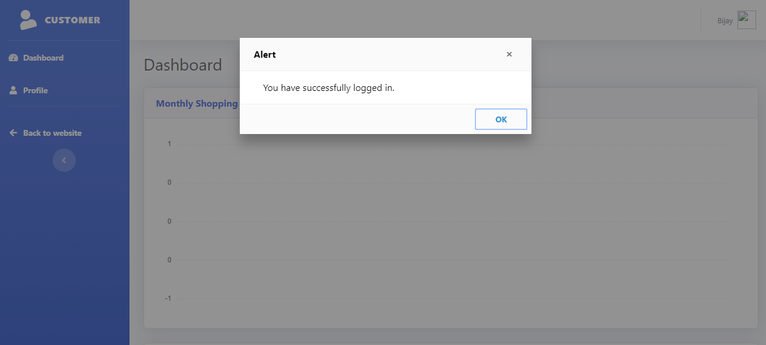

Once the customer is logged in, he/she is redirected to customer account.

##### Logout

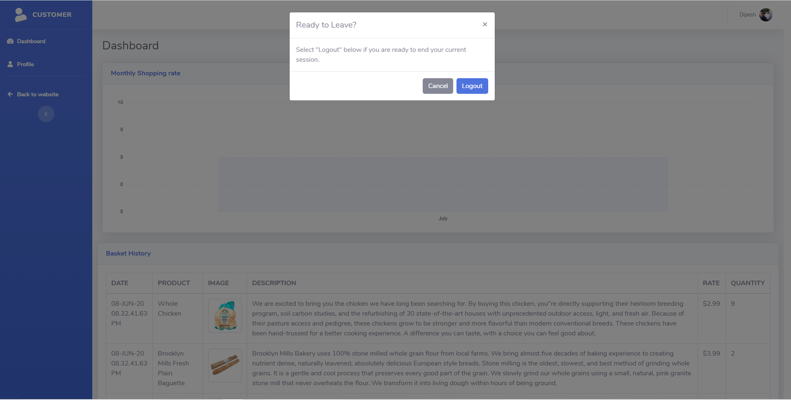

Customer can click on the top right profile icon to sign out of their profile. After clicking on log out button customer is displayed a warning message and if the user clicks on logout, he/she is logged out of the profile.

##### Password Reset

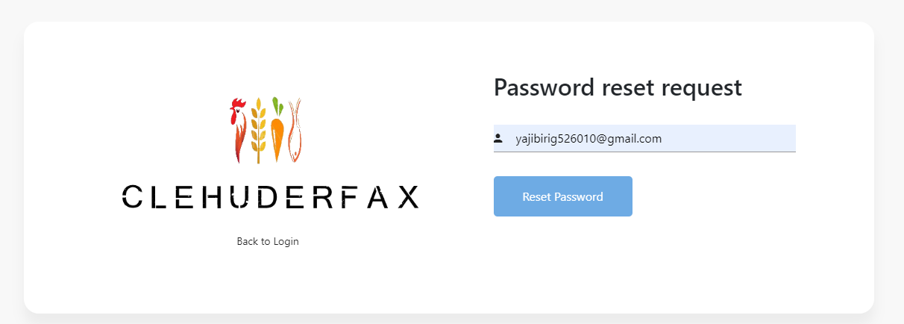

If the user forgets his/her password, the user can request for a new password by providing a valid email account.

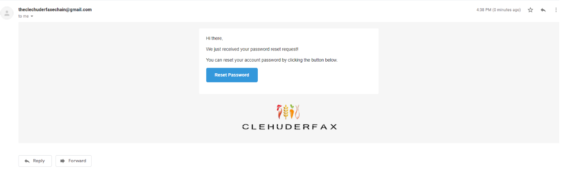

A link for password reset is sent to the user’s inbox. By clicking on Reset password, user can reset his/her password.

##### Create New Password

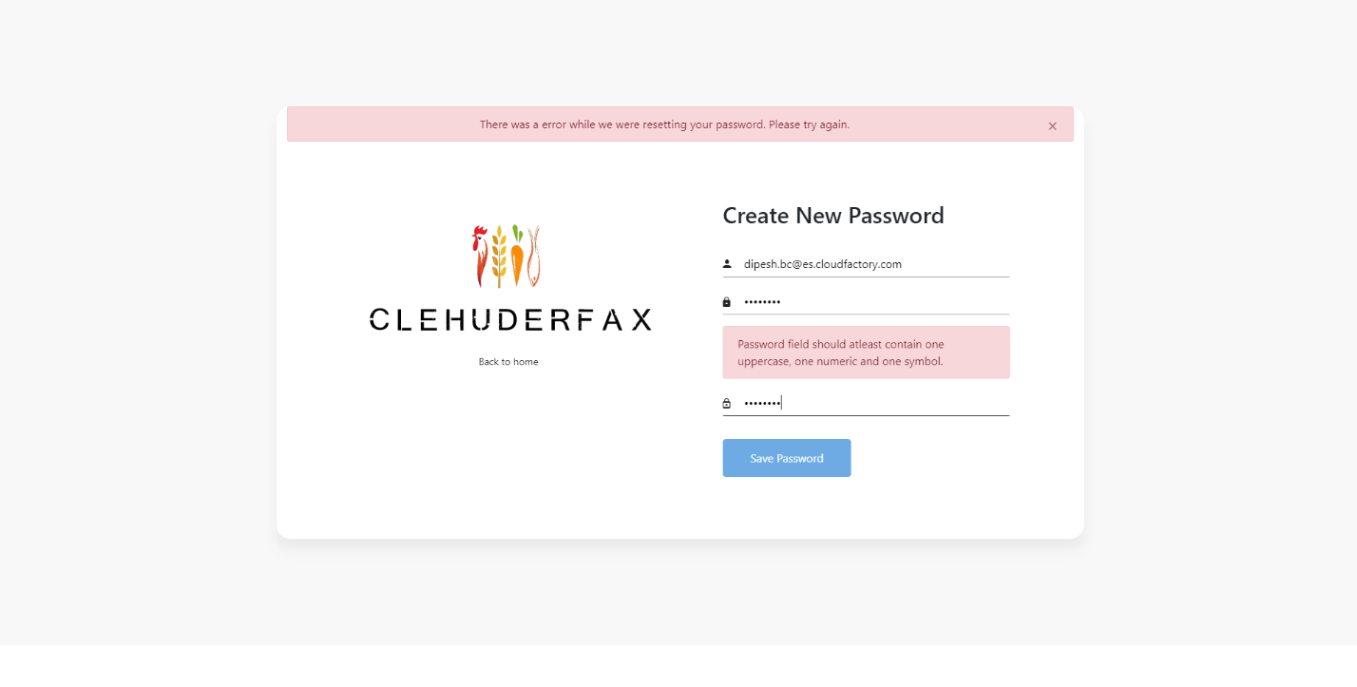

User can now change his/her password and instant validations are shown for any errors while changing the user password.

##### Profile

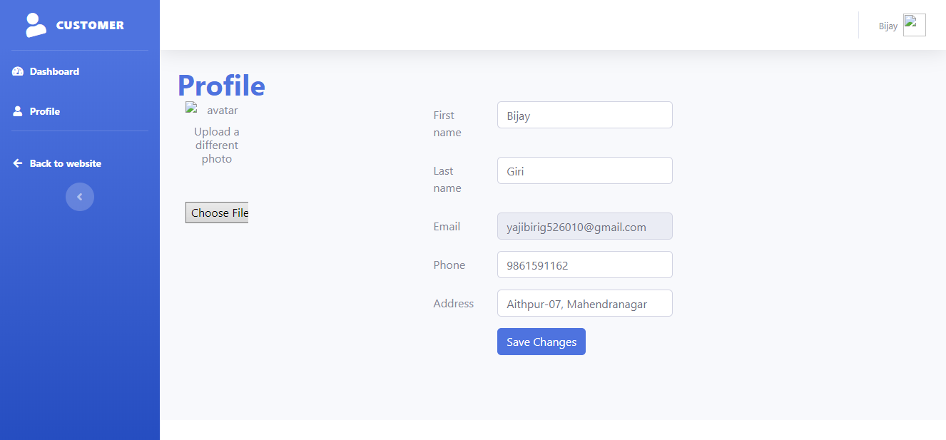

This is the profile for a customer. User can modify his/ her account information from the profile tab.

##### Profile Change

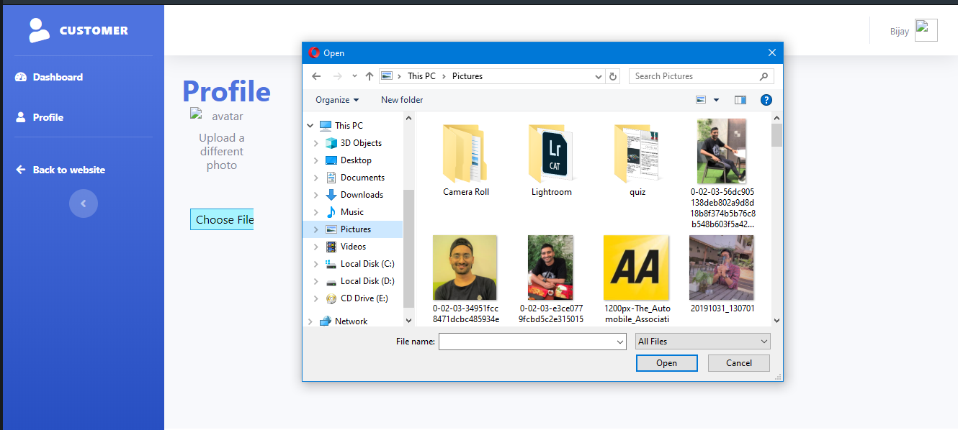

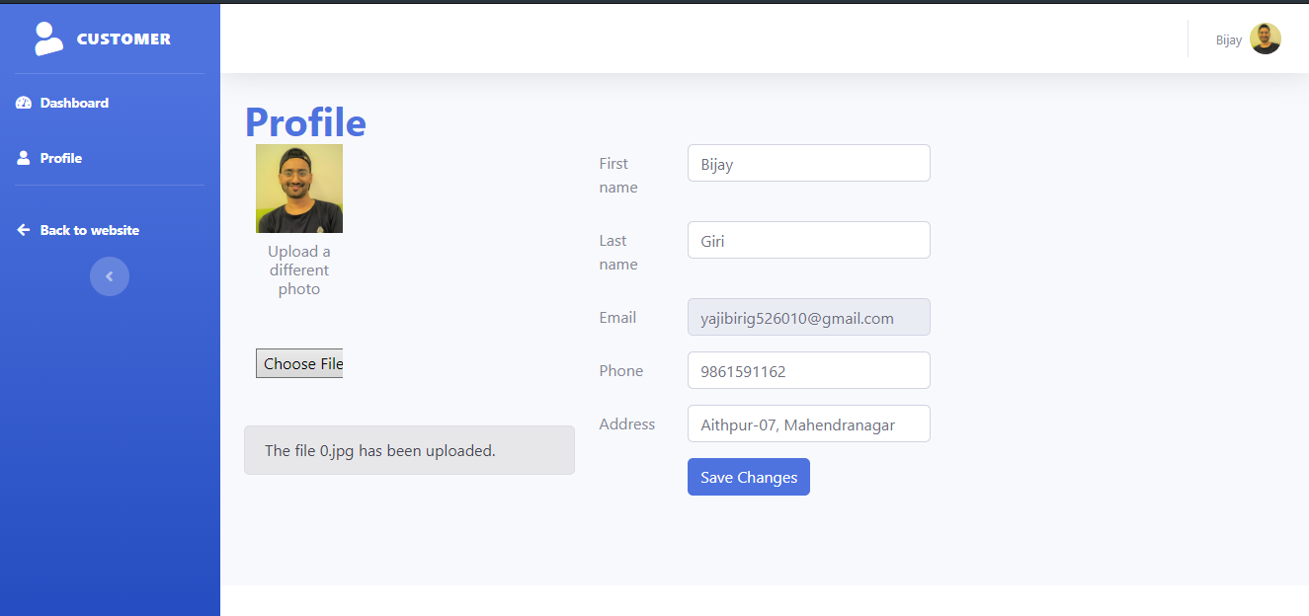

Customer can click on choose file and select a profile picture for his/her account.

##### Checkout

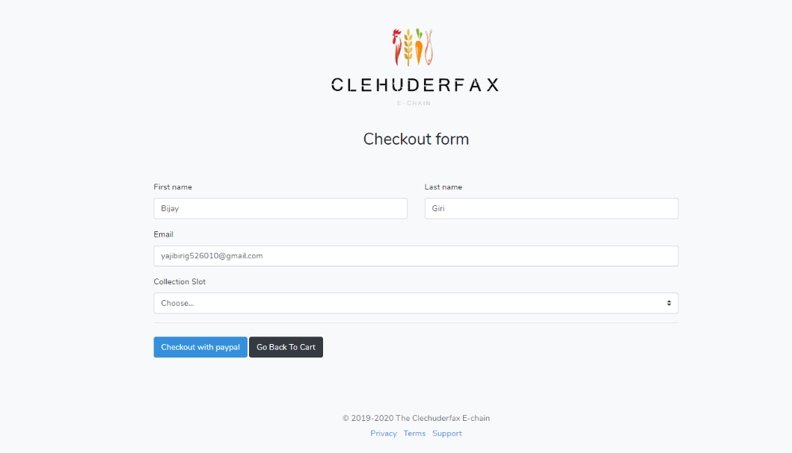

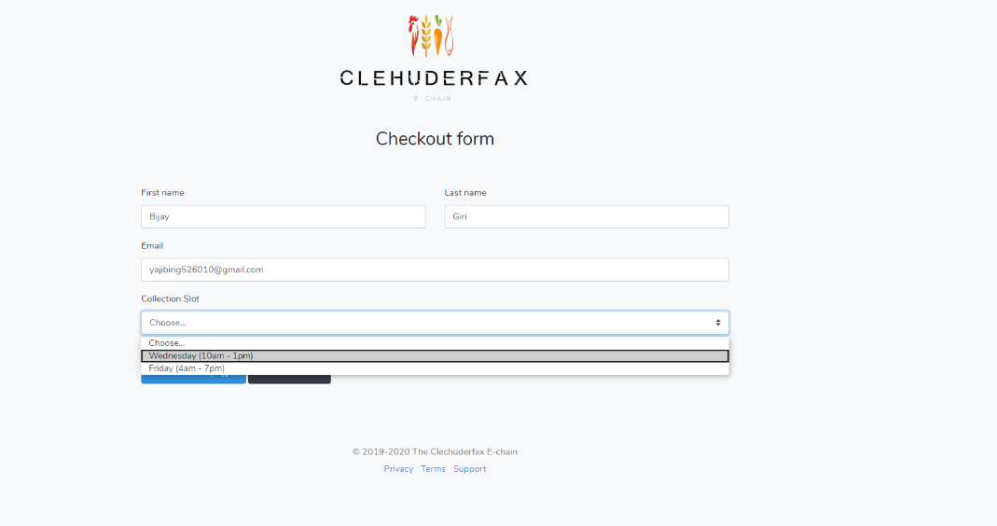

This is the checkout form which is displayed after the customer clicks on check out in his/her cart. The customer can select desired collection slot and can proceed to payment.

##### PayPal Payment

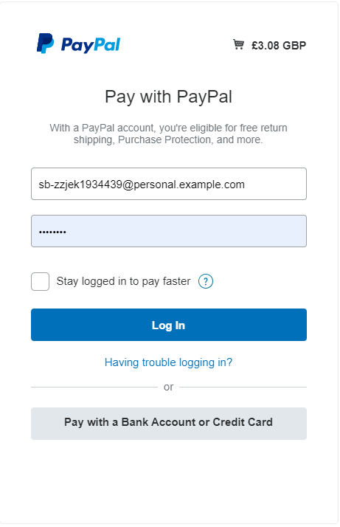

The customer is then redirected to the PayPal login page. Customer provides with correct login credential and is logged into his/her PayPal account.

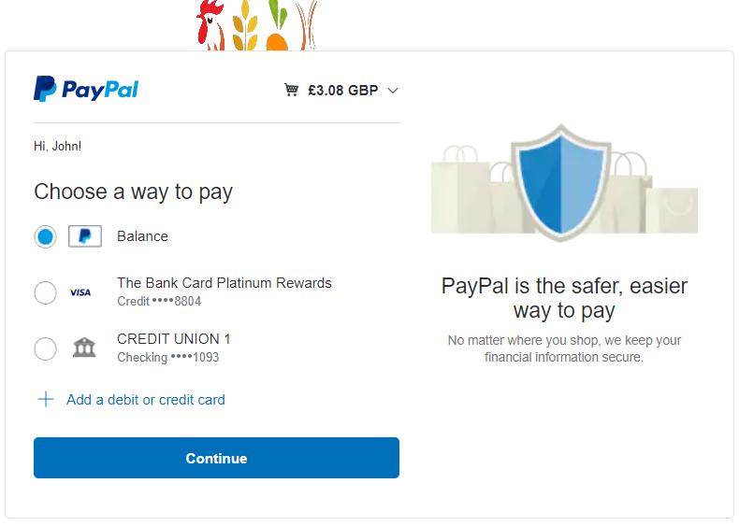

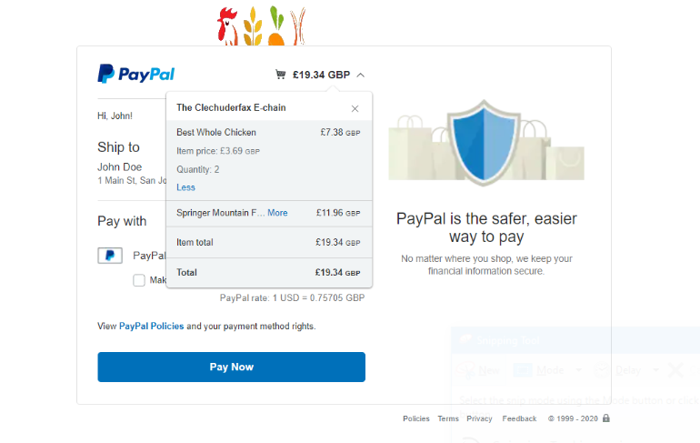

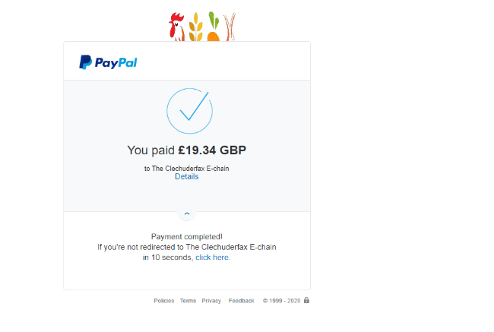

Customer completes the payment for the products and is shown the total paid amount.

##### PayPal Receipt Mail

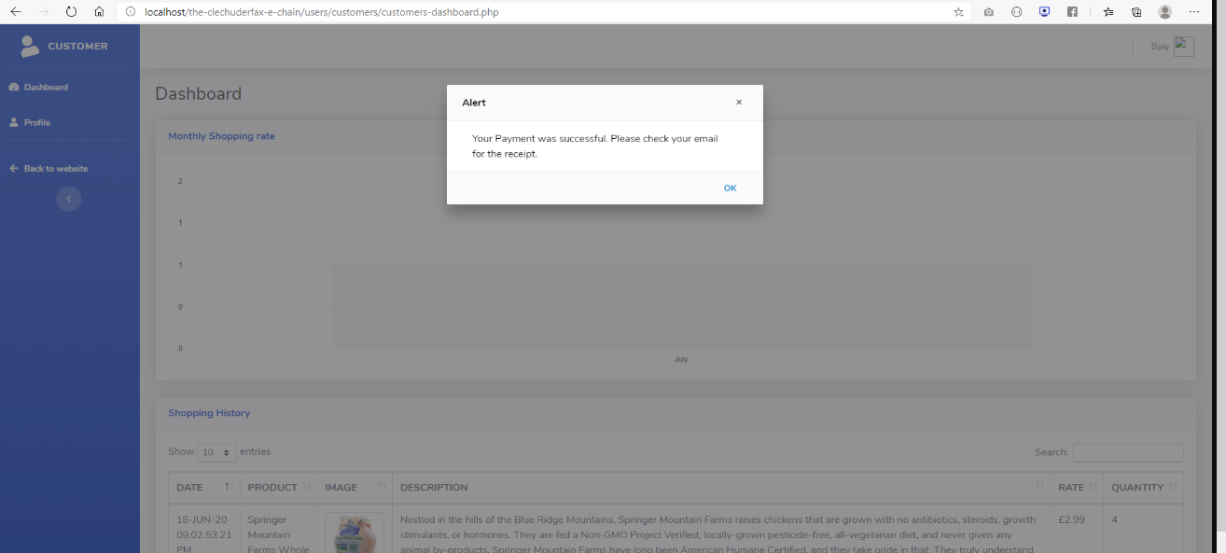

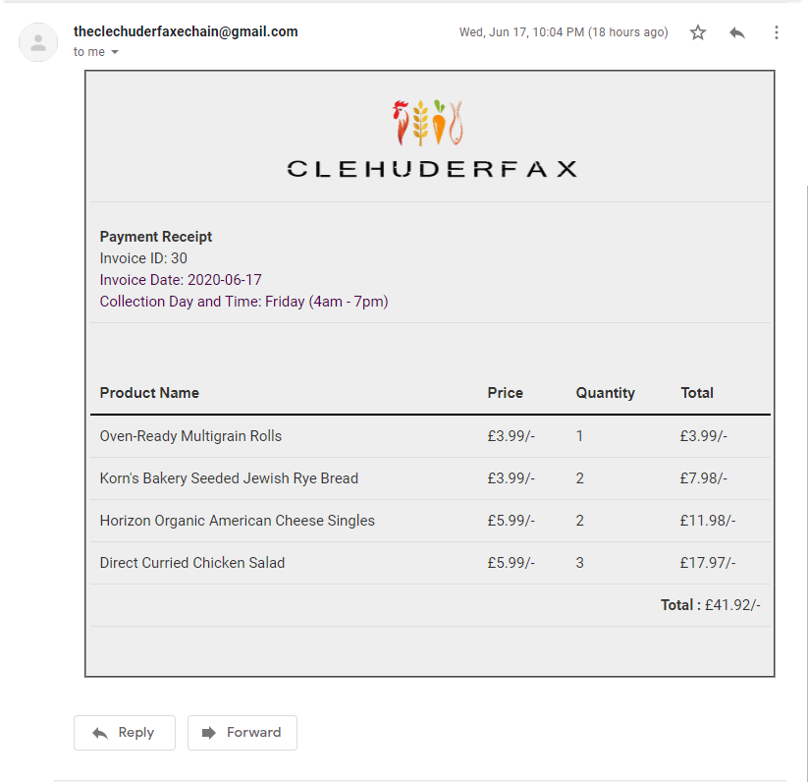

The customer can view his receipt for the shopping via mail. The payment receipt shows the product, price quantity, and total price. It also has the invoice number, date and collection slot. User can print this invoice.

##### Customer Dashboard

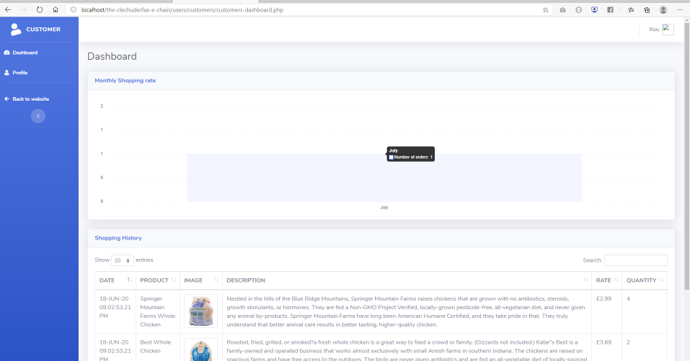

The customer dashboard shows customer’s monthly shopping rate and all the shopping history for the customer.

#### Trader PHP

##### Sign Up



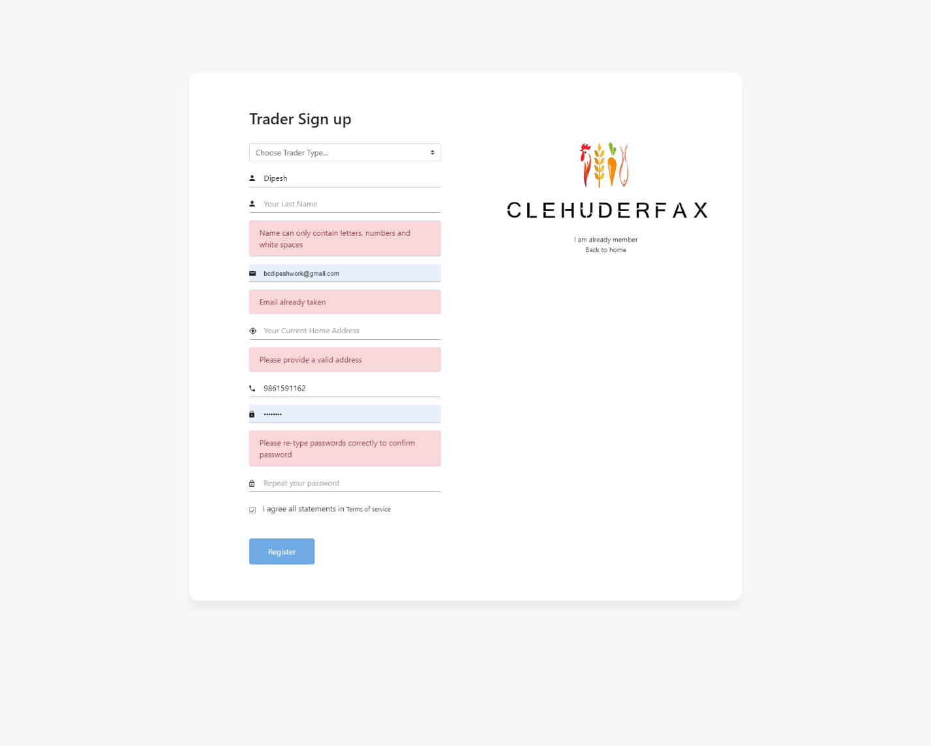

This is Trader sign up with validation.

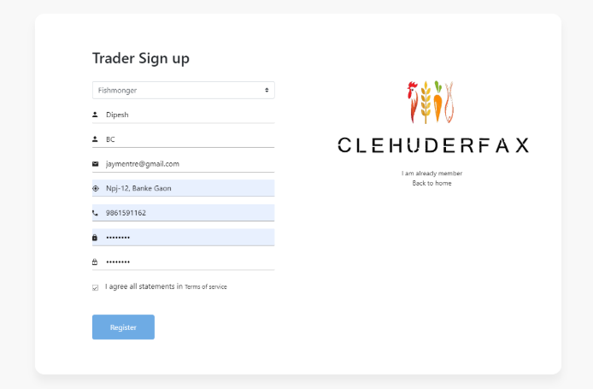

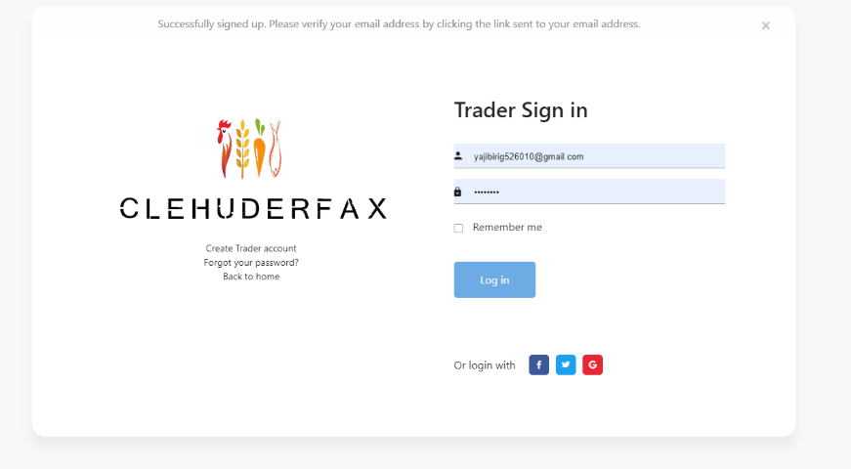

Customer needs to sign up before selling his product in the website and should be verified. This is a customer sign up page. Instant validation is available in the sign-up page.

##### Unverified Trader Log In

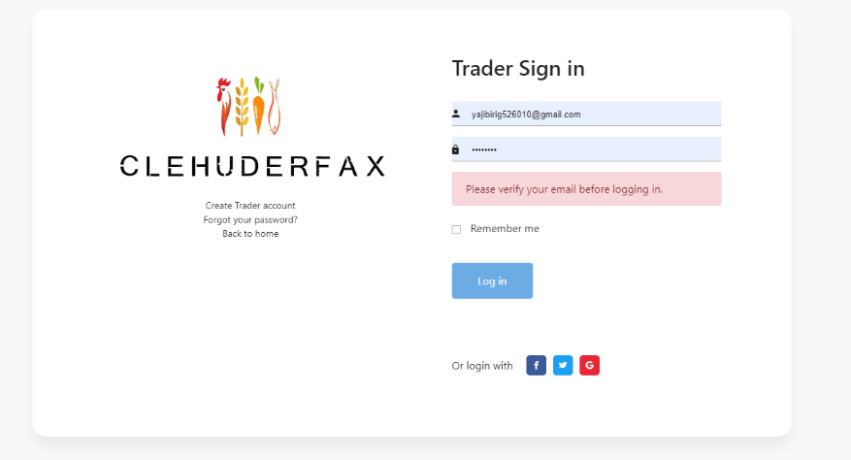

If an unverified trader tries to login, alert message to verify his/her account is shown.

##### Trader verification

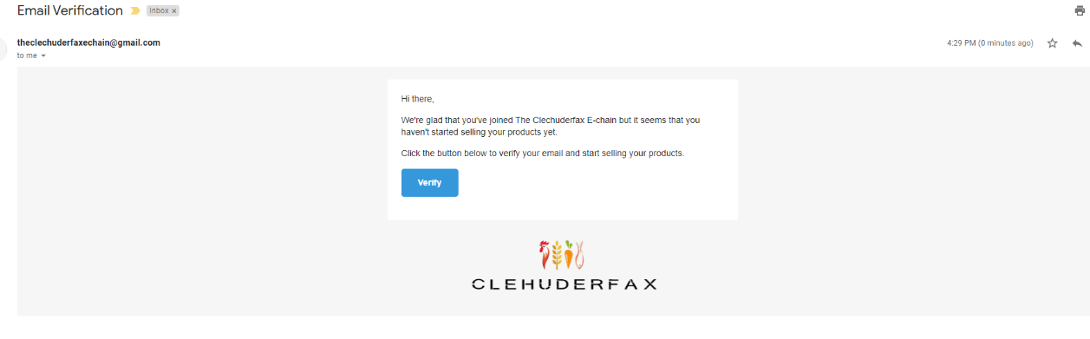

An email to verify trader is sent to the trader and after clicking verify button trader is verified.

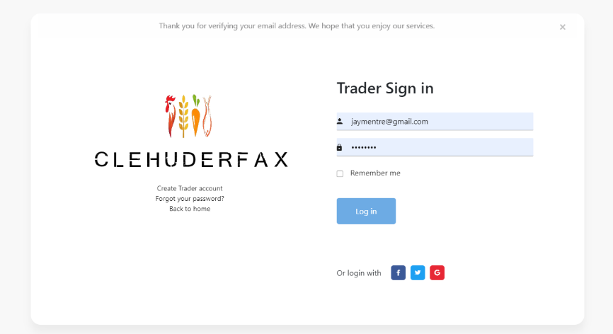

Now, the trader is verified.

##### Trader Sign In



Trader can sign in after verifying his/her account from the sign in page by providing correct login credentials.

##### Trader Dashboard

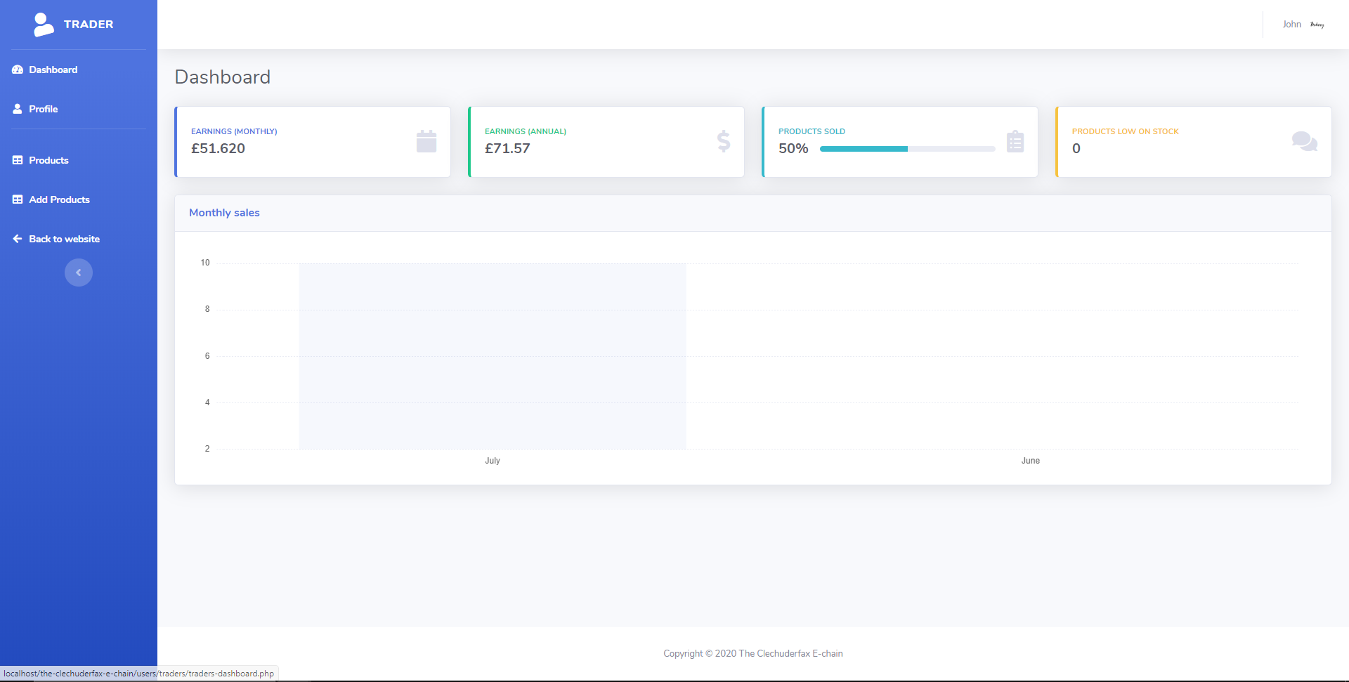

This is how the trader dashboard looks like. It has the monthly sales report, products sold and earnings.

##### Add Shop

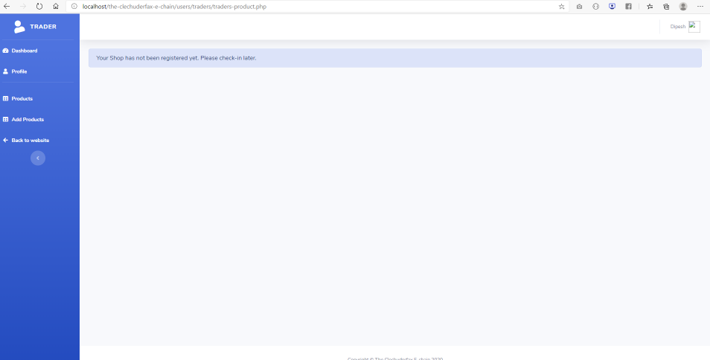

The trader must wait for shop to be registered before adding any products.

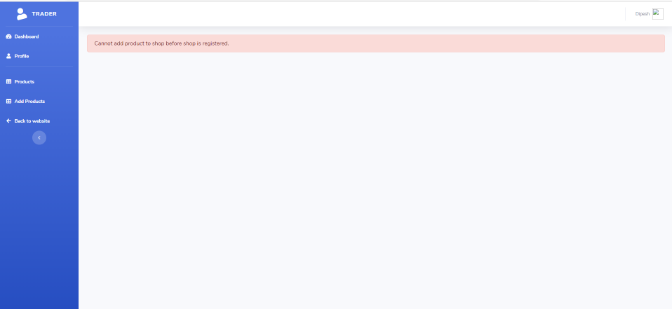

If the trader tries to add a product before the shop is verified, error message is shown.

##### Product

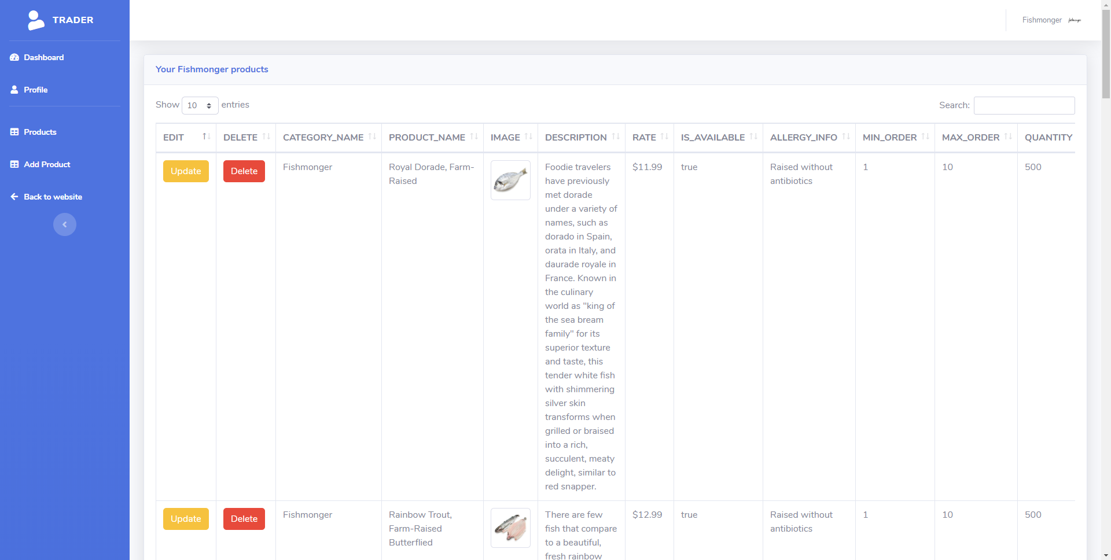

##### Add Product

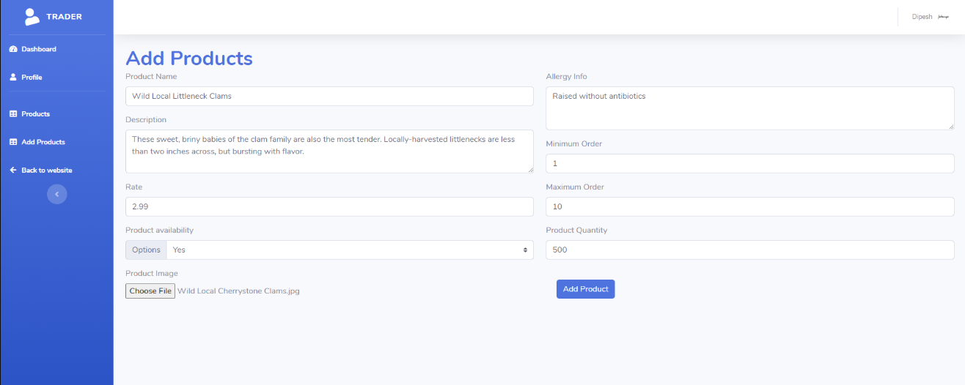

The trader can add product by clicking on add product from the navigation menu. Different field must be filled with a product picture for adding any products.

##### Update Product

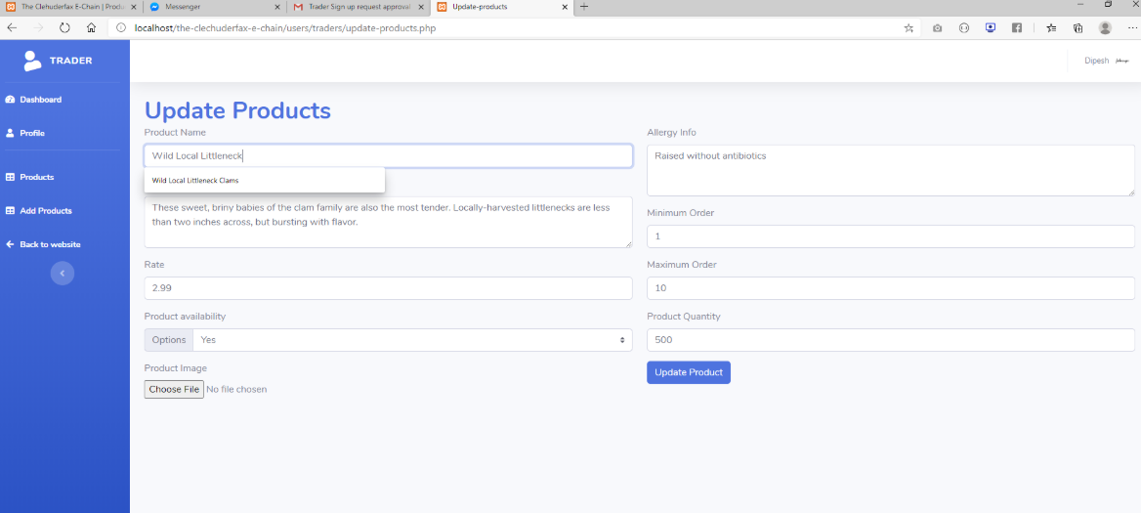

This is the update product page for trader. The trader can update the product info and picture from this page.

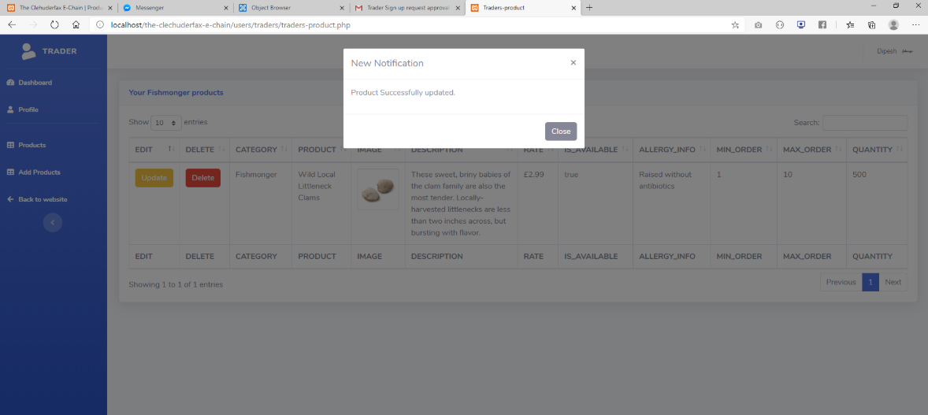

This page is displayed after successfully updating the products.

##### Delete Product

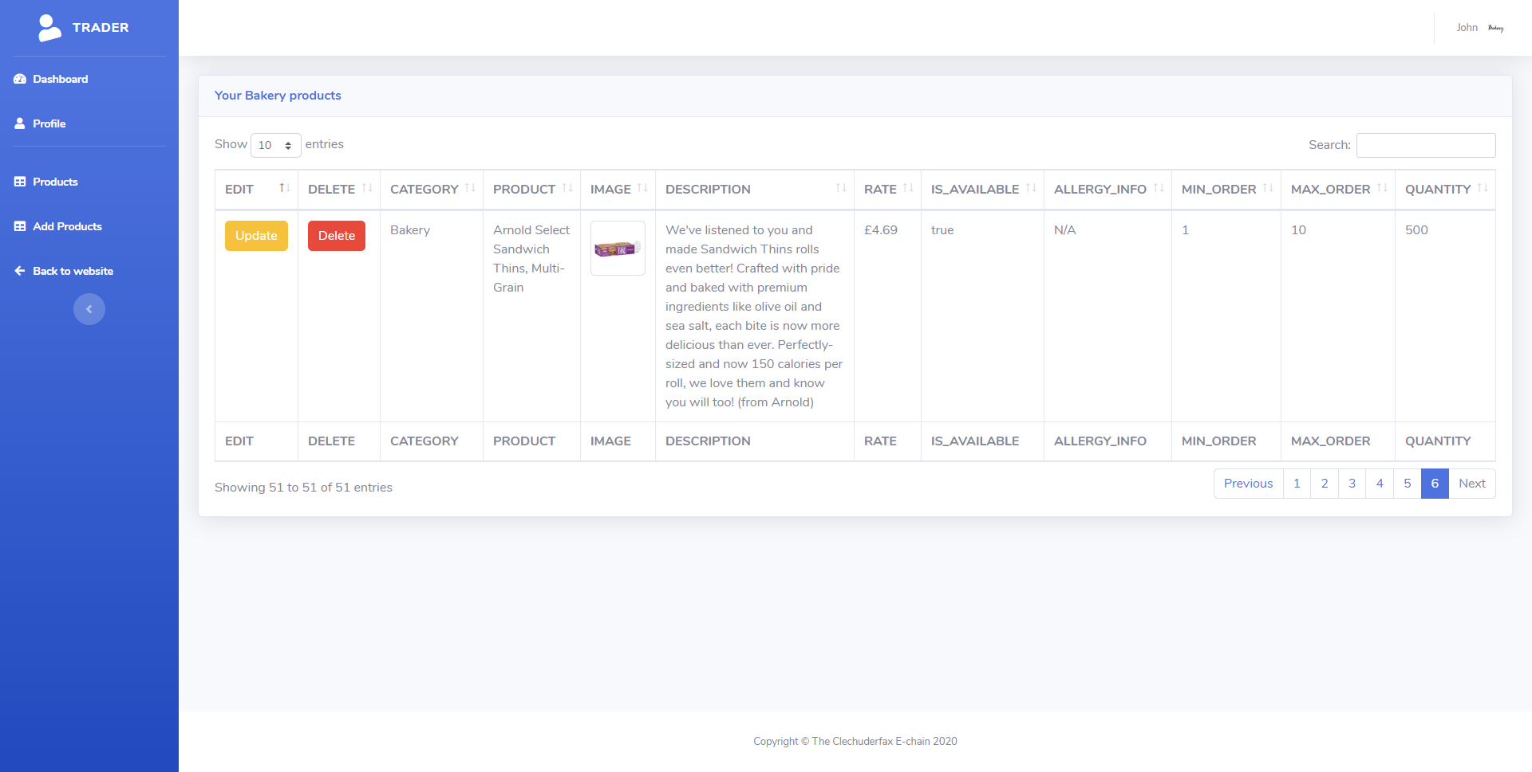

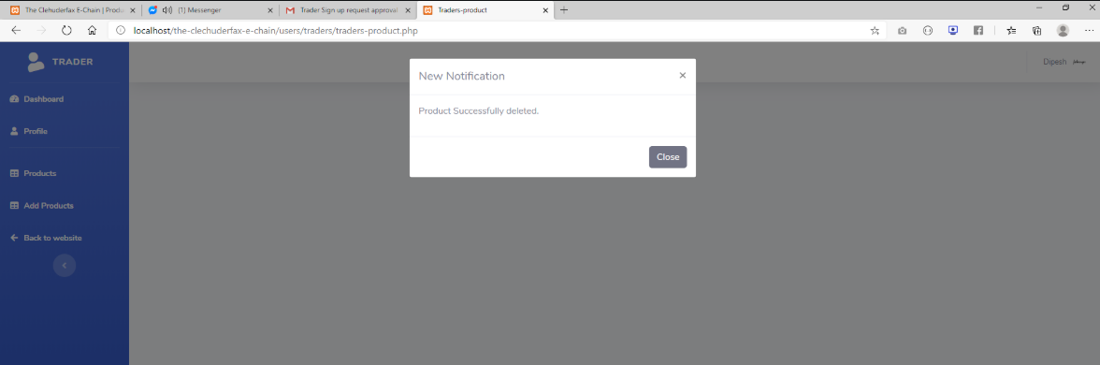

The trader can delete any product by clicking on delete button next to a product. This page is displayed after deleting a product.

##### Profile

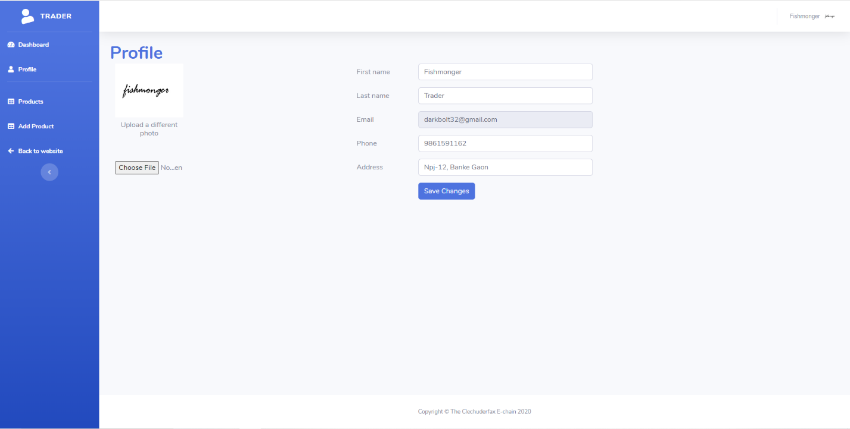

This page allows a trader to update his/her profile information including the profile picture.

##### Payment Receive Mail

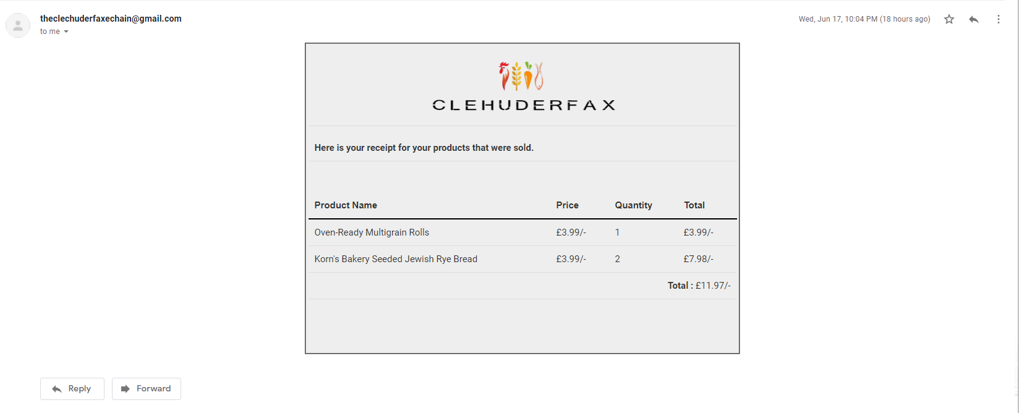

This is the screenshot of the payment receipt that is sent to the trader when a customer buys a product from his/her shop.

#### Trader APEX

##### Login

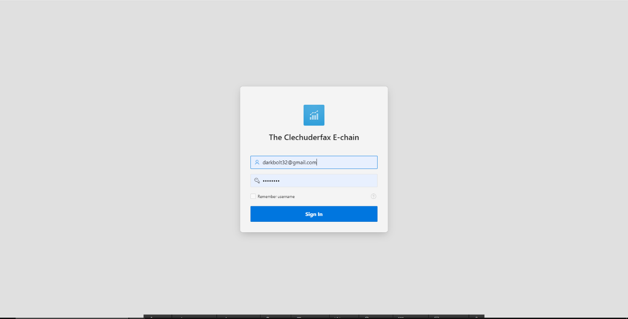

This is trader login in APEX with valid details.

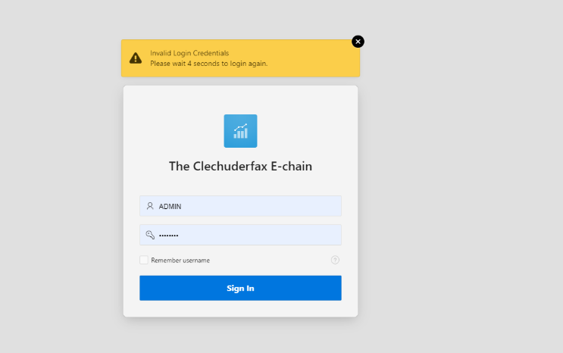

This is trader login with invalid credential.

##### Dashboard

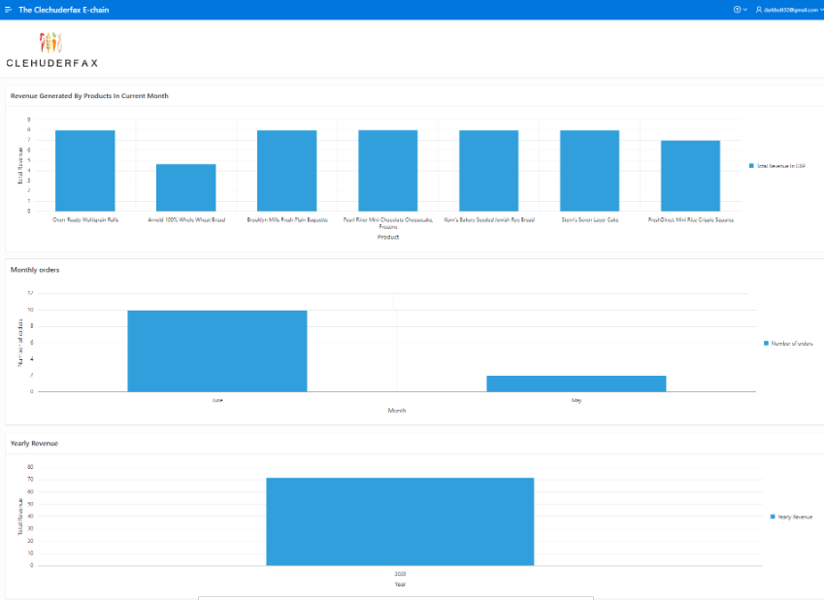

This is the dashboard for a trader which includes the revenue generated and orders and sales.

##### Shops and Products

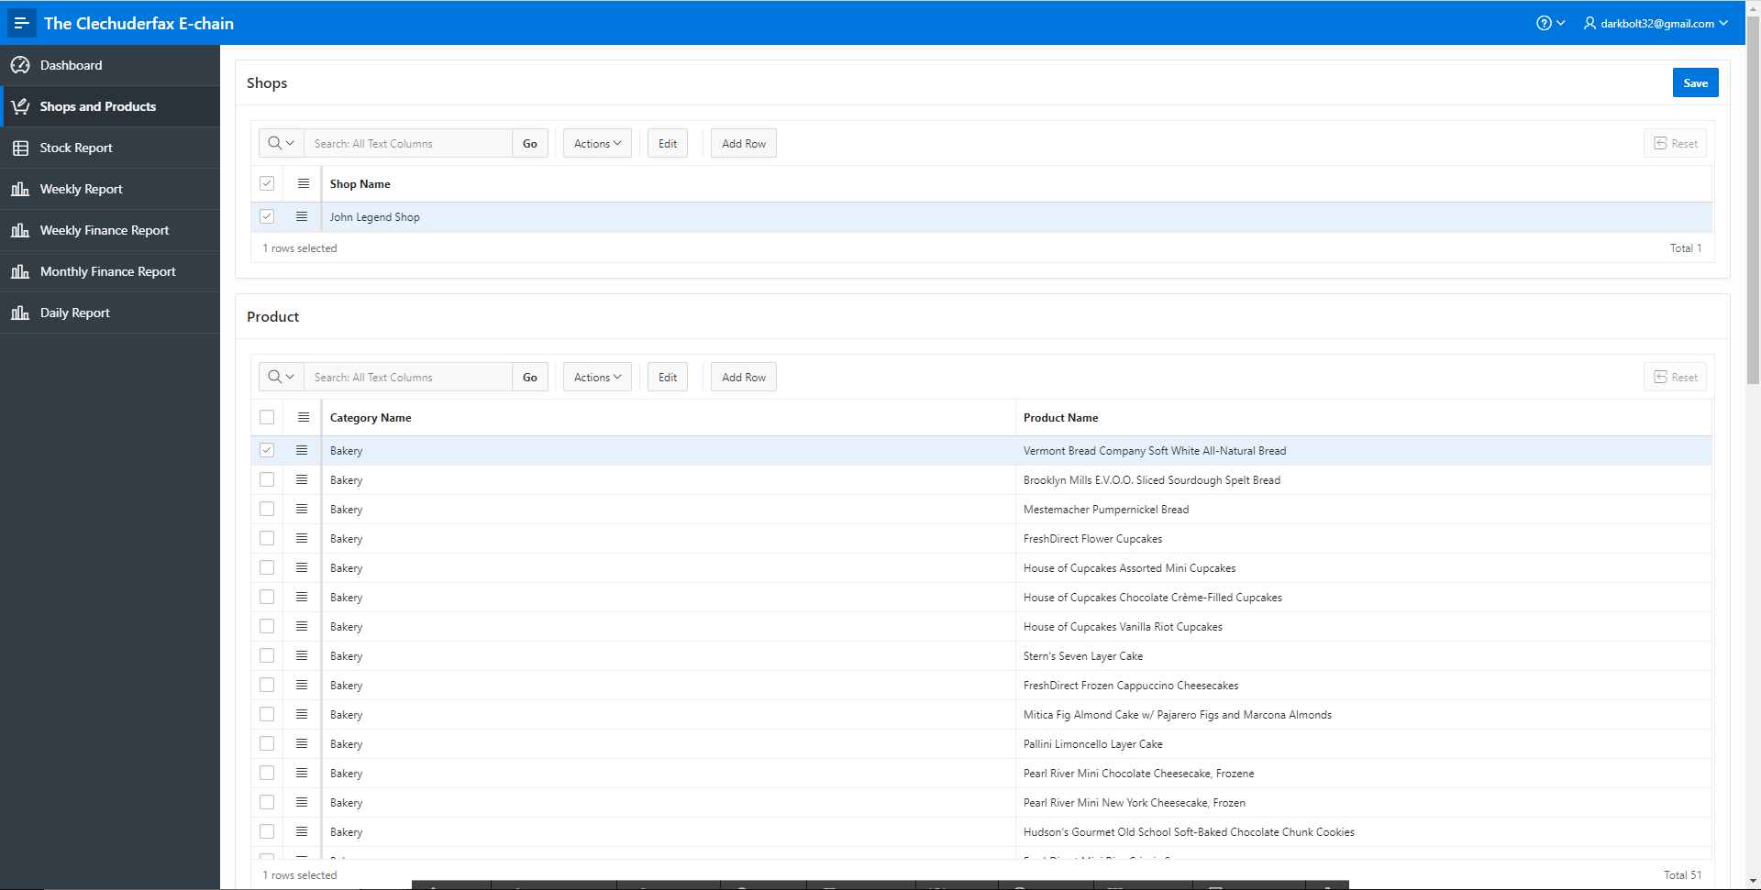

This page displays the shop name of the logged in user and all the products in his/her shop.

##### Stock Report

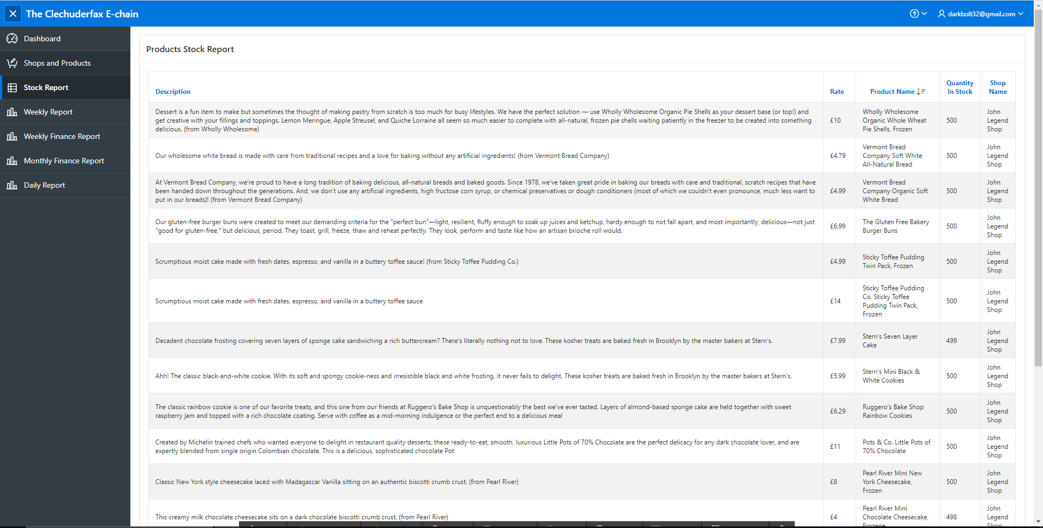

This page displays all the stock, their price, quantity in stock and prices. Traders can tell if any products are low on stock from this page.

##### Weekly Finance Report

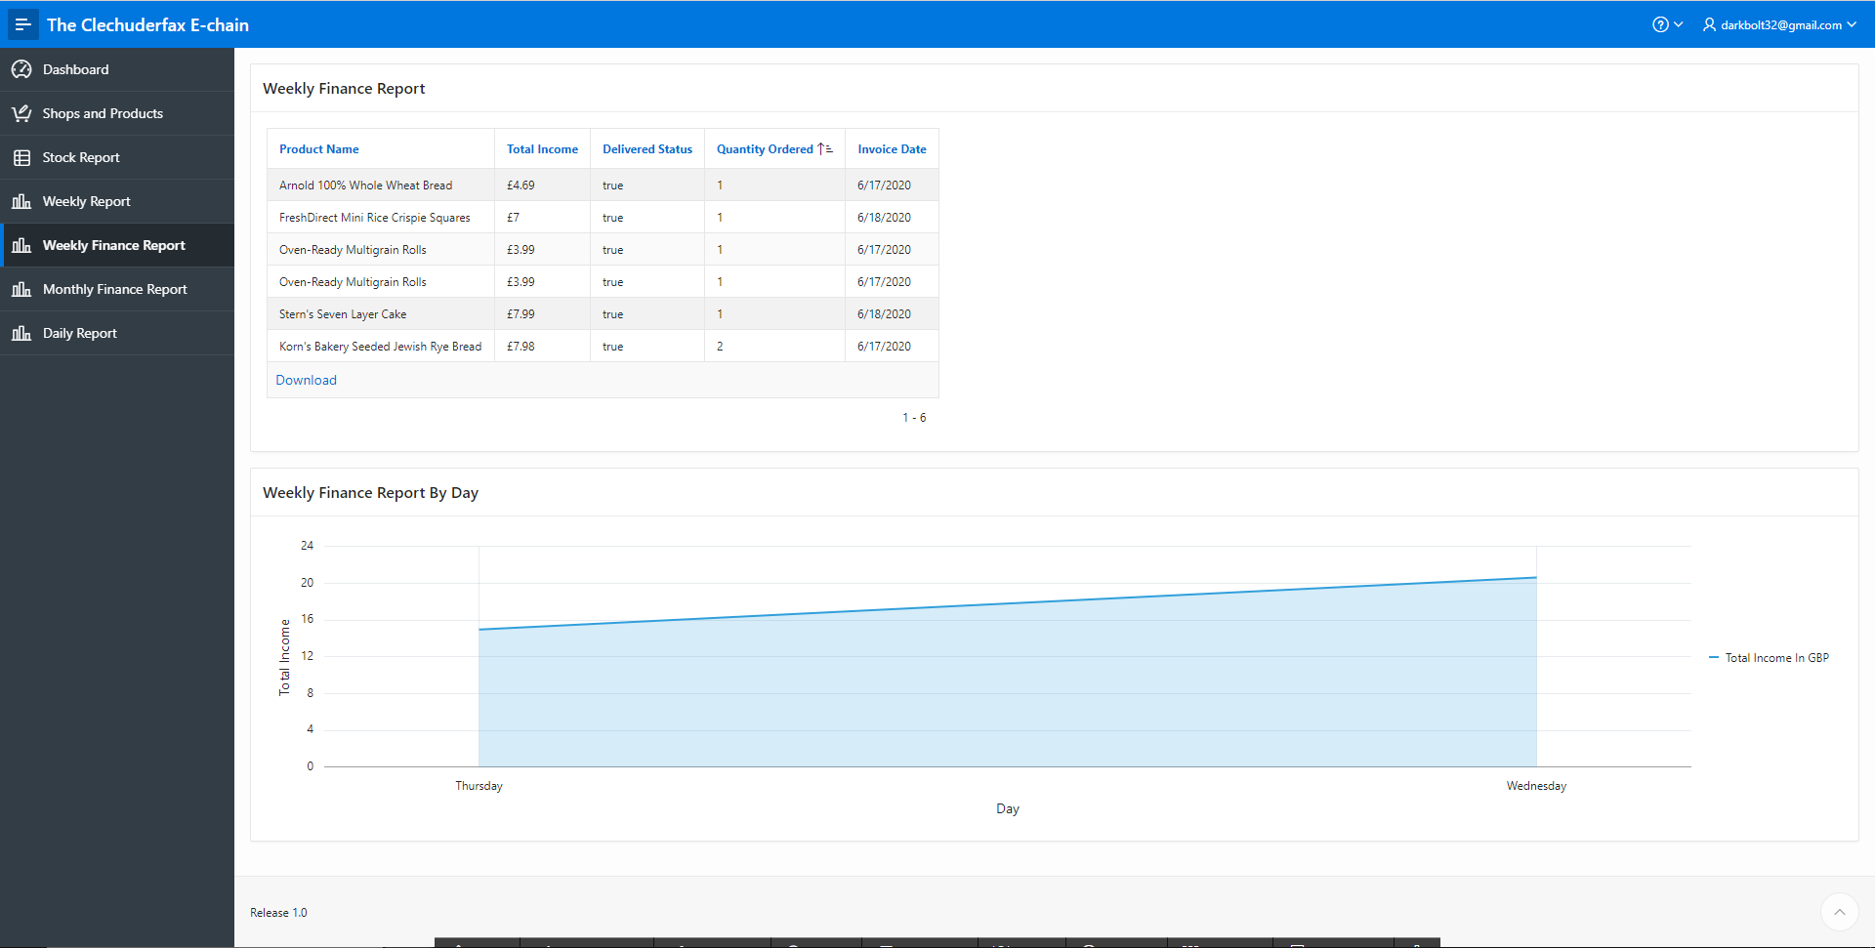

Traders can view weekly finance report of their respective shop from this page.

##### Monthly Finance Report

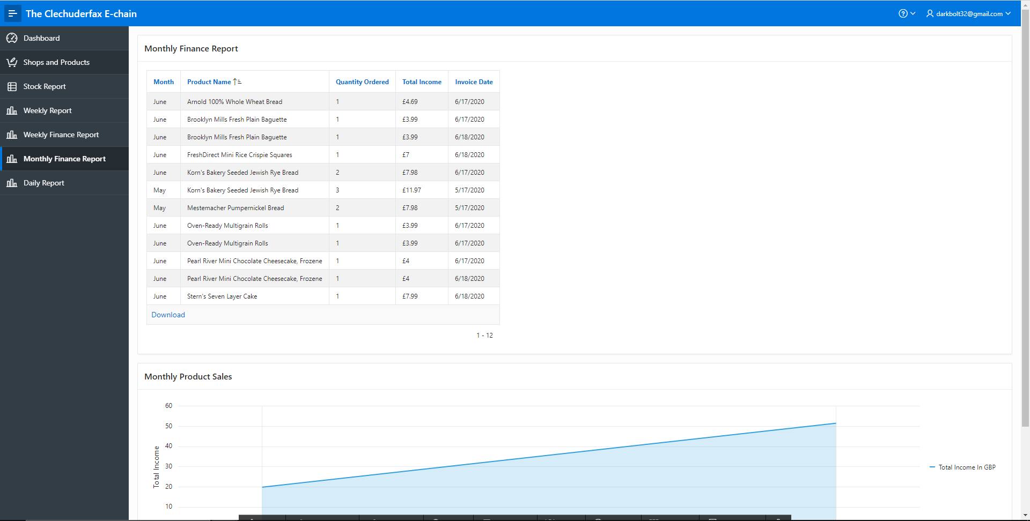

Traders can view monthly finance report of their respective shop from this page and product sale in line graph by month.

##### Daily Finance Report

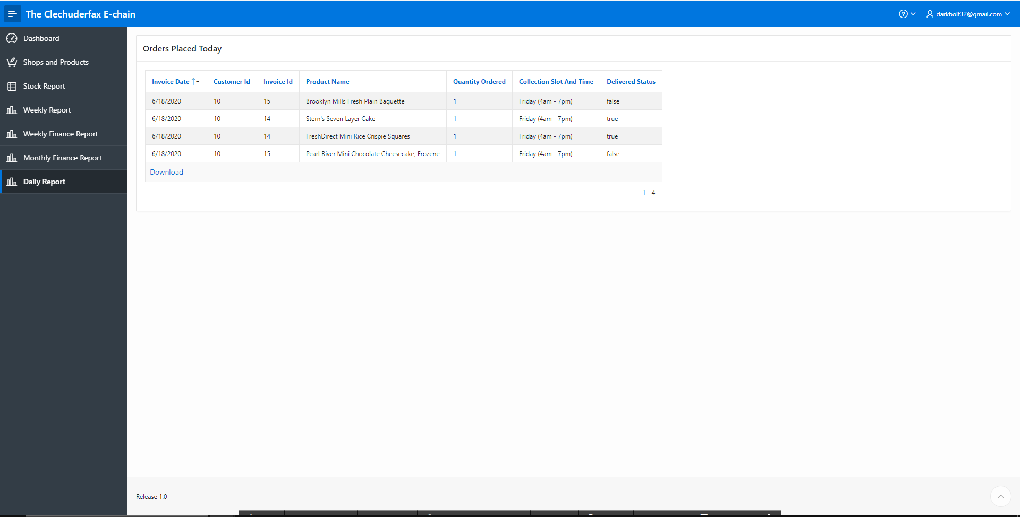

Traders can view daily finance report of their respective shop from this page.

#### Admin PHP

##### Admin login

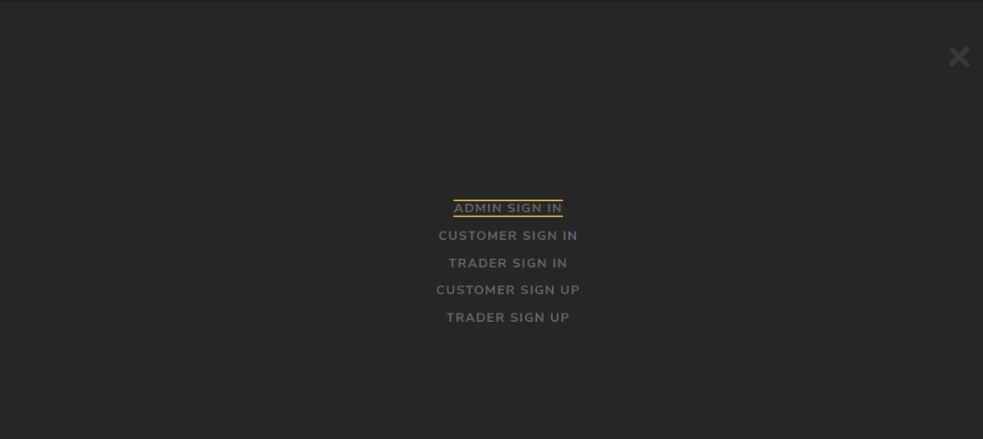

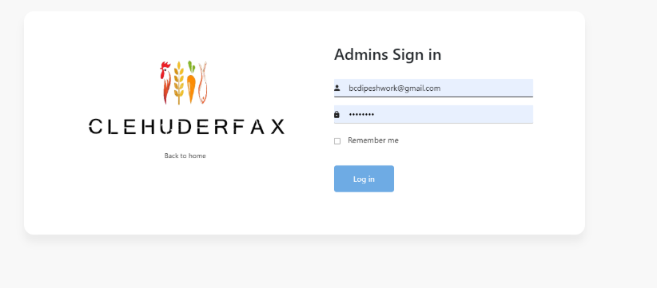

This is admin login page. Admin can access his/her dashboard using correct login credential.

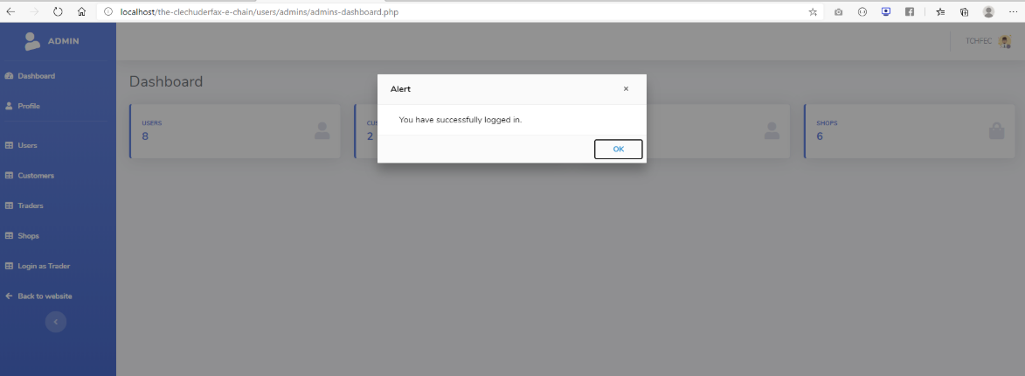

Admin logged in successfully.

##### Admin Dashboard

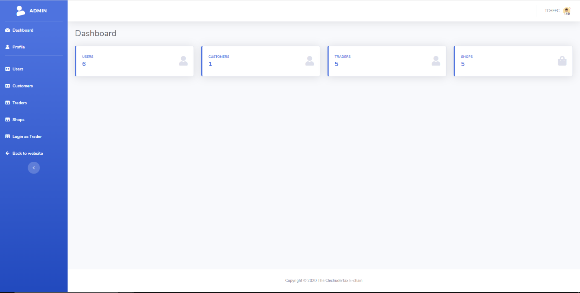

This is the admin’s dashboard. The admin can view total users, customers, and traders and shops.

##### Admin Profile

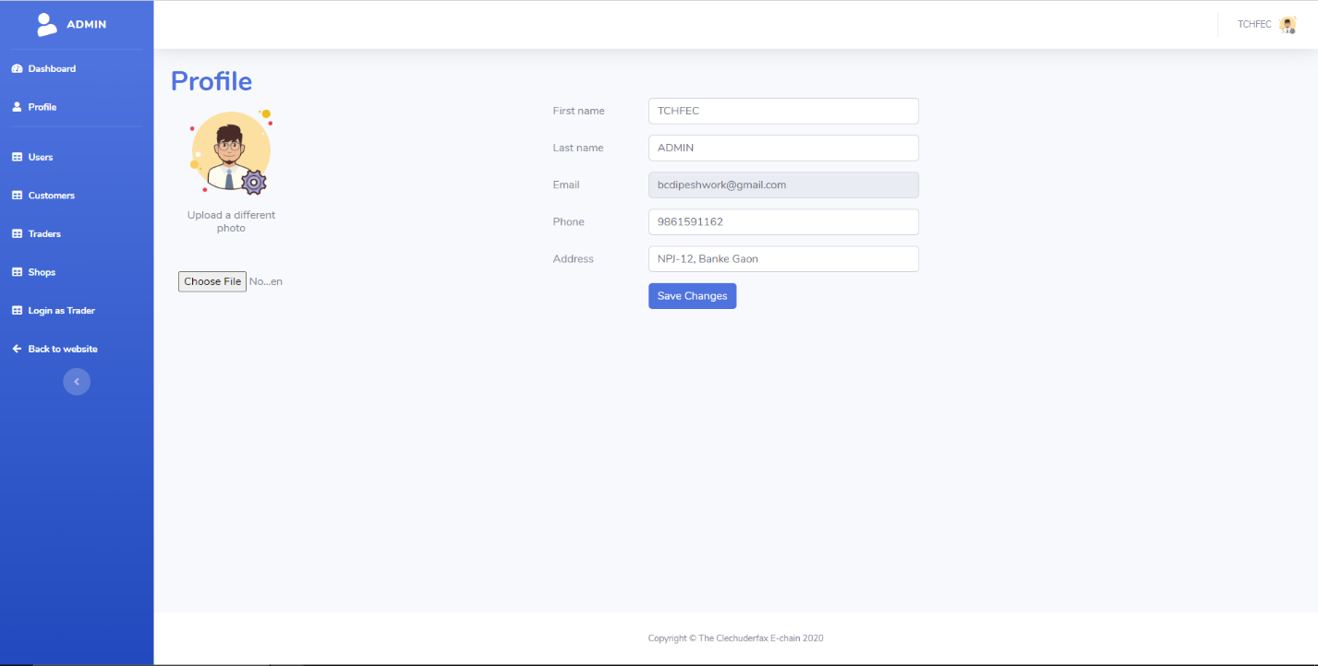

This is the admin profile page. Admin can change his details and profile picture here.

##### Admin User Panel

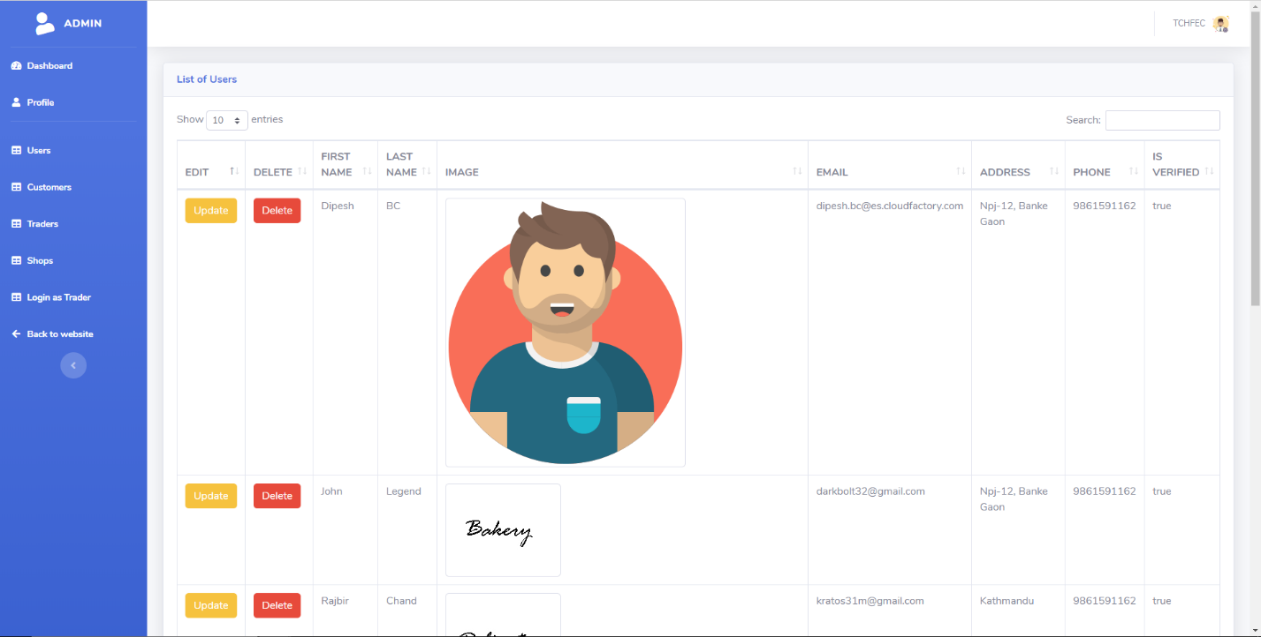

Admin can view all the users from this page and can update and any of the users.

##### Admin Customer Panel

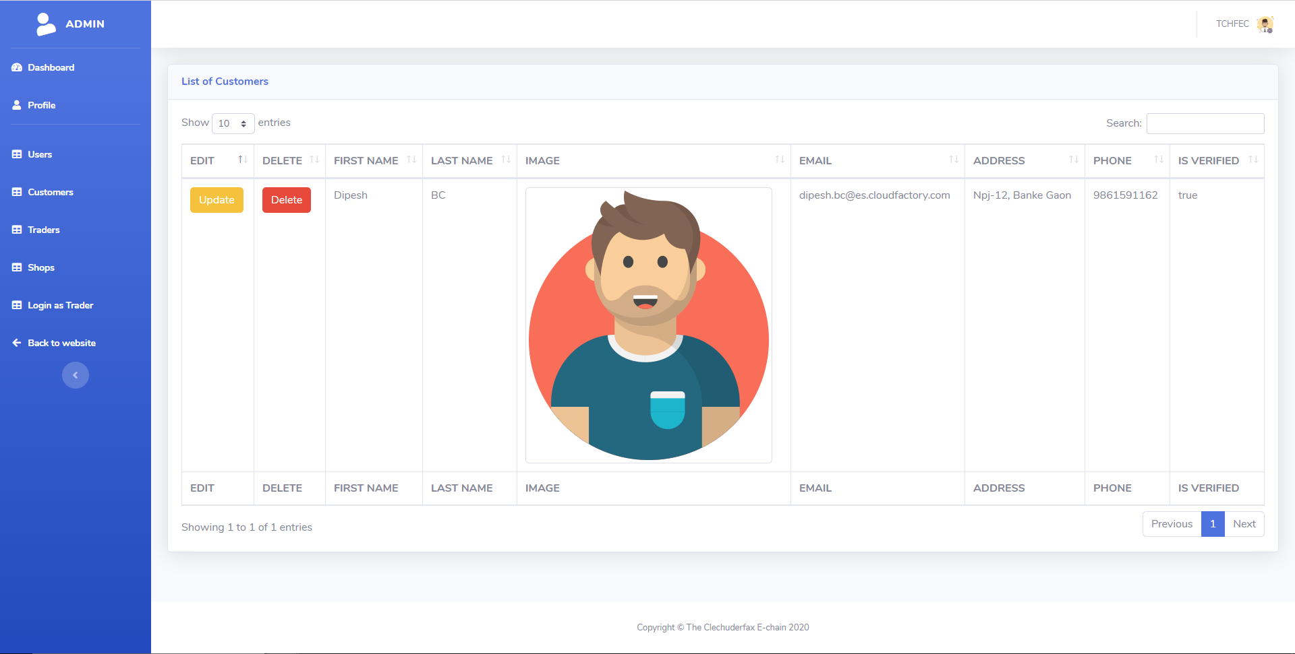

Admin can view all the customers from this page and can update and any of the customers.

##### Admin Trader Panel

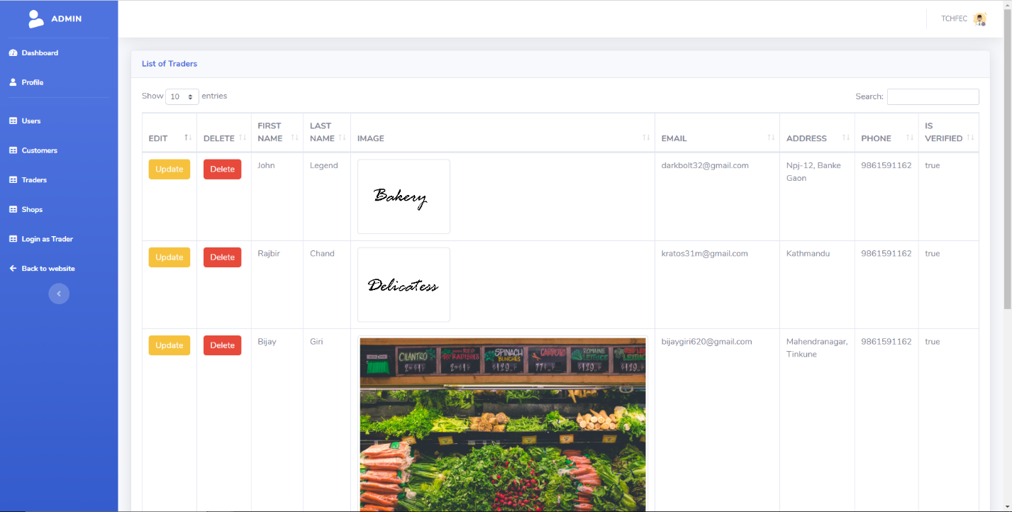

Admin can view all the trader from this page and can update and any of the trader.

##### Shops

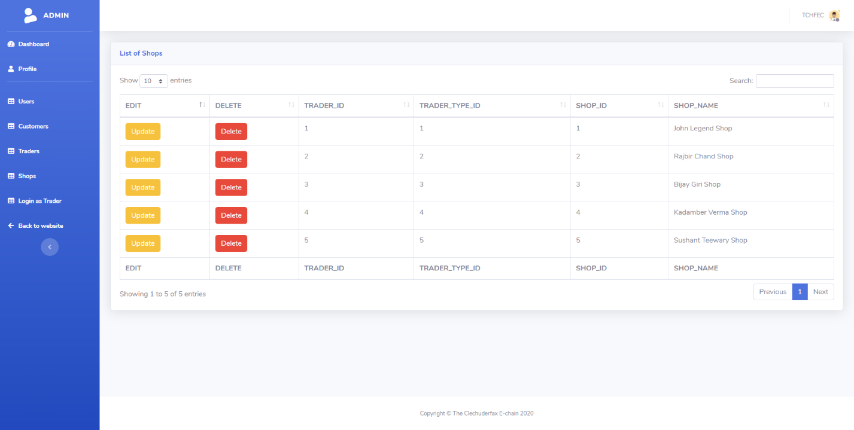

This is the shops page for admin. Admin can update and delete desired shop from this page.

##### Login as Trader

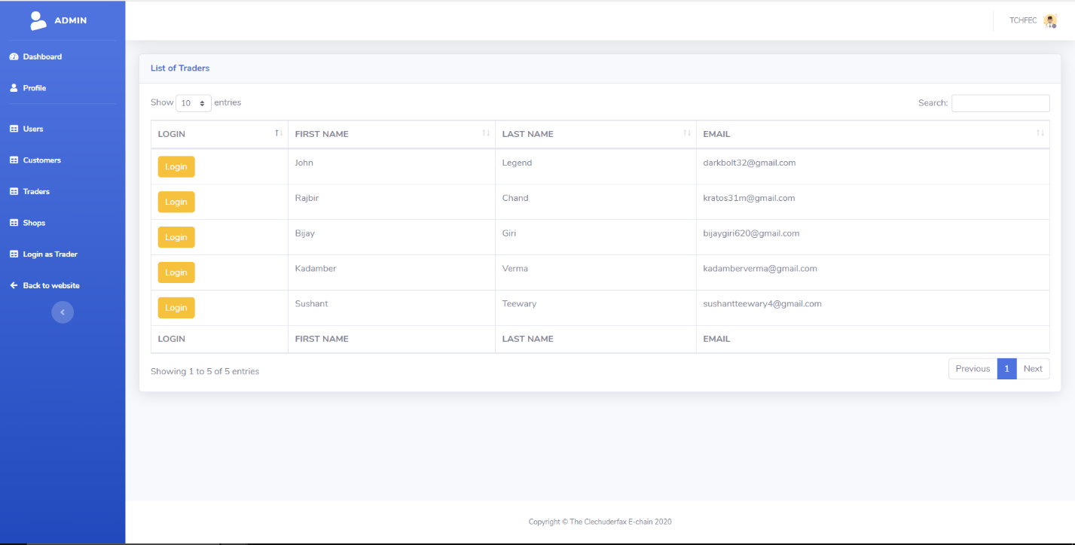

The admin has rights to login to any of the trader account. Admin can login to any trader from this page.

##### Update User

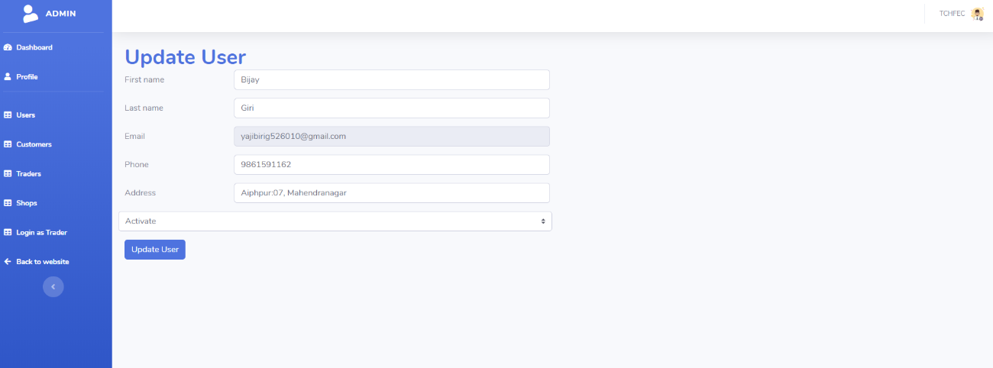

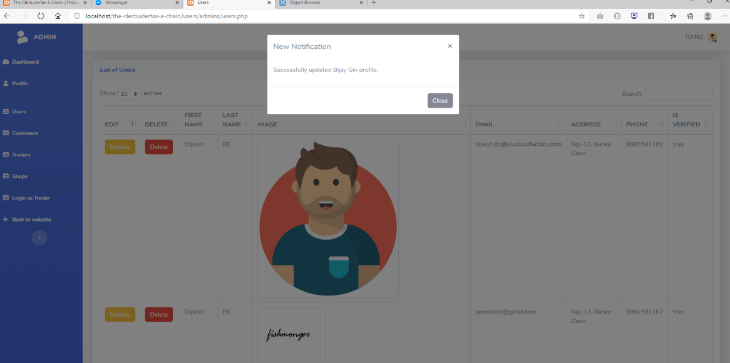

Admin can update any of the user’s profile from the update button next to the user.

##### Delete User

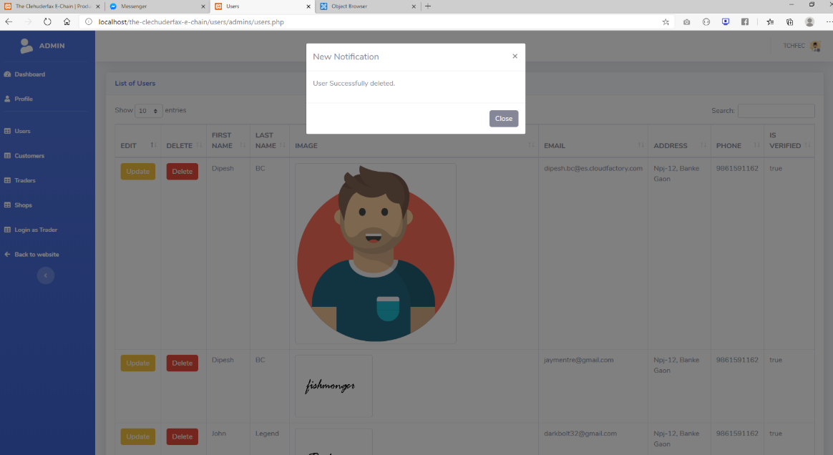

Admin can delete any of the user’s profile from the update button next to the user.

##### Update Shop

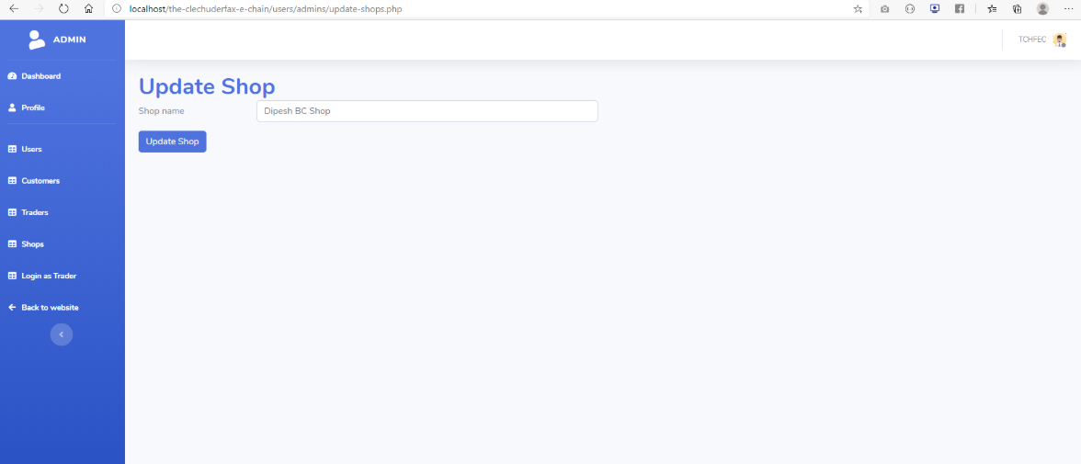

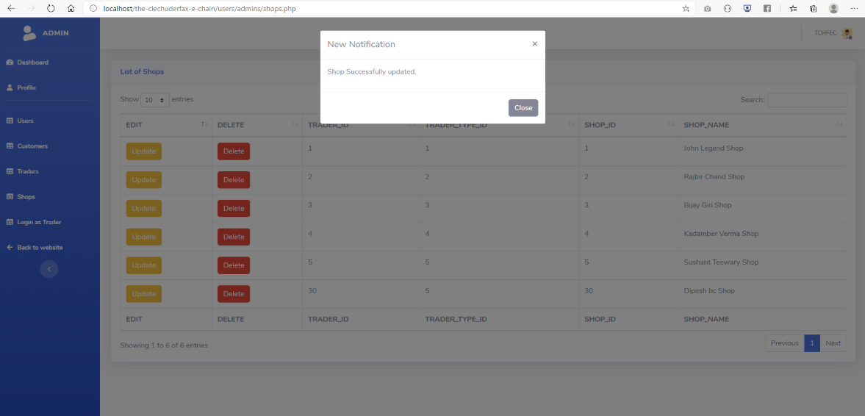

Admin can update any shop from the update button next to the shop name in shops tab.

##### Delete Shop

Admin can delete any shop from the delete button next to the shop name in shops tab.

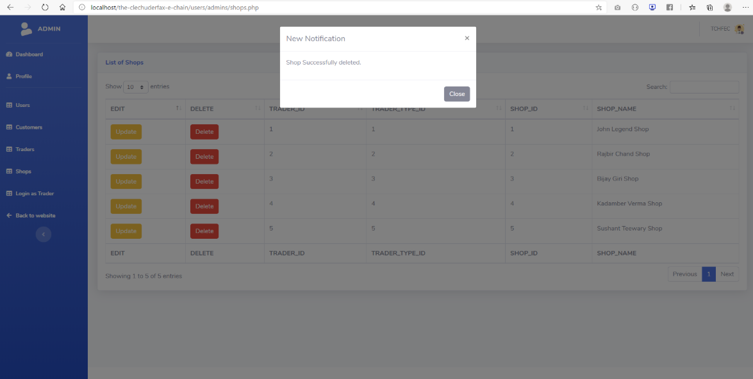

#### Admin APEX

##### Admin login

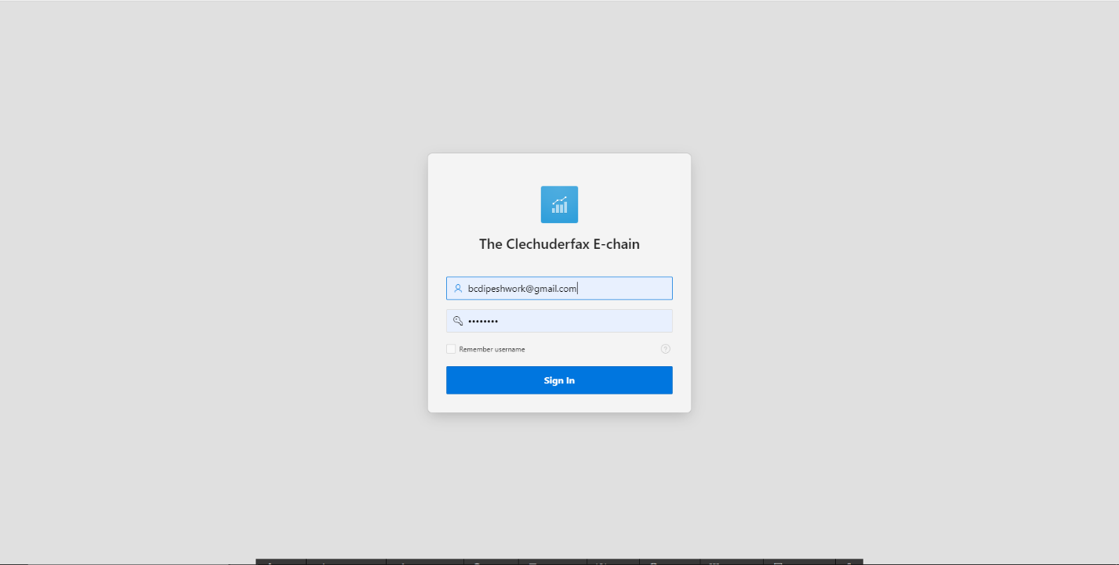

This is admin login page in APEX.

##### Admin Dashboard

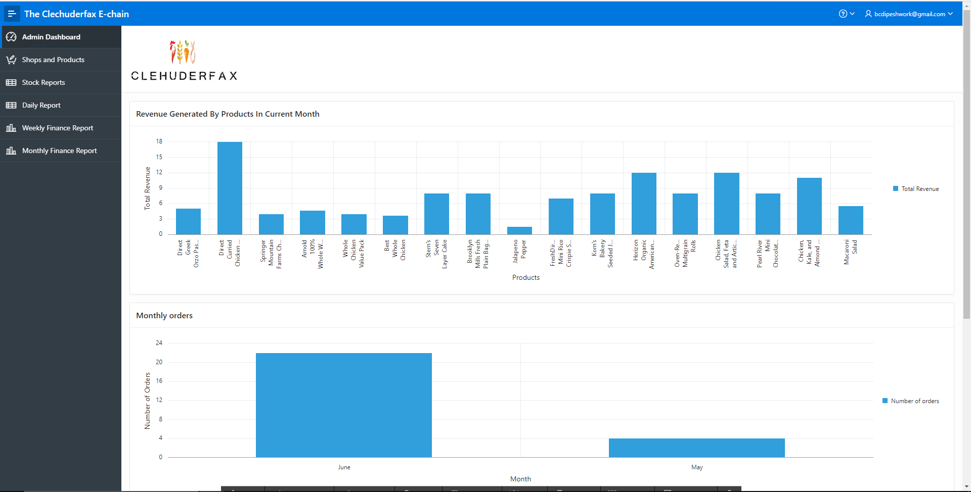

Admin can view the revenue generated by products, monthly orders and sales.

##### Shops and Products

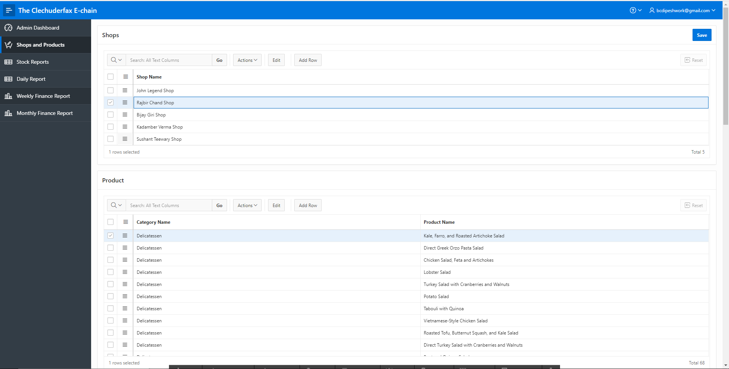

Admin can view all the shops and all the products in that respective shop via shops and products page.

##### Stock Reports

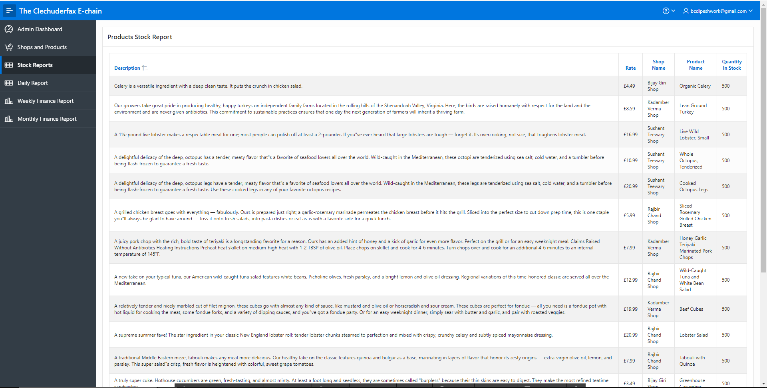

Admin can view all the stock report for all the traders from this page.

##### Daily Reports

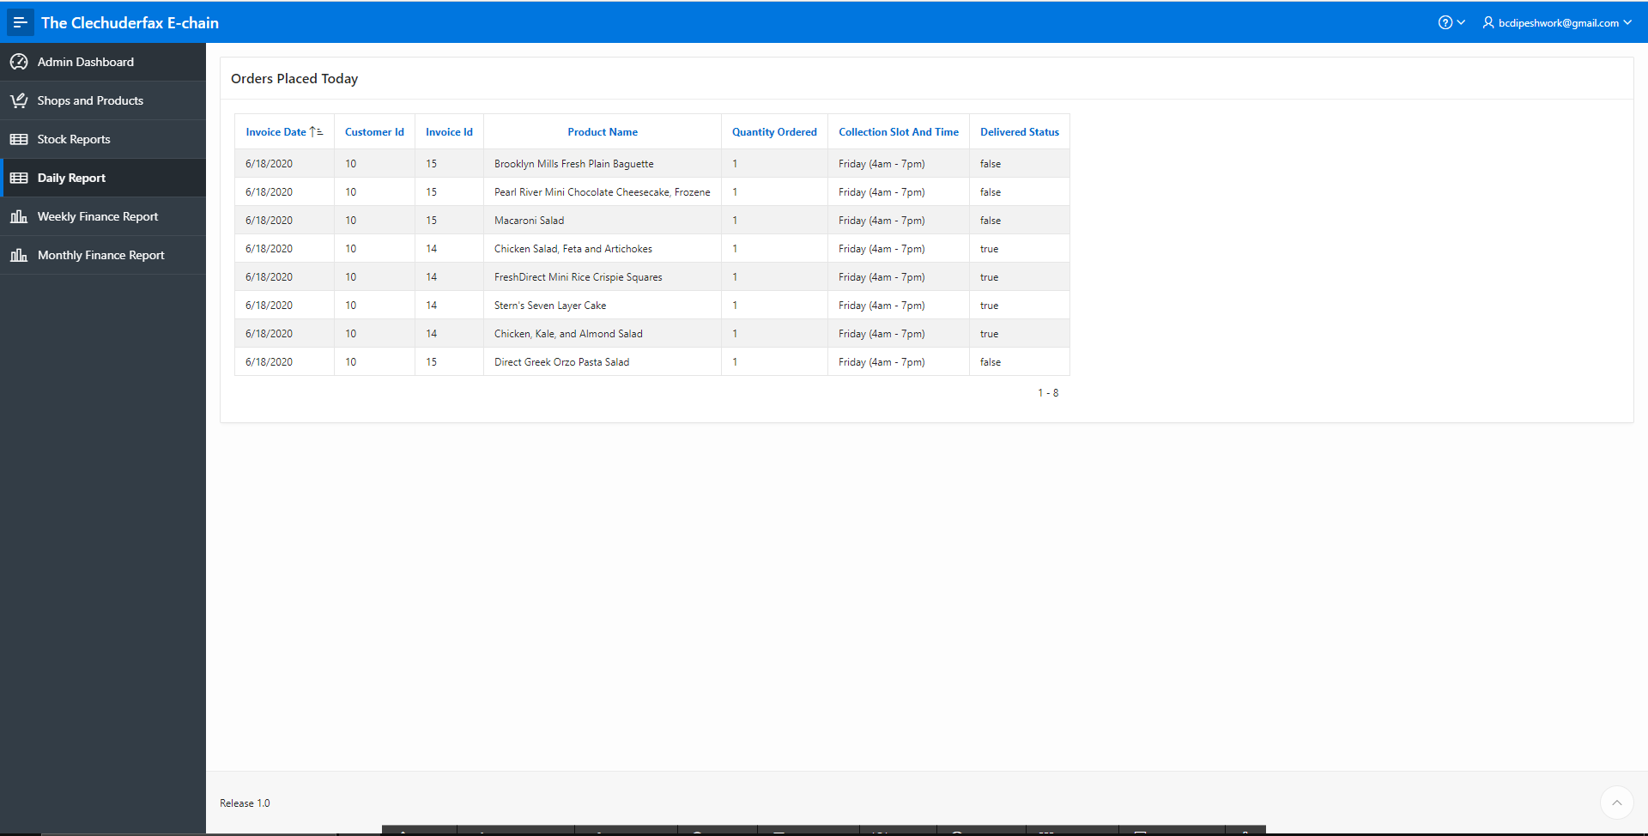

Admin can view daily product orders report of all the products from this page.

##### Weekly Finance Reports

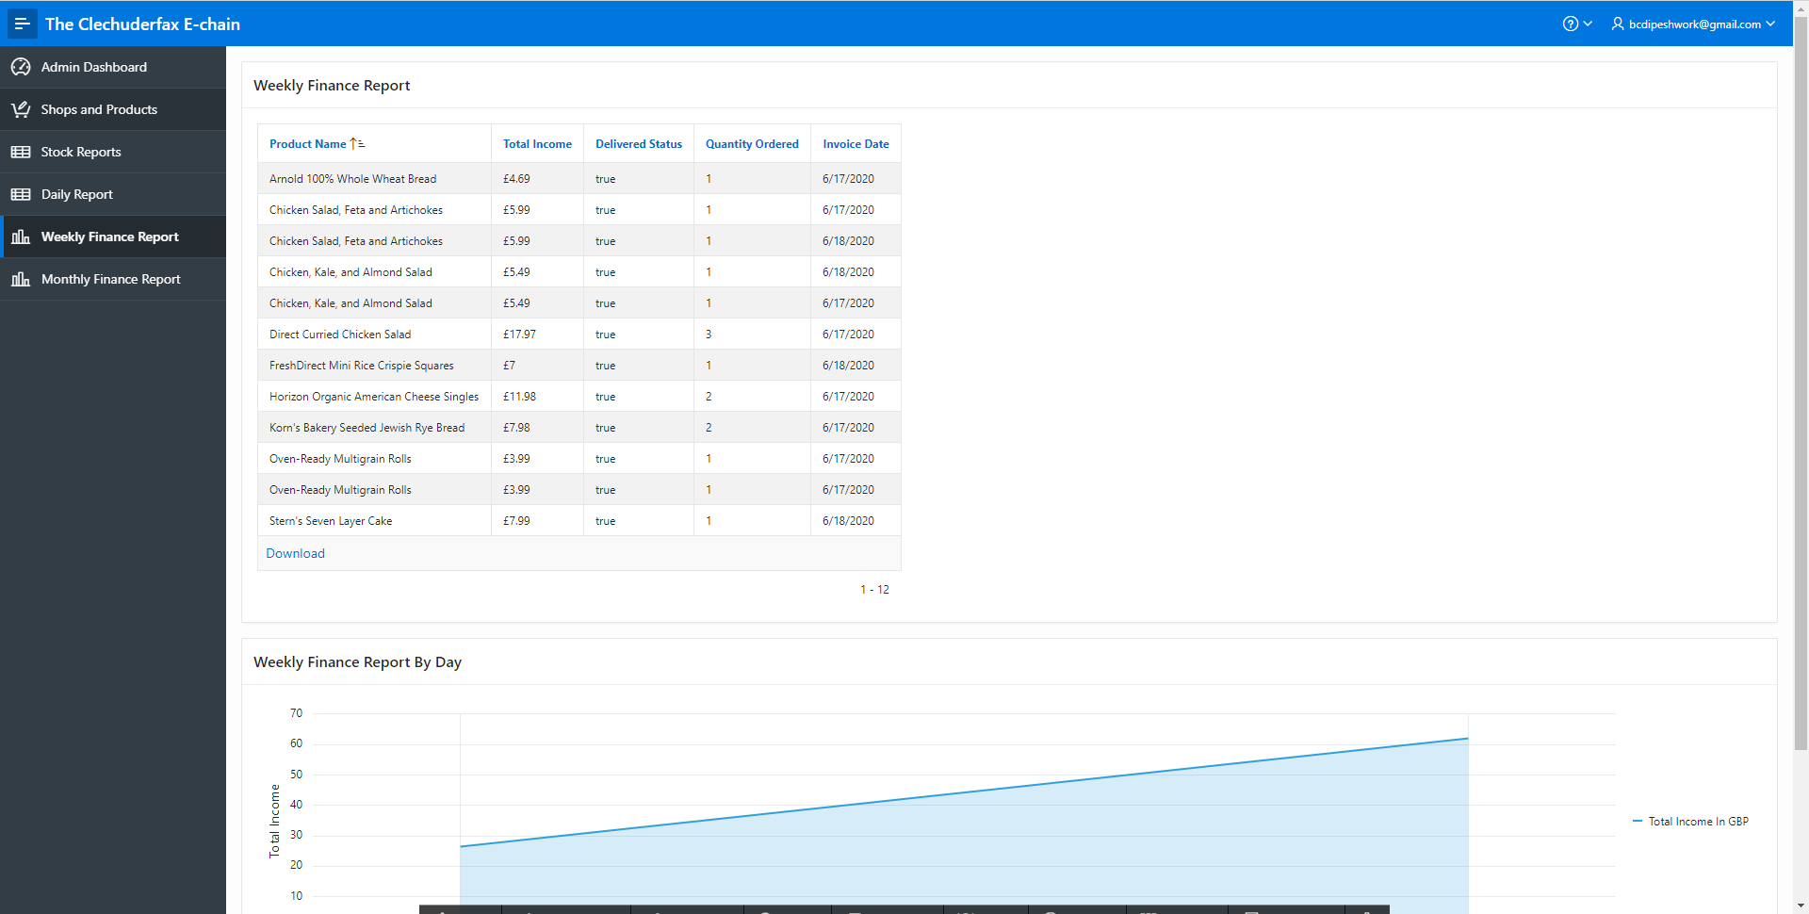

Admin can view Weekly finance report of all the products from this page.

##### Monthly Finance Reports

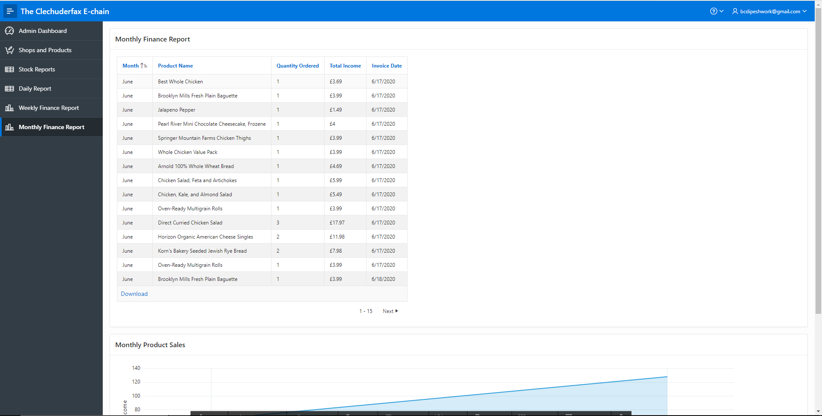

Admin can view monthly finance report of all the products from this page.